MRs Lenkienė and Mrs Miltinienė Lesson plan

Title
MYSTERIOUS SICILY. TELL NO ONE.
Author(s)
Irma Lenkienė, Irada Miltinienė
Licenses
Please indicate below which license you attribute your work with by picking one of the options below. If you include images in the lesson plan, please make sure to add the source and licenses under the picture itself.
- Attribution CC BY. This license lets others distribute, remix, tweak, and build upon your work, even commercially, as long as they credit you for the original creation. This is the most accommodating of licenses offered. Recommended for maximum dissemination and use of licensed materials.
- Attribution ShareAlike CC BY-SA. This license lets others remix, tweak, and build upon your work even for commercial purposes, as long as they credit you and license their new creations under the identical terms. This is the license used by Wikipedia, and is recommended for materials that would benefit from incorporating content from Wikipedia and similarly licensed projects.
- Attribution-NoDerivs CC BY-ND. This license allows for redistribution, commercial and non-commercial, as long as it is passed along unchanged and in whole, with credit to you.
- Attribution-NonCommercial CC BY-NC. This license lets others remix, tweak, and build upon your work non-commercially, and although their new works must also acknowledge you and be non-commercial, they don’t have to license their derivative works on the same terms.
- Attribution-NonCommercial-ShareAlike CC BY-NC-SA. This license lets others remix, tweak, and build upon your work non-commercially, as long as they credit you and license their new creations under the identical terms.
√ Attribution-NonCommercial-NoDerivs CC BY-NC-ND. This license is the most restrictive of the six main licenses, only allowing others to download your works and share them with others as long as they credit you, but they can’t change them in any way or use them commercially.

Subject
List all the subjects that this lesson plan is intended for. If this is an interdisciplinary lesson, list multiple subjects.
English, ICT, Geography, History, Art.

Aim of the lesson
Describe in 1-2 sentences what you would like to achieve with your students by the end of the lesson.
By completing speaking, reading and quiz activities online, the students will enrich their knowledge on Sicily, expand their travelling related vocabulary. They will also develop the 21st century skills such as ICT literacy, critical thinking, creativity, collaboration, communication, global awareness and citizenship through social inclusion.

Age of students
Year 6 (age 13 -14)
Time
Preparation time: 180 min
Teaching time: 45 min

Teaching material
Online:
List here all the links of online tools and support documents that you will use during the lesson.
Computers and smartphones with the Internet access.
https://www.menti.com/
https://b.socrative.com/teacher/#edit-quiz/44809330
https://quizizz.com/admin/quiz/5e4eec0b7b2ac3001b7ab1f6/palermo
https://www.classdojo.com
https://www.youtube.com/watch?v=CRqPWliOyWs

Offline:
Paper, posters, writing and drawing implements, computer prints.

21st century skills
Add here how the lesson plan corresponds to 21st century skills. To find out more: http://www.p21.org/our-work/p21-framework .
Activities are designed to foster the learning of 21st century skills of students:
- critical thinking. Students analyze information objectively and make a reasoned judgment about which sightseeing places in Sicily are worth visiting. They evaluate research findings. They draw reasonable conclusions from a set of information and discriminate between useful and less useful details to decide.
- creativity. Students draw and colour the flag of Sicily.
- communication. Students impart and exchange information by speaking and writing.
- collaboration. Students work together to answer the quiz questions on Palermo and Sicily and to fill in the empty gaps with the given relative pronoun and active vocabulary.
- ICT literacy. During this lesson 4 different online platforms are used. Students use mentimeter platform to share their travelling experience; to show their knowledge on Palermo and Silicy they use socrative and quizizz platforms. For their assessment students use an online platform classdojo.
Lesson Plan
Describe here in detail all the activities during the lesson and the time they require.

Name of activity | Procedure | Time
Brainstorming | Questions on mentimeter online platform provide a free and open environment that encourages everyone to participate in the discussion based on the given questions. After expressing their point of view, students draw the conclusion that the theme of the lesson will be related to travelling.  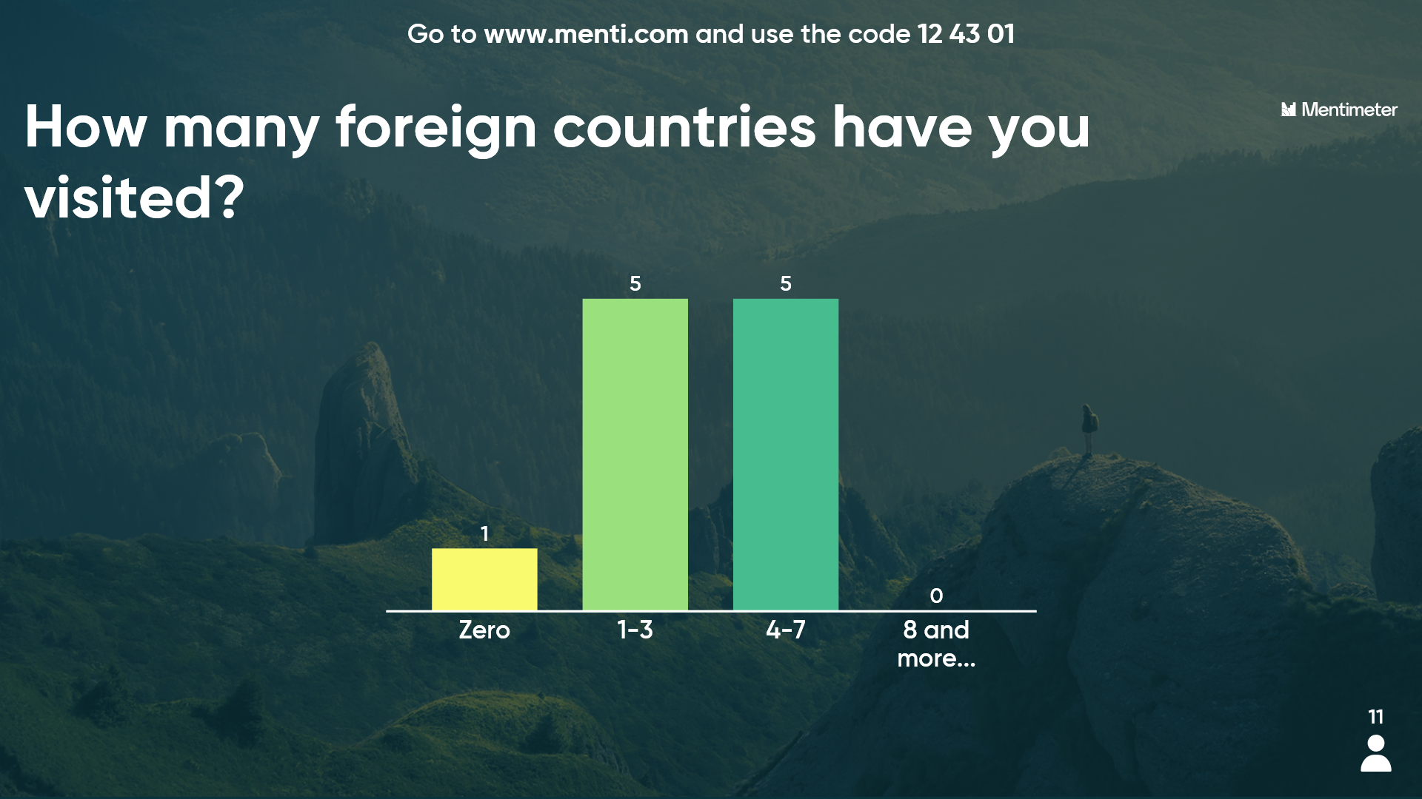  Students discuss the reasons for travelling, their expectations and priorities while travelling, they also express their preferences for local or foreign destinations. | 5 min
Students’ knowledge on Sicily | Students show their knowledge on Sicily history, geography, culture, sightseeing places, cuisine, travel tips, etc.  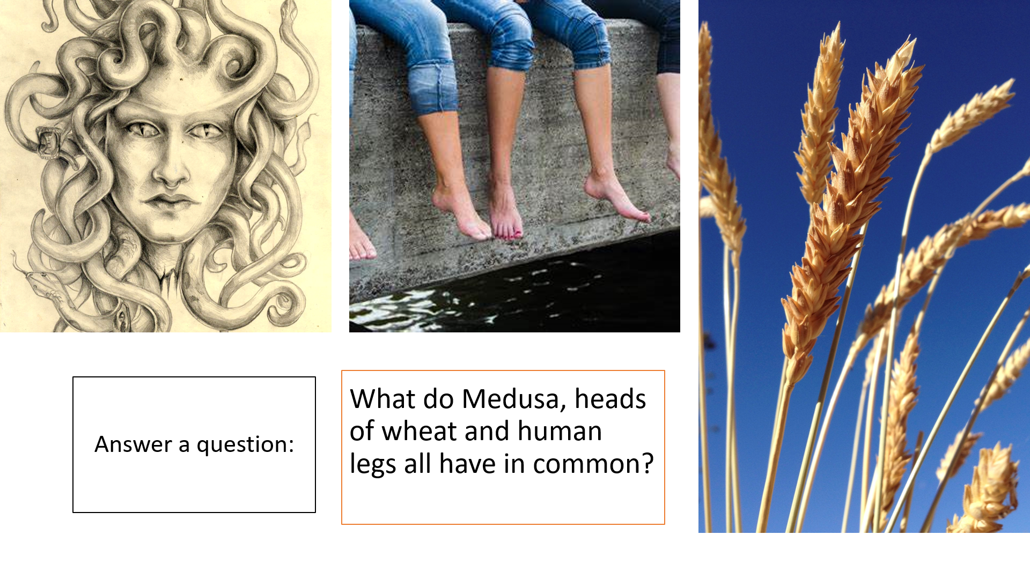  Students show their knowledge about Sicily answering questions on socrative online platform. Questions, along with answer choices, appear on a student’s smartphone screen and students submit their responses there while their results appear on the classroom screen. Their performance is presented in the lesson’s filmed material as well.  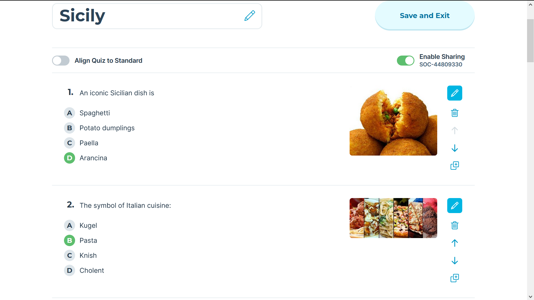 | 10 min
Gap filling | 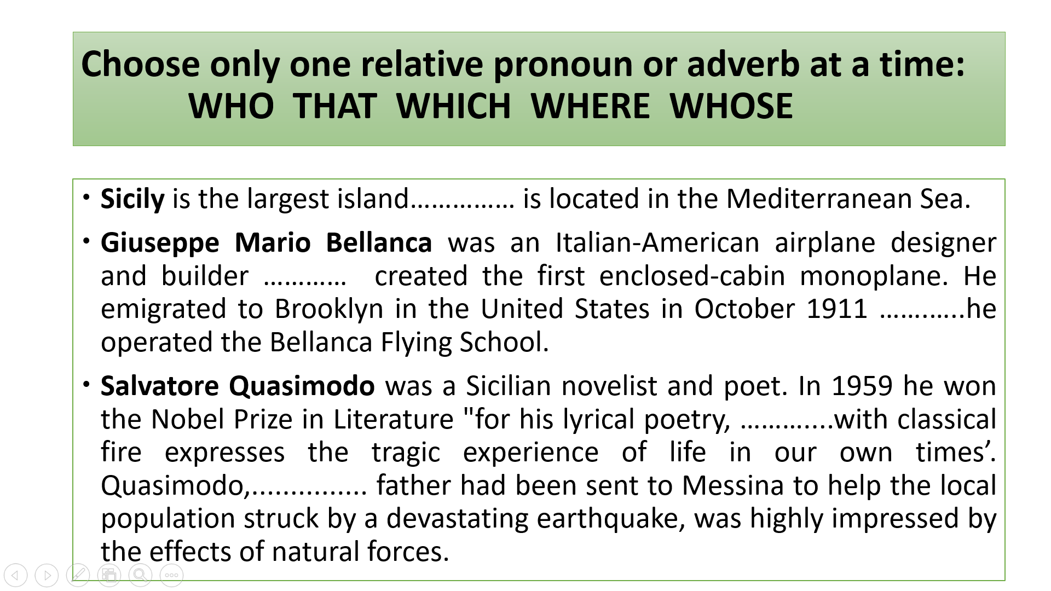  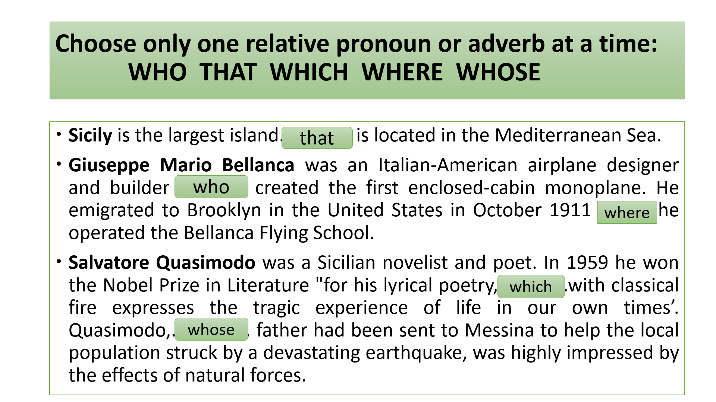 | 5 min
Students’ knowledge on Palermo | Students continue to show their knowledge about Sicily, in this case they concentrate on the capital city, Palermo, and answer the questions about it on quizizz online platform. Questions, along with answer choices, appear on a student’s smartphone screen and students submit their responses there while their performance appears on the classroom screen. Their performance is presented in the lesson’s filmed material as well.  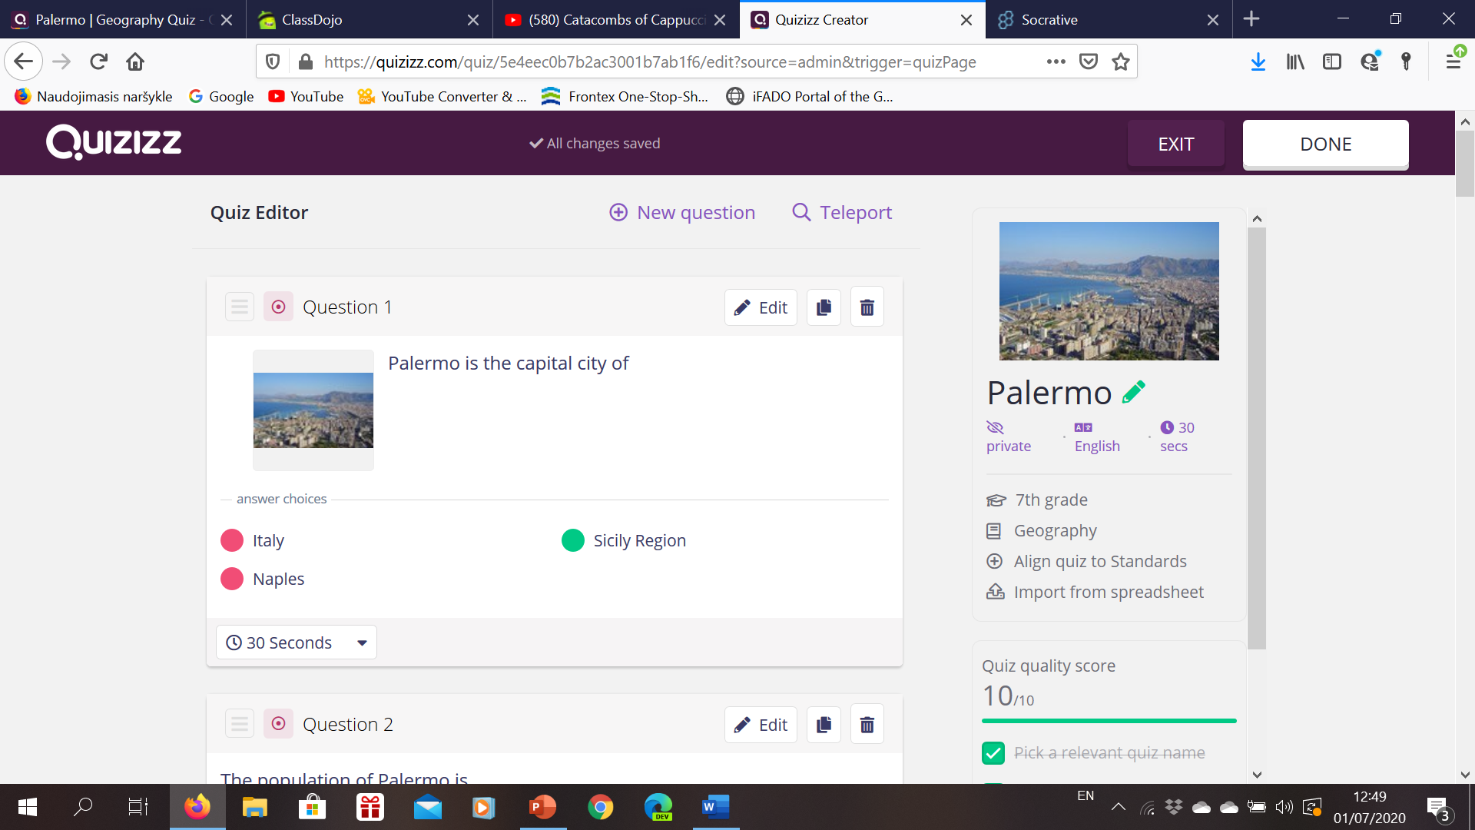 | 10 min
Video watching and gap filling | Students watch a short Youtube video about The Capuchin Catacombs of Palermo and fill in the text about the catacombs with the given words.  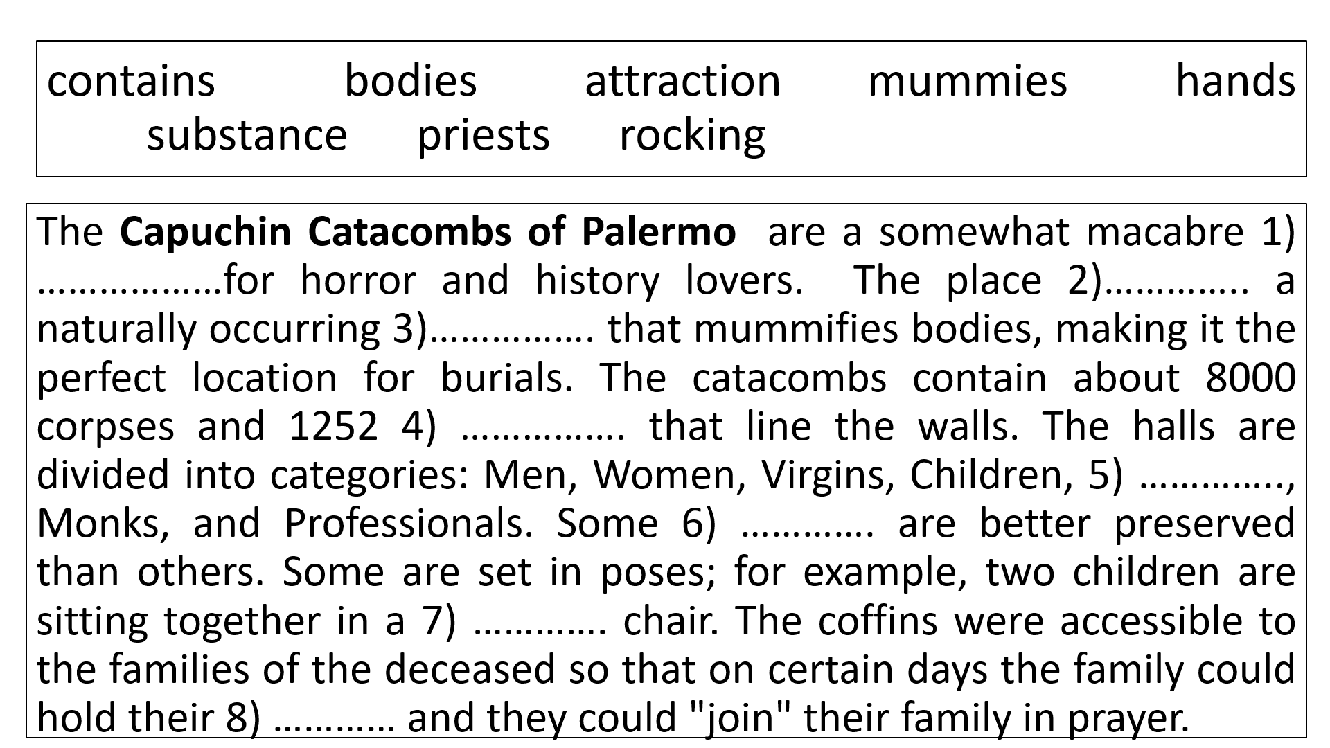  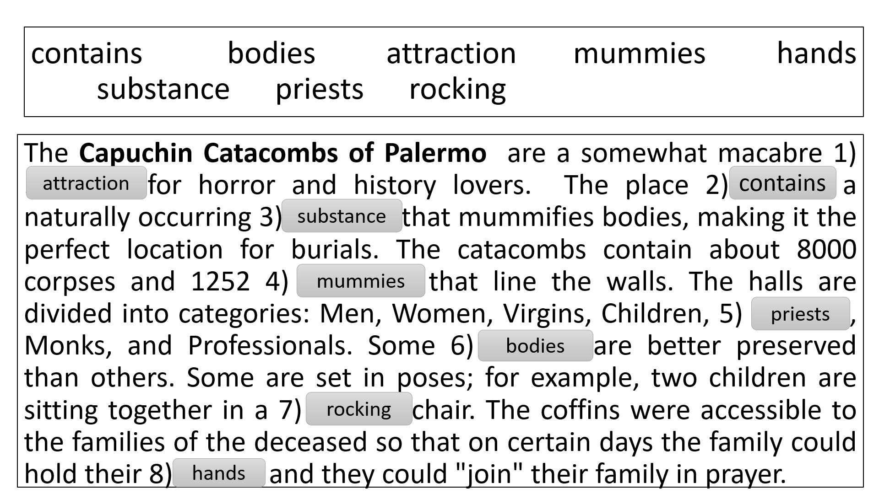 | 10 min
Self-assessment. | Online platforms socrative and quizizz are used to assess the students. Questions, along with answer choices, appear on a smartphone screen while students’ responses are presented on a classroom screen.
Student feedback | The class is gathered in a casual circle and some questioning strategies are used to hear what the students truly feel about the lesson. | 5 min

Assessment
Describe here the assessment method of the lesson, if any. For example, if you plan on assessing your students with a quiz, include here questions and answer options with color-coding the correct answers.
Online platforms Socrative and quizizz were used to assess the students. For the agreed number of correct answers in the quizzes, students were given a reward point, which were added next to the student’s name on a classdojo platform.
https://teach.classdojo.com/#/classes/5e53a9fb03f3d1c6911f11dc/points
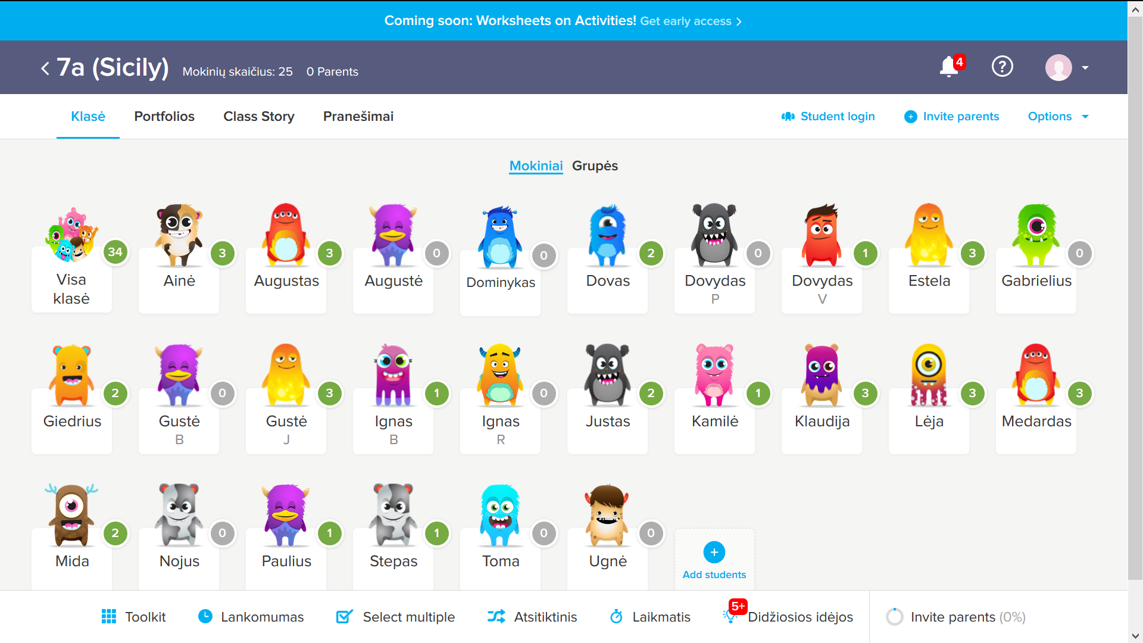

https://b.socrative.com/teacher/#edit-quiz/44809330

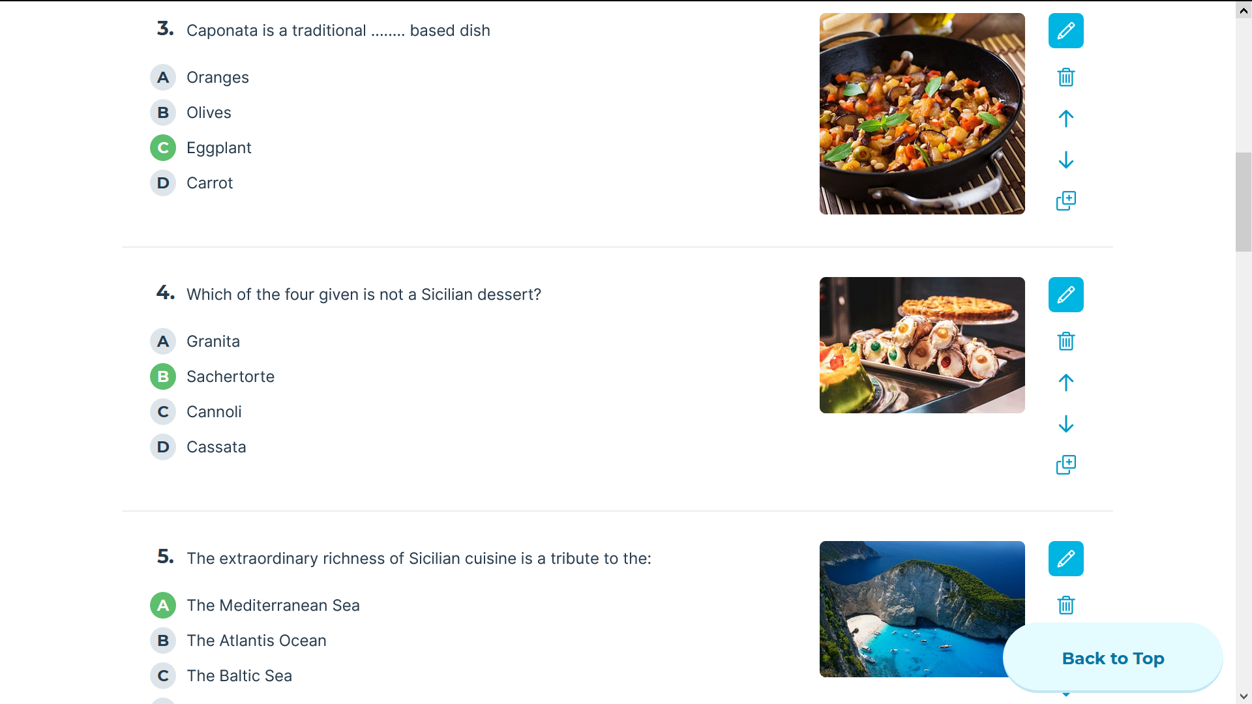
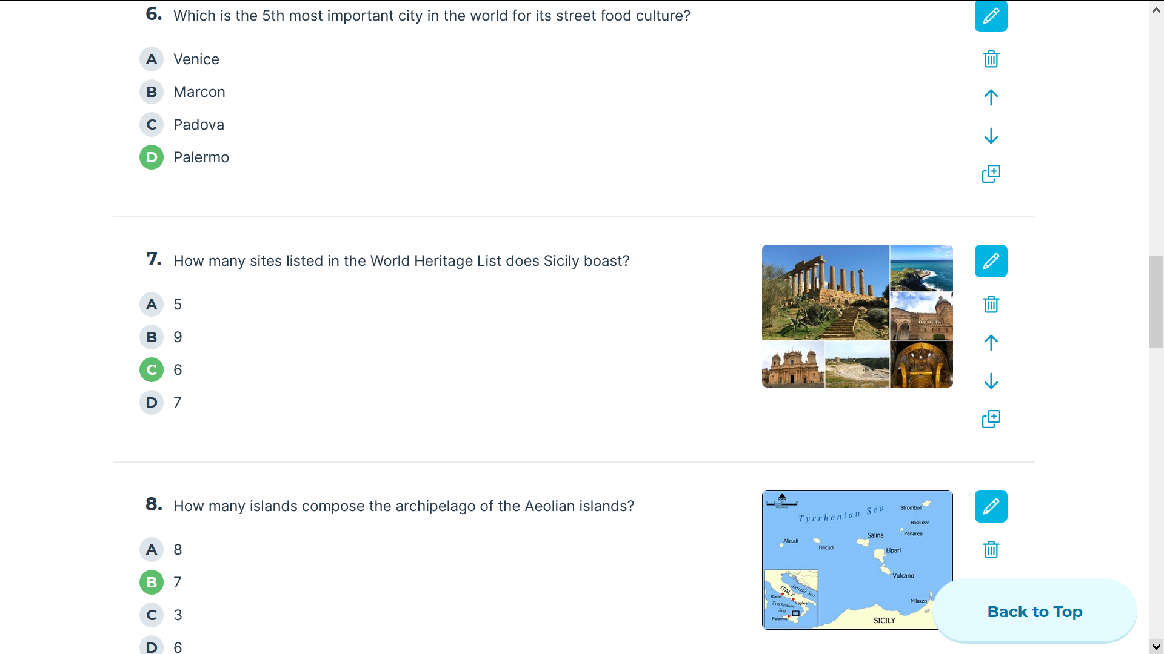

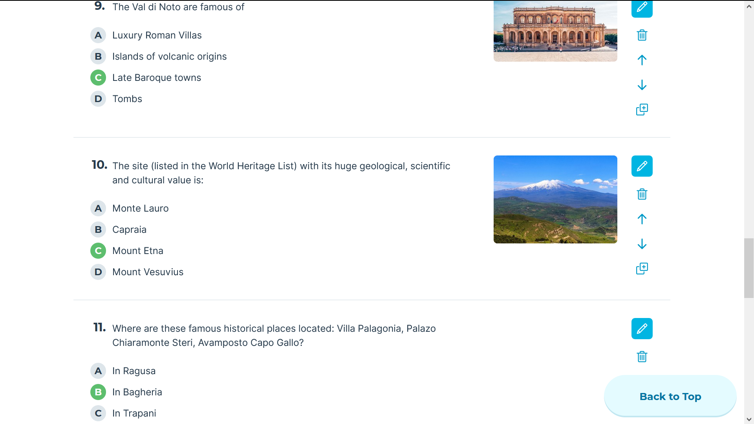
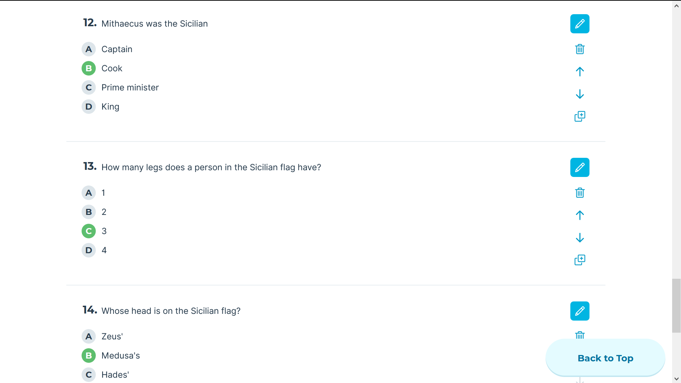

https://quizizz.com/admin/quiz/5e4eec0b7b2ac3001b7ab1f6/palermo
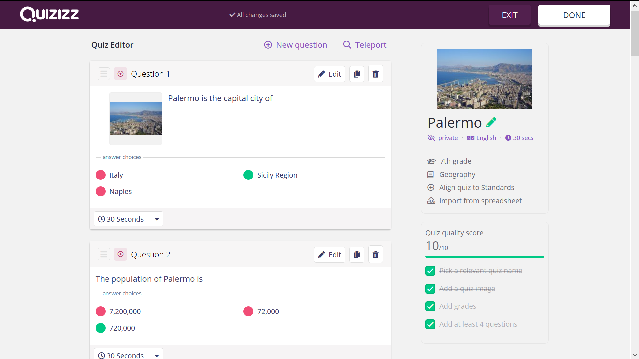
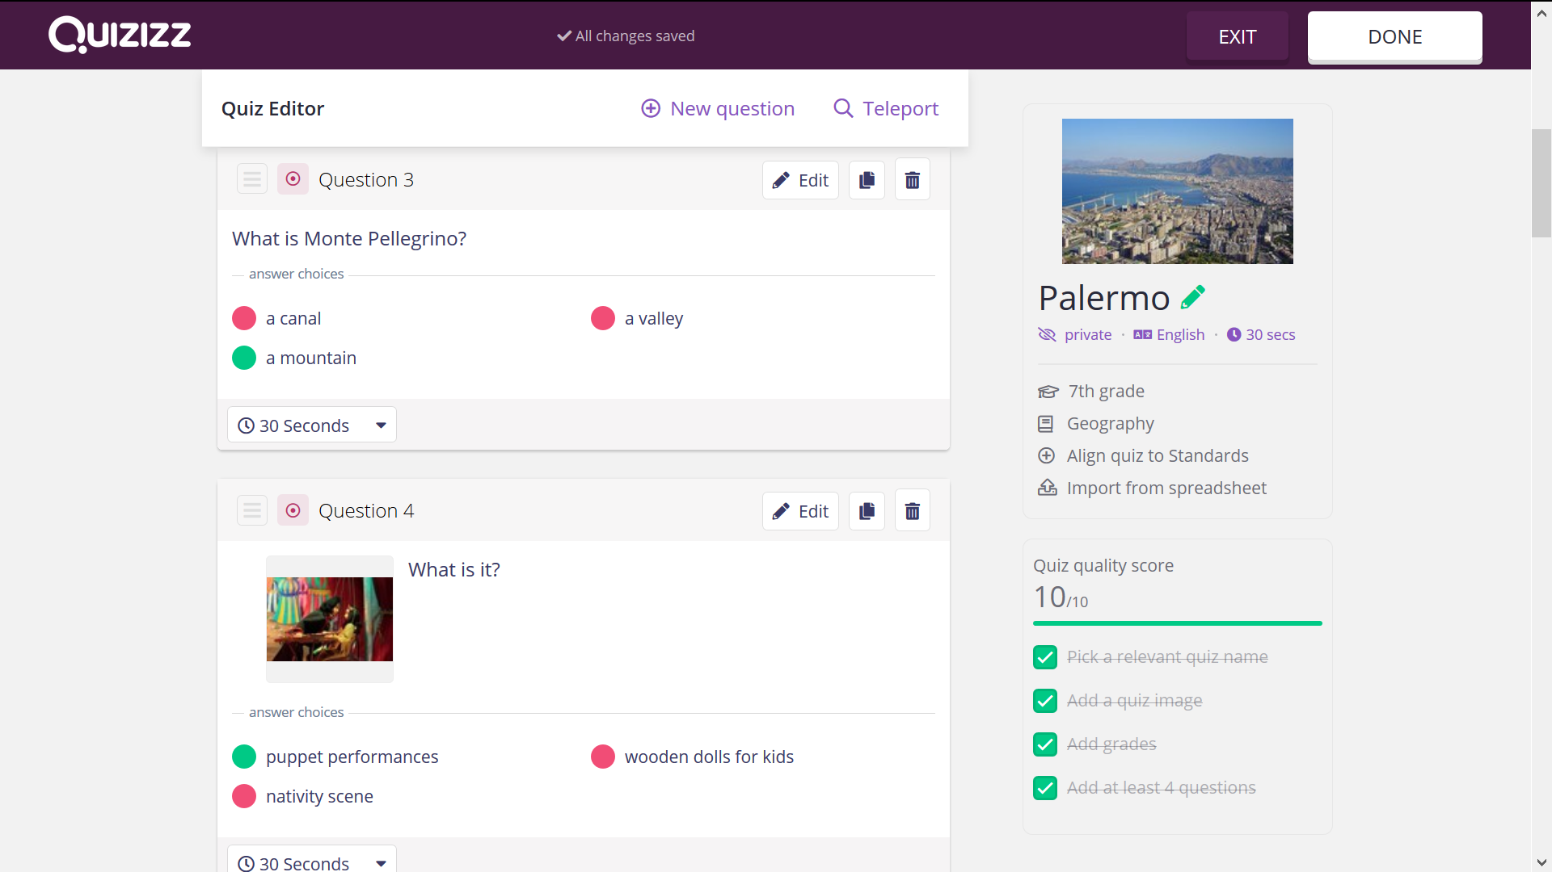
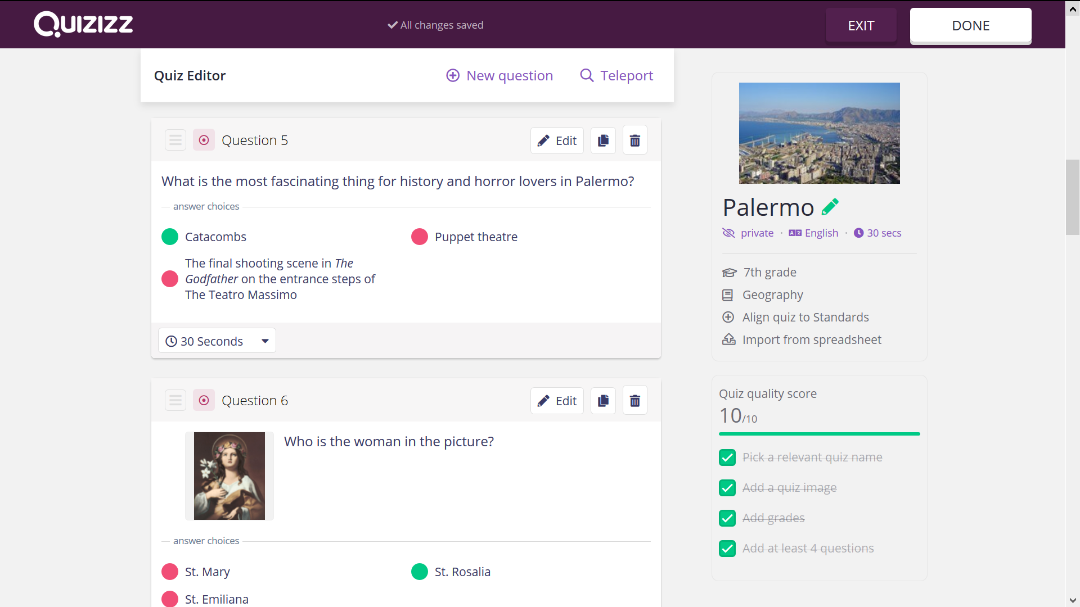
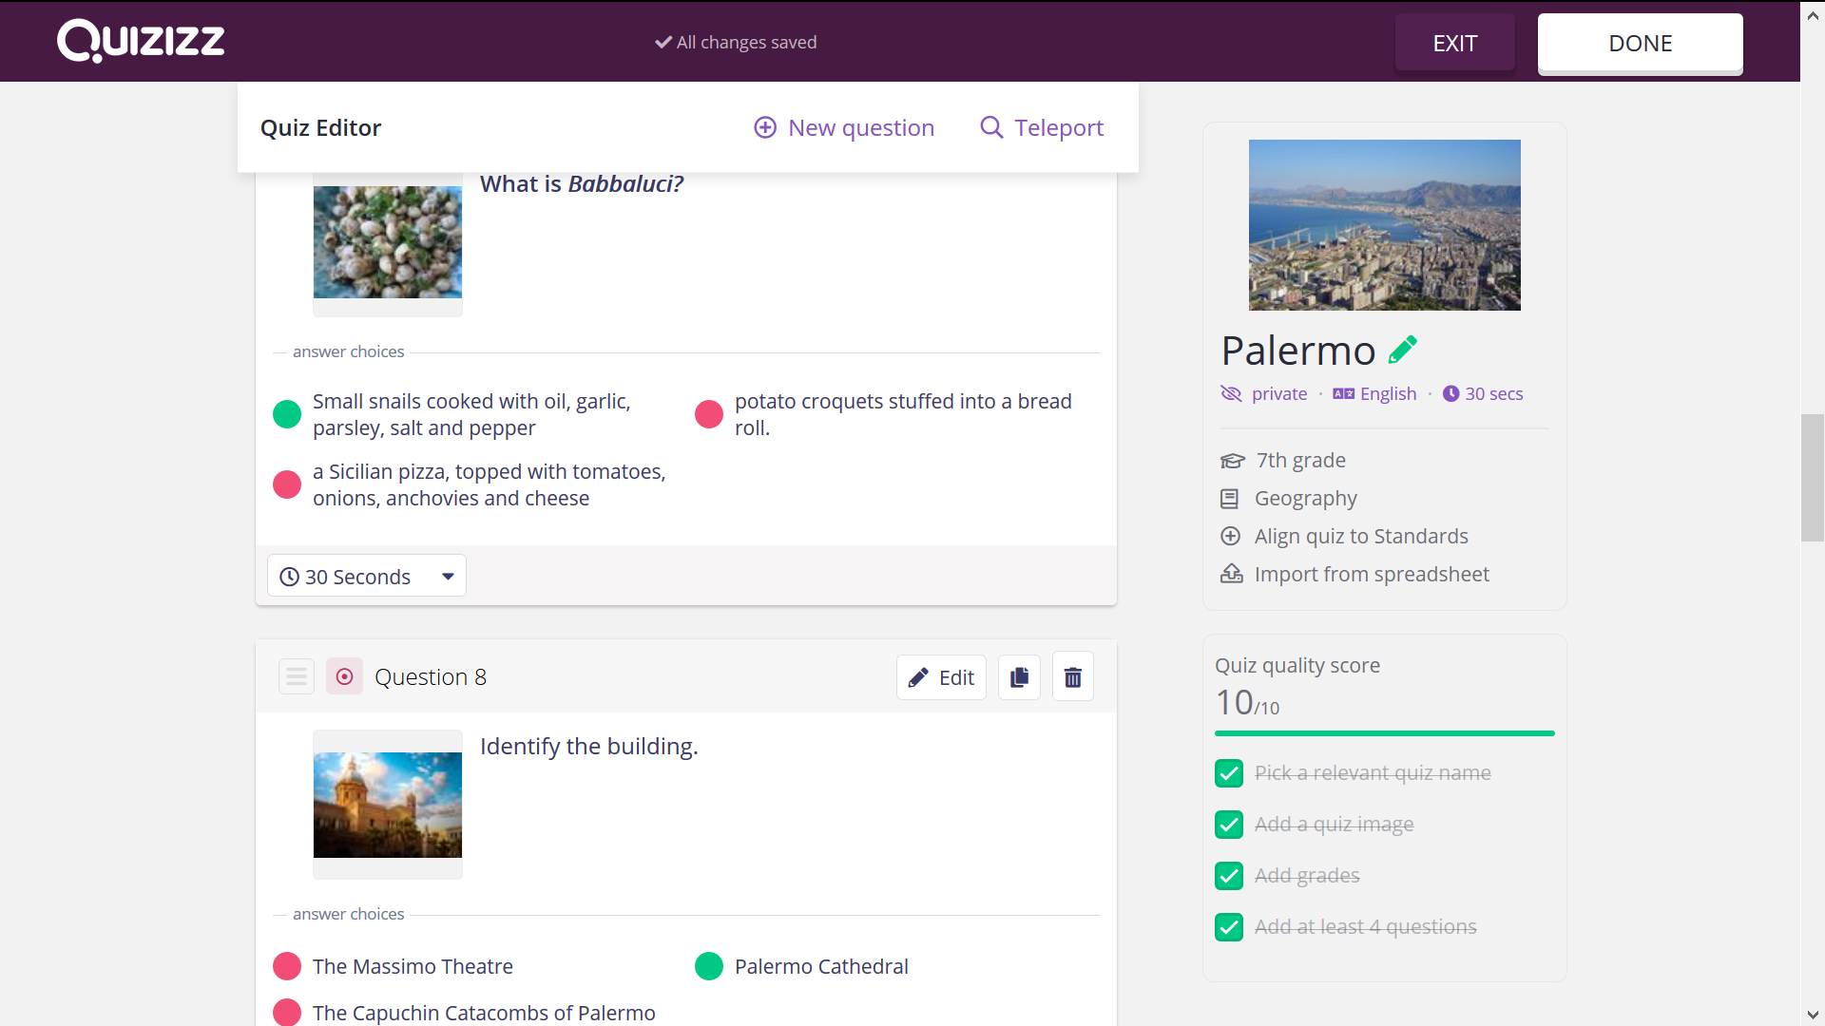
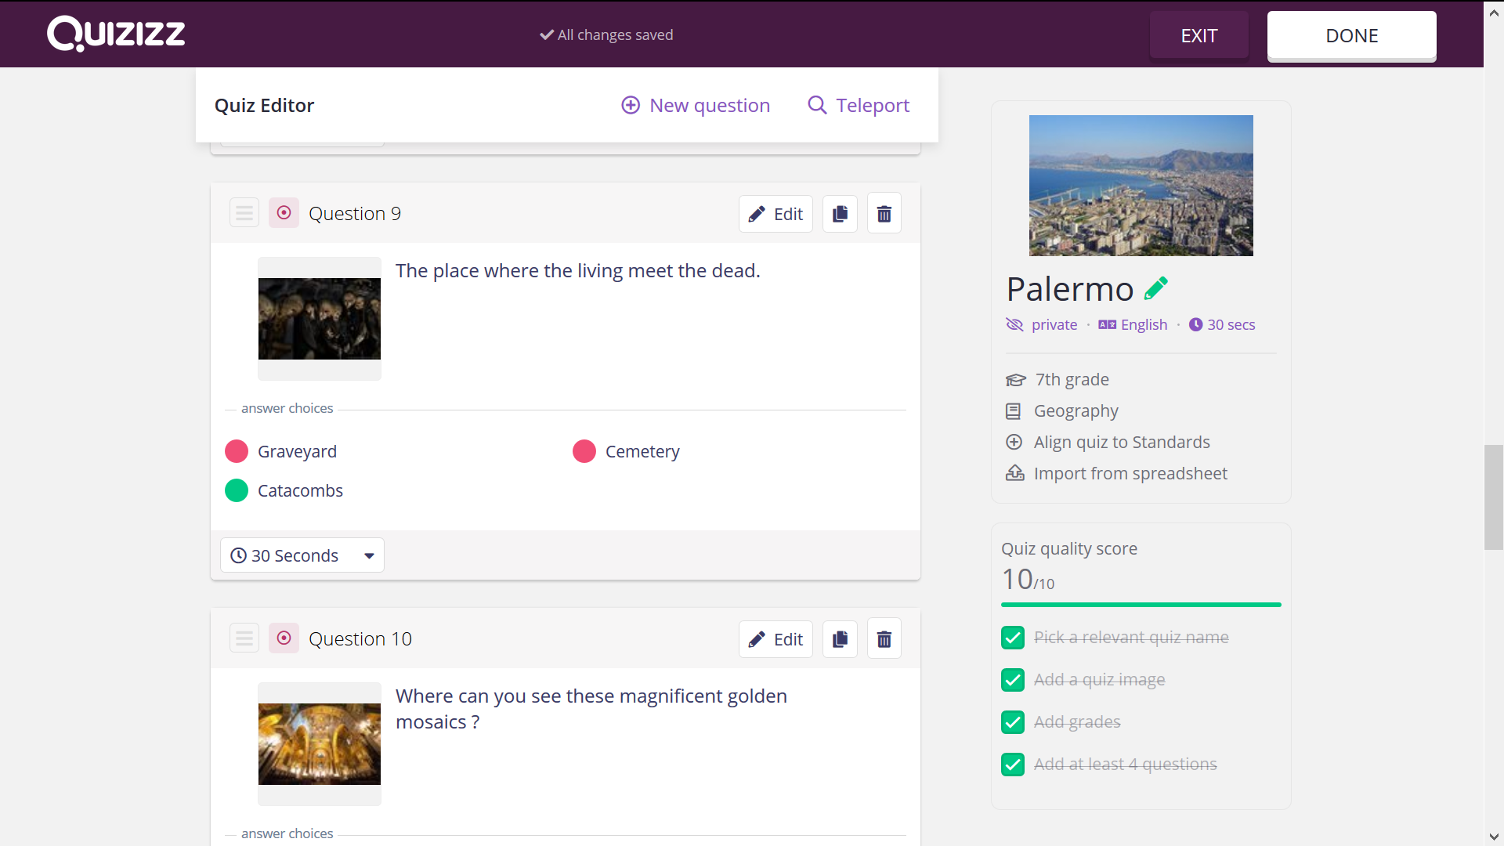
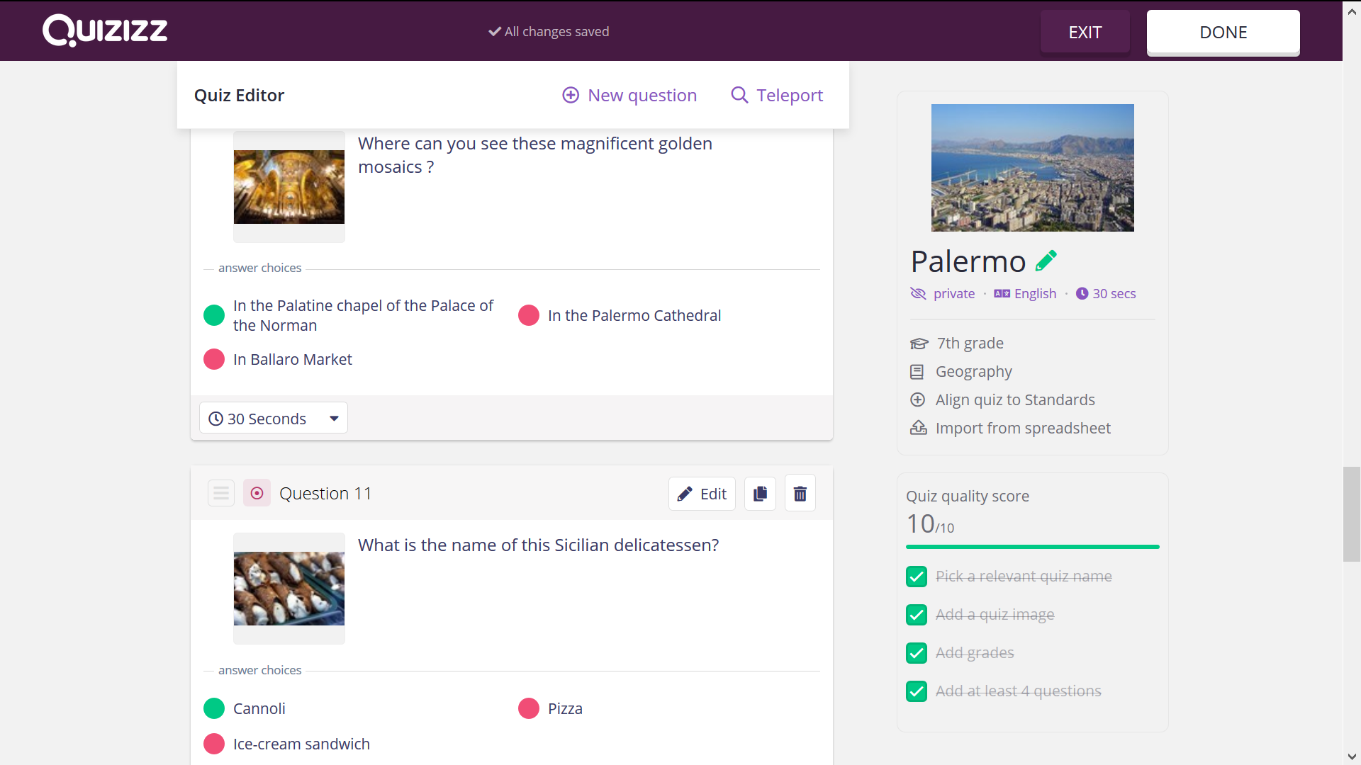
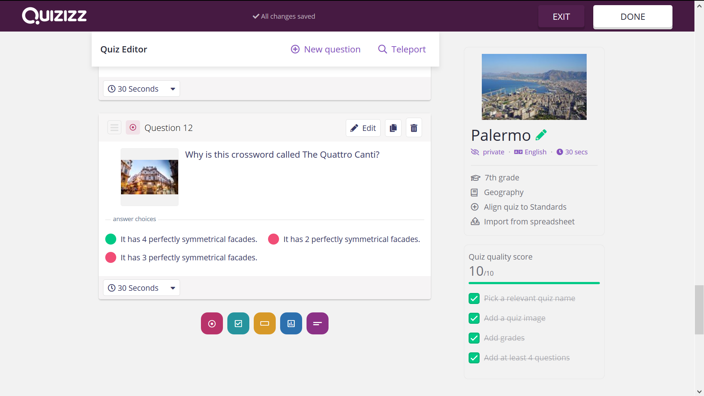

Student feedback

Add here the method with which your students will be able to give you feedback and discuss the lesson.
The class was gathered in a casual circle and some questioning strategies were used to hear what the students truly felt about the lesson.
• What are three things you learned today?
• What were the things you really liked about this lesson? And the things you really didn’t like?
• What do you wish we had more time for?
• How many different ICT have you used today?

Teacher feedback
The learning approach proved a real success and achieved significant learning in personal, learning and thinking skills. Including students of all backgrounds and abilities increased tolerance and empathy among students. Differentiated assignments proved that students are capable to work in pairs at their current abilities, use 4 different online platforms. Their knowledge of travelling related vocabulary, Sicily sightseeing places, the proper use of relative pronouns or adverbs, the interaction, collaboration and critical thinking, the sense of identity made the activities playful, meaningful and open to all students.

