4 Elements – For a Green Planet!
Erasmus+ 2017-1-PT01-KA219-035800

Name ___________________________________ nr _____ Class ________

Water usage and sustainability

After watching the Water Usage and sustainability video, fill in this worksheet and take it to class.

- True or false?

- The water cycle also describes how water is moving around all over the world. _____
- The Earth hasn’t a limited amount of water. _____
- The water doesn’t change its form. _____
- The process of the water cycle happens everywhere. _____
- The cycle always begins at the oceans. _____

- Complete:

The cycle is made up of 4 different parts. Write them.

_______________________ (and transpiration)
_______________________
_______________________
_______________________

- Order the sentences starting at the stage 1 (already there).

____ When water vapour rises up high into the sky, it cools and turns back into a liquid, forming clouds.

____ The fallen precipitation is “collected” in bodies of water.

1 Energy from the Sun heats up the surface of the Earth, causing the temperature of the water to rise. Then some of the water evaporates turning into a gas called “vapour”.

____ When too much water has condensed, the water droplets in the clouds become too big and too heavy for the air to hold them so they fall back down to Earth.

Now, copy the 4 paragraphs into your notebook in the correct order.

- When the process of collection occurs where does the water lands?

- __________________________________________________________
- __________________________________________________________
- __________________________________________________________

- Write the captions for this example of Water Cycle.

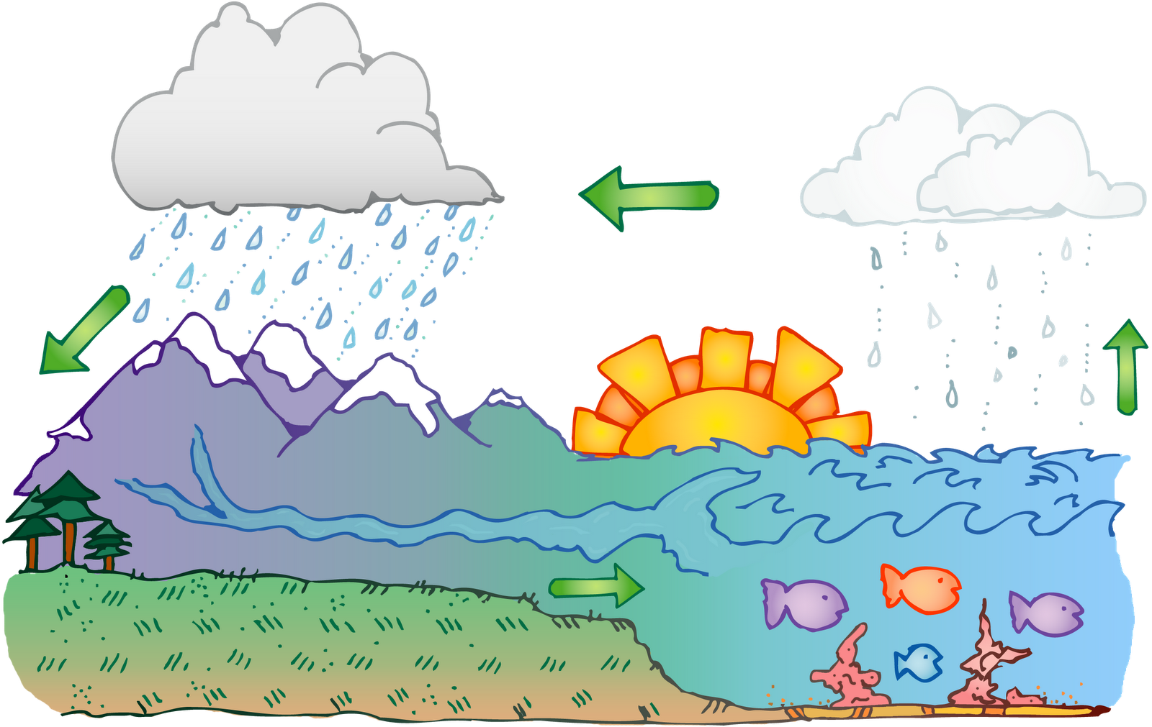

In http://www.thinglink.com/scene/895638742520299520

