Sand cake - Liivakook

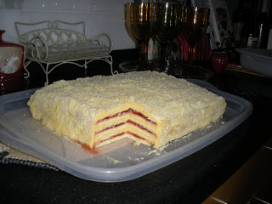
6 cups flour
1 tsp baking powder
juice and peel of one orange
1/2 lb unsalted butter (2 sticks)
1 1/2 cups sugar
1 tsp vanilla
2 eggs (whipped)
3/4 cup milk
Combine flour, sugar, baking powder, and butter. Using either a pastry blender or a knife, cut these combined ingredients until they become a coarse mixture. Add the grated orange peel and juice. Make a hole in the mixture, and slowly add the whipped eggs. Keep cutting and add the milk. Use your hands to form the dough, but do not knead.
Preheat oven to 350F. Divide the dough into sixths. Roll out 1/6th onto a floured board. Using a sheet of regular 8.5 x 11 paper, roll out dough so that it is at least this size, with about a 1 inch overhang. carefully place the dough on a greased thin cookie sheet. Bakefor 11-12 minutes or until light brown. Immediately after baking, cut the baked crust to the size of the paper, reserving the overhang (this will be used to make the crumbs on top). Repeat this procedure 5 more times with the remaining dough.
Filling:
A.
3 small packages of vanilla pudding mix (slow-cook, not instant)
3 cups of milk ( this will be 1/2 of the amount called for on the pudding boxes)
1 lb sweet butter (4 sticks)
B.
3-12 oz jars of plum preserves
Cook the pudding according to the package instructions, using 1/2 the amount of milk. Cream the butter and mix it into the cooled pudding.
When the cakes have cooled, put one layer onto a cake plate (I place a piece of foil under the edges of the cake on all sides to help spread the crumbs and keep the plate clean). Spread it with the (B) plum preserves. Place the second layer on top of the first, and spread it with the (A) pudding filling. Repeat until finished. Frost the top and sides of the cake with a thin coating of the pudding filling. Put the leftover cake pieces into a food processor and blend to make crumbs. Press the crumbs 1/4 inch thick onto the top and sides of the cake. Chill for 2-3 days before serving to allow the flavors to blend.
There are many variations to this recipe in Estonia.

