Fairy tales ans gastronomy
Greek worshop

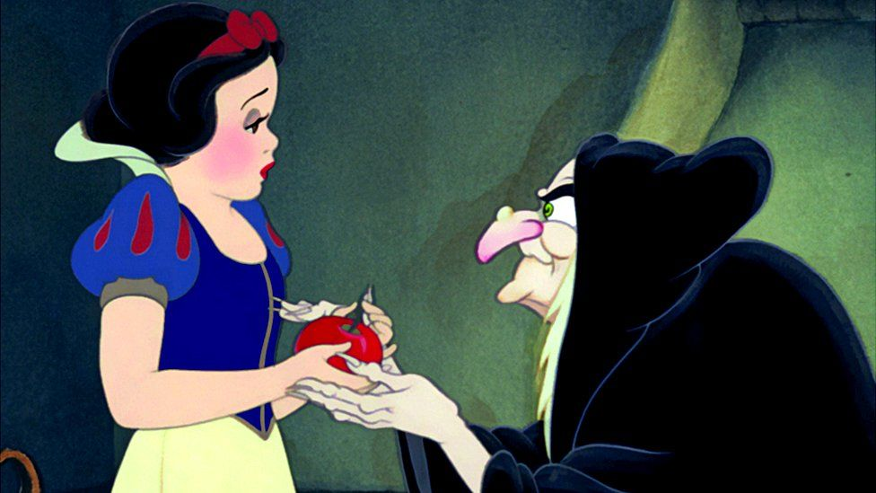

Victor Da Costa

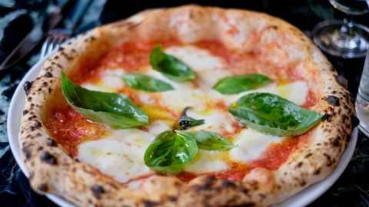
Preheat the oven to 200oC, thermostat 7. Prepare the tomato sauce: in a frying pan fry the sliced onion until brown, pour the tomato paste with a ...
Cut the muffins in half. Cut the ham into pieces. Place the muffins on the baking sheet.
Spread tomato sauce over muffins like pizza. Place a few pieces of ham on the muffins. Add the grated gruyere.
Aminata Kaba

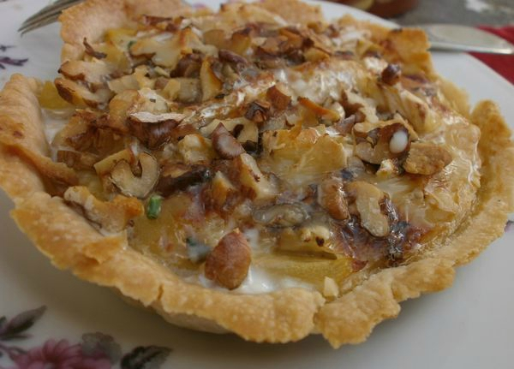
flags’ apple pie
three pie crust pastry sheets, ½ cup of stalted butter (57)g, 3 tablespoons flour or cornflour, 1/2 cup packed brown sugar
one teaspoon of vanilla
one teaspoon of cinnamon , 1 egg
four Granny Smith apples
four Pink Ladies apples
grilled flags a, blood coulis
I chose this recipe in order to coax her by making her believe that she will become more beautiful than white
Franck Xia

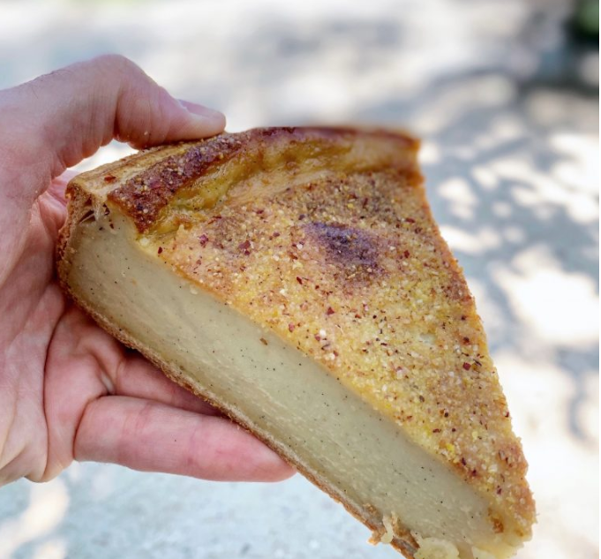
shortcrust pastry with corn flour, vanilla flan, orange blossom and a touch of armagnac and covered with polenta. this flan is very good it will have to give the appetite to the witch for who cancels the spell

Diaguily Soumare

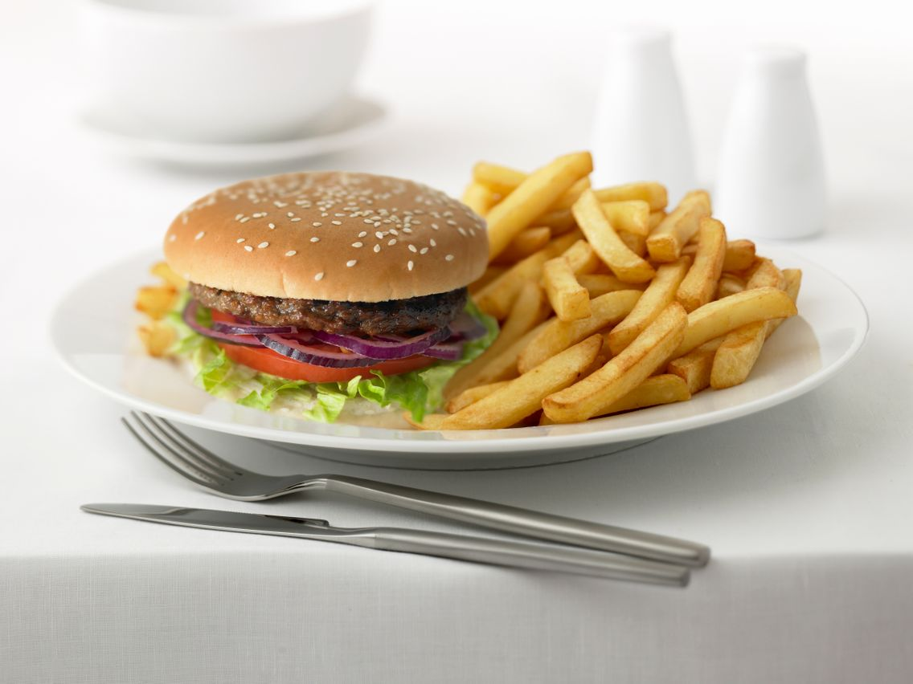

Heat the oil in a pan. Cook the hamburger steaks. Cook them 4 to 5 minutes per side. Salt and pepper at the end of cooking.
Meanwhile, rinse the tomatoes and cut them into thin slices. Slice the iceberg lettuce. Peel and mince the onion.
Split the buns. Lightly toast them on the toaster. Spread the ketchup mixed with the mayonnaise, mustard and maple syrup on the bottom of each.
Place 1 slice of cheddar on each steak. Cover and set aside for 2 minutes off the heat: the cheese will begin to melt in the heat of the meat.
Divide the onion and steaks on each bun. Top with tomatoes and lettuce. Style each loaf with its hat. Serve with fries.

Tips and advice for hamburger fries

Vary the sauce to your taste: American Sauce or Three Pepper (Heinz), Hamburger Sauce (Bénédicta)… In all cases, offer ketchup with the fries.

