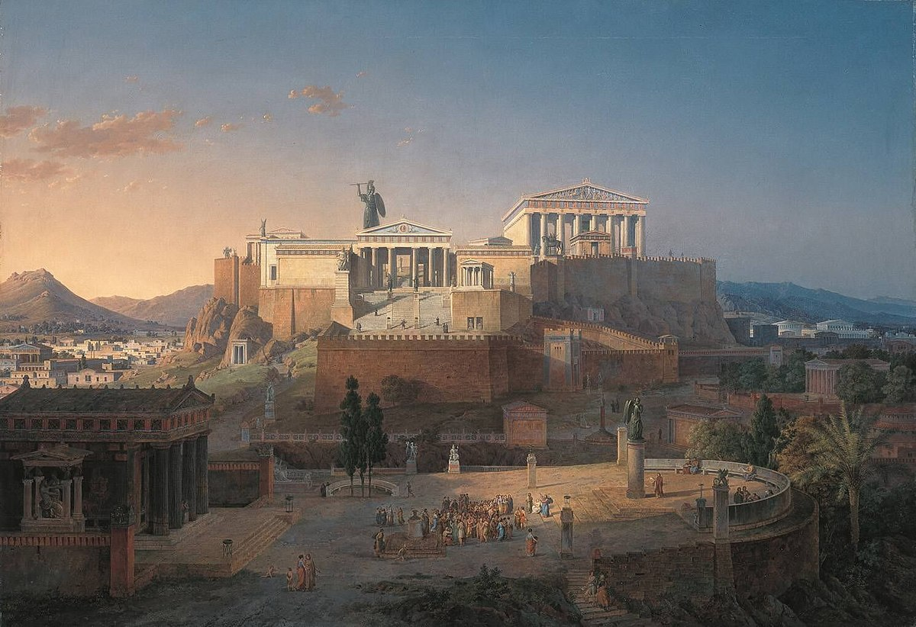What are they talking about?

**SORRY BUT WE MUST WAIT TAVERNS TO BE OPEN**

**I WOULD LIKE AN AFTER WORK DRINK**

