NAME :
COUNTRY : GERMANY

PAINTING AND MEALS
“The wedding dinner”, Albert Fourié
Create a dialogue between the characters.
Example :
The young girl : Hey ! I would like to have some too !

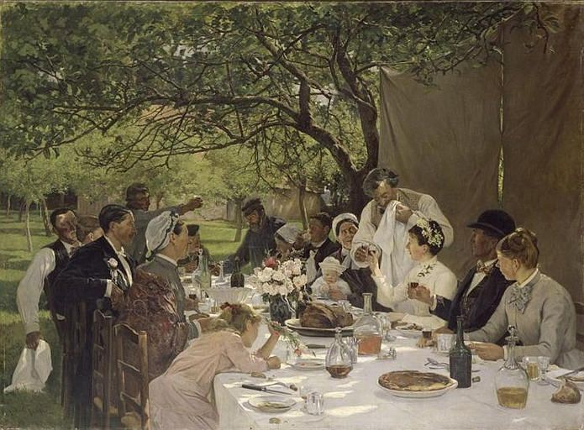

WRITE YOUR DIALOGUE HERE
…………………………………………………………………………………………………………………………………………………………………………………………………………………………………………………………………………………………………………………………………………………………………………………………………………………………………………………….

