NAME :
COUNTRY : France

PAINTING AND MEALS

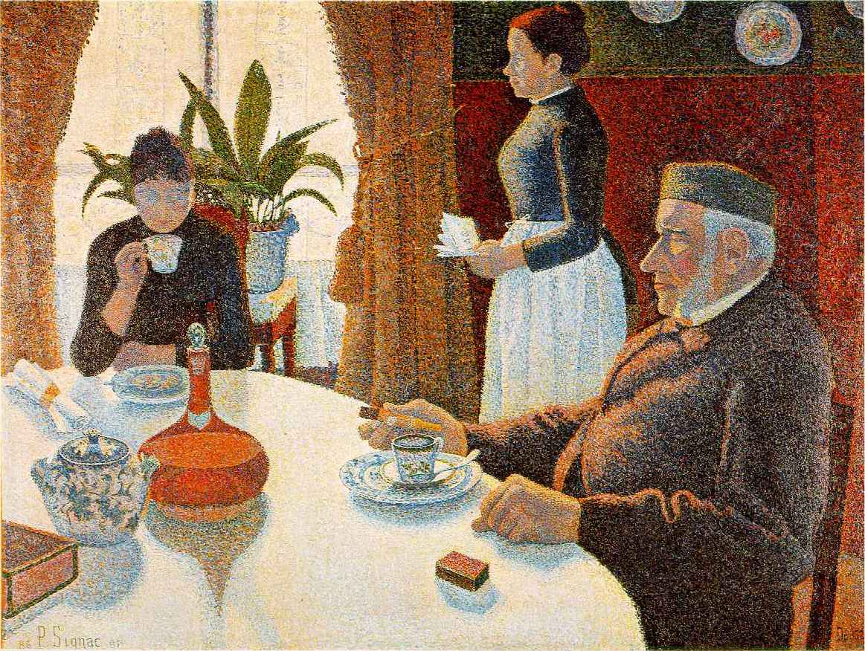

The dinning room, Paul Signac

Create a dialogue between the 3 characters.
Example : You came back home very late last night, my daughter….

