PADLET
Paris seen by famous photographers
https://padlet.com/monikarusz65/vn3naaz2ca58lg7i

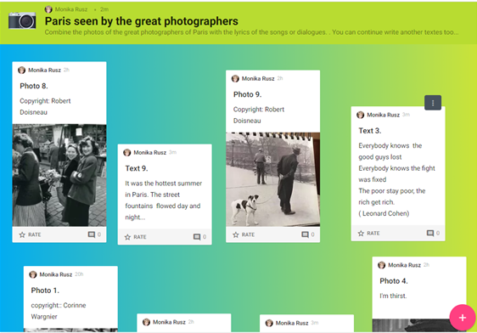

PADLET RESULTS

The famous photographers of Paris
Link the photo to the text

PICTURES
1

2

3

4

5

6

7

8

9

10

