Visiting Greek Gods and Goddesses
Situation 3
Athena and Ares are fighting (German team)
Task 1
Look at the picture and study the situation 3.
Complete the mind-map below!

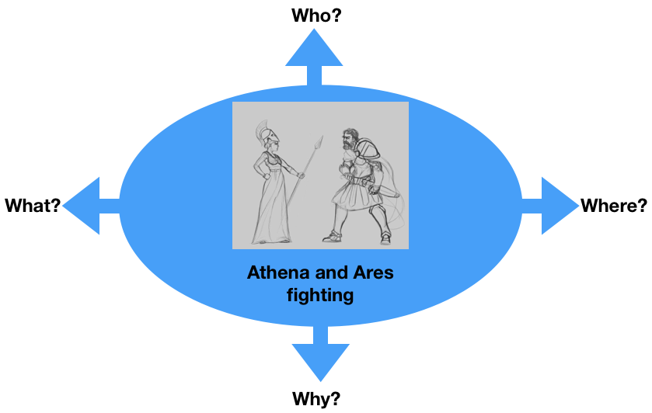
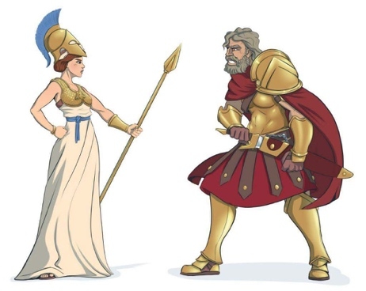

Task 2
Athena and Ares are fighting because of the future of Europe.
What are they fighting for?
For example:
- Peace
- Civil Rights
- Solidarity
- Your suggestion…..

Discuss in the group.

Task 3

Write a dialogue using Task 1 and 2.
Express the emotions of Athena and Ares (e.g. angry, lovely, happy, anxious… etc.). Use the worksheet “Act 3”.

Worksheet Act 3
Write down the dialogue:
the introduction of the narrator, the dialogue of Athena and Ares, the emotions to express
Introduction: they meet at the Olympic and have a heated argument about divine food because areas does not want to share with Athena.

Athena: why don't you want to share with me the divine food belongs to all of us, lets fight fore it

Ares: I don't want to share with a woman who is weaker than me

Athena: I'll show you that I can fight like a man

Ares: you underestimate my power little girl

Athena: Rein your tongue I'm a god too

Ares: Well, so be it I will break you so that you are no longer worthy of calling yourself a goddess

Athena: Even if you are strong, I will defeat you because you are arrogant and run too fast

Ares: wait what are you doing here that’s not your business Zeusss …

