Visiting Greek Gods and Goddesses
Situation 1
Zeus and Poseidon at Business Lunch (Romanian team working for French team)
Task 1
Look at the picture and study the situation 1.
Complete the mind-map below!
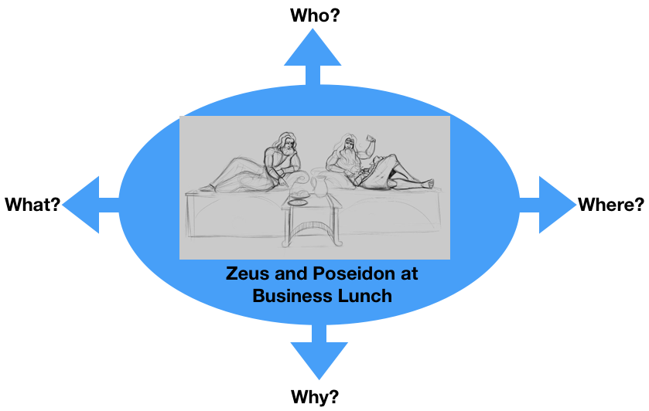
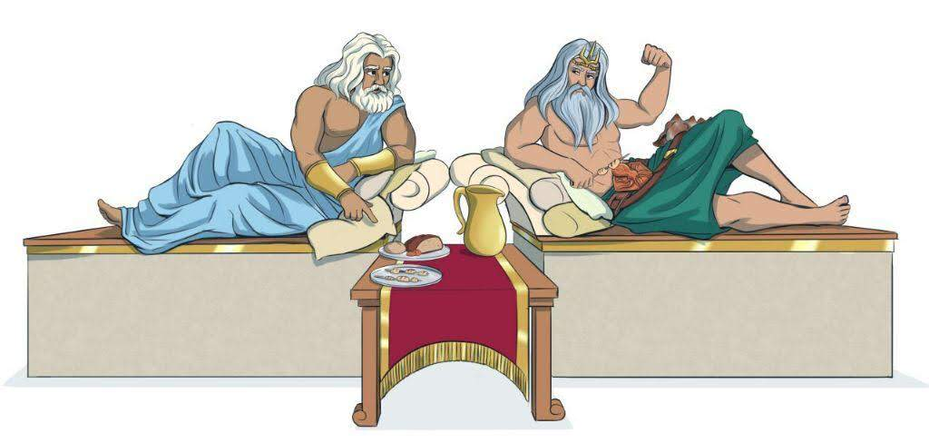

Who?- Poseidon and Zeus
Why?- for business
Where?-at lunch
What?-Business
Task 2
Zeus and Poseidon are talking about the future of Europe having business lunch together.
What are they discussing?
For example:
- Healthy food and drinks
- Clean mineral water
- Protecting nature
- Your suggestion…..

Discuss in the group.

Zeus rules the sky and Poseidon her sea and they talk about weather
3

Write a dialogue using Task 1 and 2.
Express the emotions of Zeus and Poseidon (e.g. angry, lovely, happy, anxious… etc.). Use the worksheet “Act 1”.

Worksheet Act 1
Write down the dialogue:
the introduction of the narrator, the dialogue of Zeus and Poseidon, the emotions to express
Introduction: Hi God

Poseidon: Hi god Zeus , why did you cause me such a big storm in my waters?
Zeus:Hi Poseidon, I caused this great storm in your waters because I was angry with you
Poseidon:Ok but what did i do wrong?
Zeus:You have neglected the waters of the seas.
Poseidon: I promise I will take care of the waters of the sea and i will not neglected them.
Zeus: -I’ll get rid of the storm.
Poseidon: Thank you so much , now i’m very happy because my waters are calm, I was very stressed. Now we are friends again and we feel great.
Zeus:The sea is so calm and the temperature so warm that makes me feel extraordinarly wonderful.I’m Glad i helped you and we’re friends again.

