NAME :
COUNTRY : GREECE

PAINTING AND MEALS

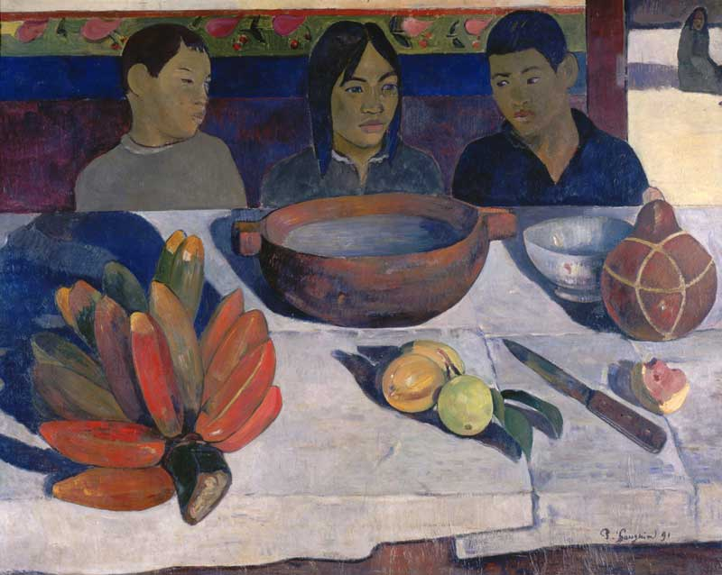

The meal or The bananas, Paul GAUGUIN

Create a dialogue between the 3 characters.
Example : we are hungry but we must wait for mum…

