Visiting Greek Gods and Goddesses
Situation 2
Aphrodite and Apollon are dreaming after lunch time
(Romanian team)
Task 1
Look at the picture and study the situation 2.
Complete the mind-map below!

The god of music and The goddess of beauty

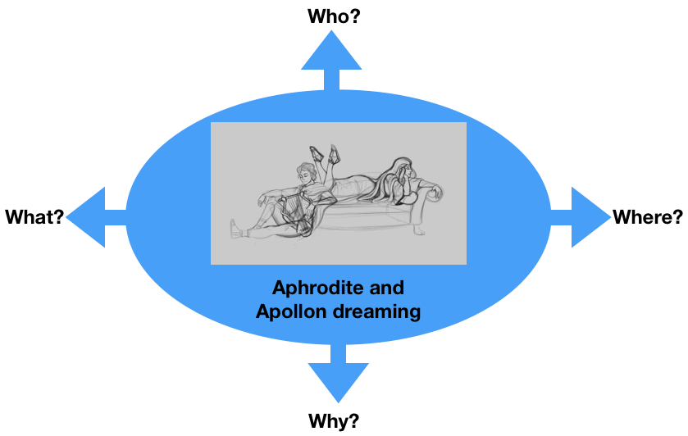
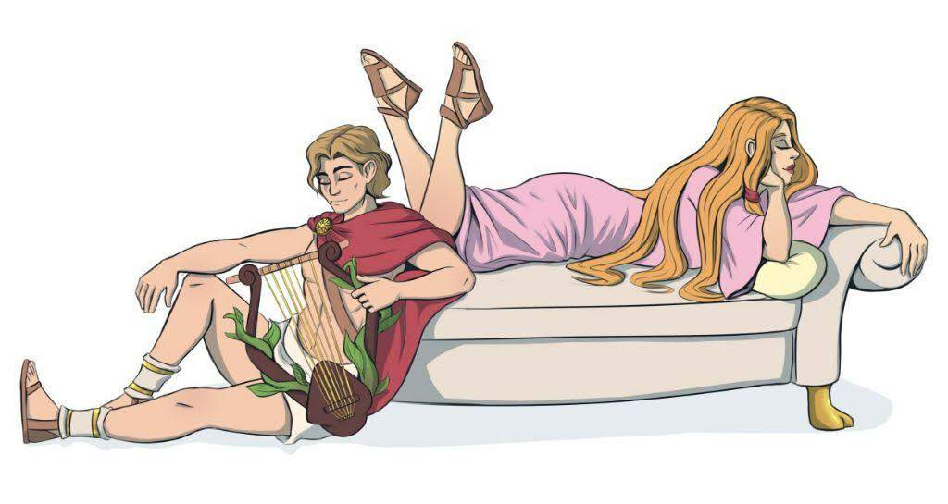

On the couch
They are dreaming
about future

Because they are sleepy

Task 2
Aphrodite and Apollon are dreaming of the future of Europe.
What are they dreaming of?
For example:
- Visiting France, Germany, Greece and Romania in 30 years
- The future of the €uro
- Traveling around Europe in 50 years
- Your suggestion…..

Discuss in the group.

Task 3

Write a dialogue using Task 1 and 2.
Express the emotions of Aphrodite and Apollon (e.g. angry, lovely, happy, anxious… etc.). Use the worksheet “Act 2”.

Worksheet Act 2
Write down the dialogue:
the introduction of the narrator, the dialogue of Aphrodite and Apollon, the emotions to express
Introduction:
Apollon feels very tired today.
Aphrodite is bored.
Aphrodite comes with a suggestion after lunchtime.
Apollon gets interested.
Aphrodite:Hey Apollon, let’s make a bit of small talk to go to sleep easier,
what do you say?
Apollon: Alright, what should we talk about?
Aphrodite: About the future of Traveling. It seems very interesting and
important to me about the future. Imagine looking back and thinkning
about this time period.
Apollon:Yeah, that seems interesting to me too. How do you think trains,
planes and boats will develop? I’m curious to hear your ideas since I have
mine.
Aphrodite:Yeah, think about the speed we could travel. For example
teleportation will be a viable way of transportation. Imagine traveling
instantly!
Apollon: Teleportation will make everything much easier. For example
imagine buying home appliances and not waiting for them to deliver to
your door.
Aphrodite: Yea, i wonder how much time do we need to bring
teleportation in our lifestyle. We will most likely get used to it very easily
when it actually will be a thing, as we do with most new stuff.
And I’m already starting to get very sleepy.
Apollon:Yeah,I say we should go to sleep. (Apollon yawns)

