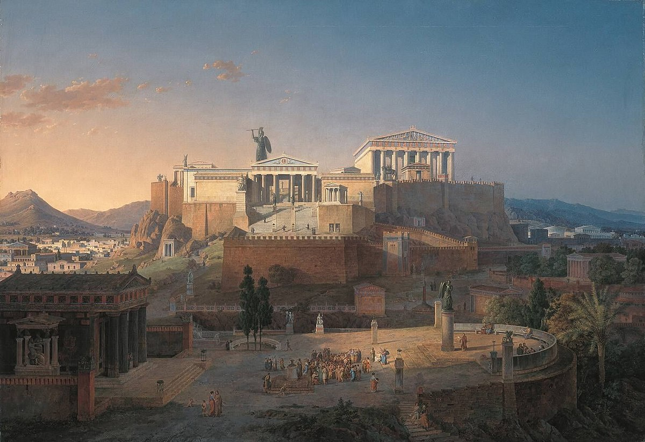What are they talking about?

And I brought the sea. You can use it!

**I gave you the olive tree, so you can eat the olivers, or use the oil**

