Visiting Greek Gods and Goddesses
Situation 3
Athena and Ares are fighting (German team)
Task 1
Look at the picture and study the situation 3.
Complete the mind-map below!

Athena Goddess of wisdom and war ruse
Ares is the god of war
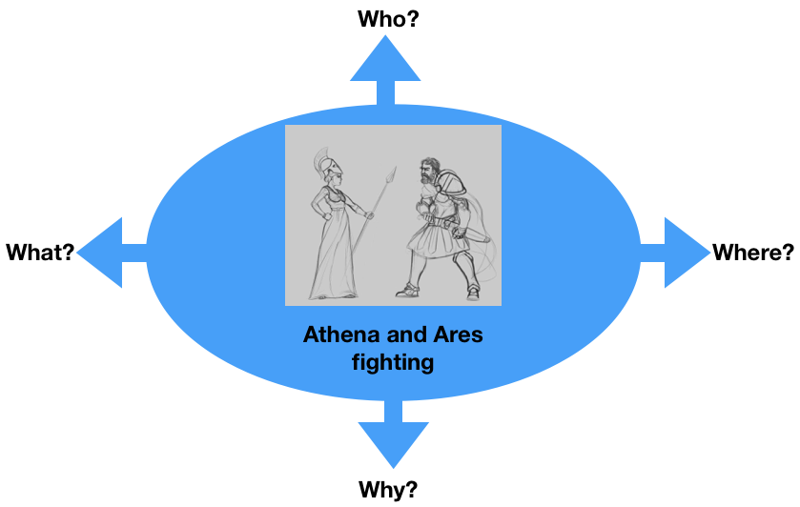
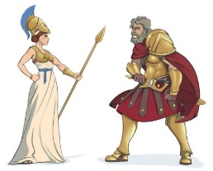

In Olympus
between
Thessalien and Makedonien
fighting

Peace
Task 2
Athena and Ares are fighting because of the future of Europe.
What are they fighting for?
For example:
- Peace
- Civil Rights
- Solidarity
- Your suggestion…..

Discuss in the group.

Task 3

Write a dialogue using Task 1 and 2.
Express the emotions of Athena and Ares (e.g. angry, lovely, happy, anxious… etc.). Use the worksheet “Act 3”.

Worksheet Act 3
Write down the Dialogue :
the introduction of the narrator, the dialogue of Athena and Ares, the emotions to express
Introduction:
They met each other in Olympus and are fighting over the war in Russia and Ukraine
Athena: Why did you start this stupid war?

Ares: I started it, so they can settle their conflict once and for all.

Athena: If people die it would make it worse.

Ares: I don’t care! I’m just playing with them. I wanna have fun.

Athena: You’re a monster! You can’t just play around with people’s lives for fun!

Ares: Yes I can, what do you wanna do about it?

Athena: I must do what I must!

Ares: If you’re not with me, THAN YOU’RE MY ENEMY!!!!!

