Four Greek Myths to Know Before Visiting Athens

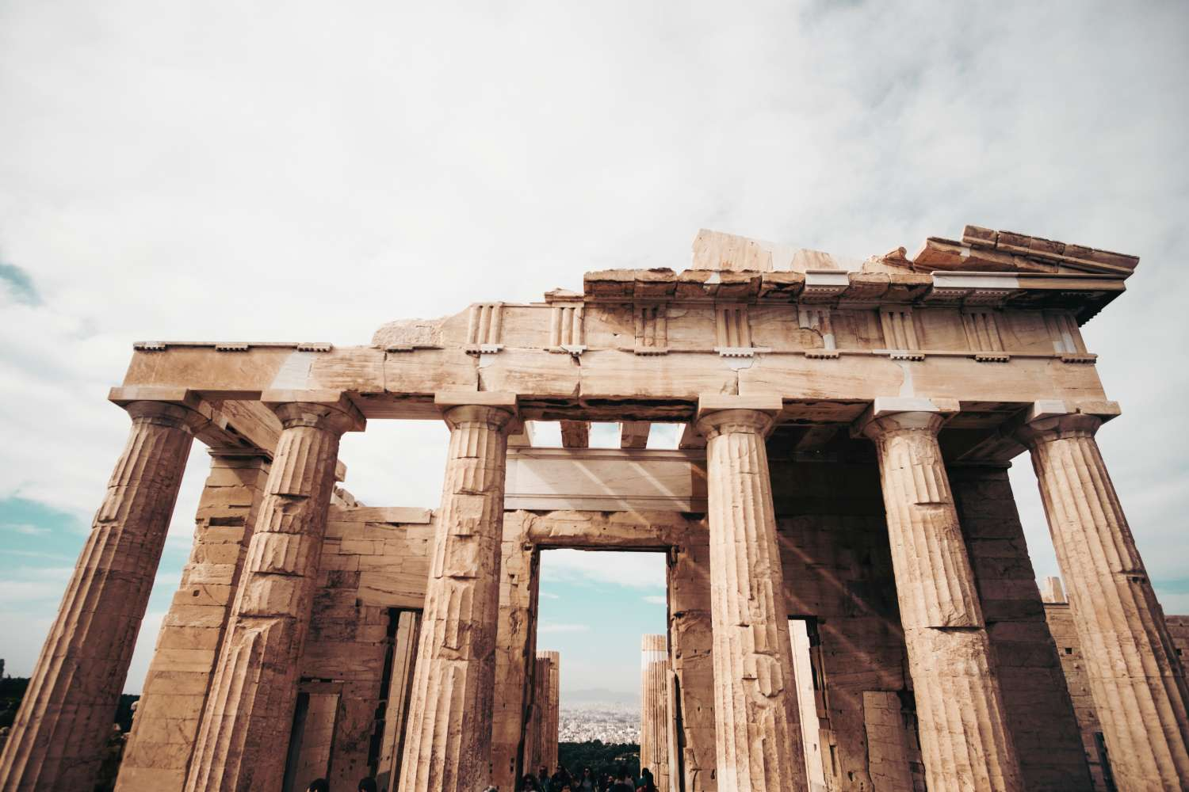
The Parthenon at the Acropolis, dedicated to the Greek goddess Athena

Athens has many ancient monuments. The Greek mythology can be closely tied to many of these sites.Here are our top four myths to prepare for a visit to Athens.

1. Athena and Poseidon compete over patronage of Athens
Site: Erechtheion
The first king of Athens, King Cecrops, set out a competition in order to decide which deity will be the patron of the city.The winner would come up with the best present to the city. Athena and Poseidon both desired to be the patron of the Athens.
When Poseidon struck the Acropolis with his trident he created a salt-water well, the so-called “sea” of the Erechtheion, which lay inside the temple, and is said to make sounds of waves whenever the wind blows from the south.Athena in her turn thrust her spear to the ground, and a fruitful olive tree appeared.
In the end Athena was chosen as the winner, while the temple Erechtheion was build to soothe raging Poseidon and prevent him from flooding the city.
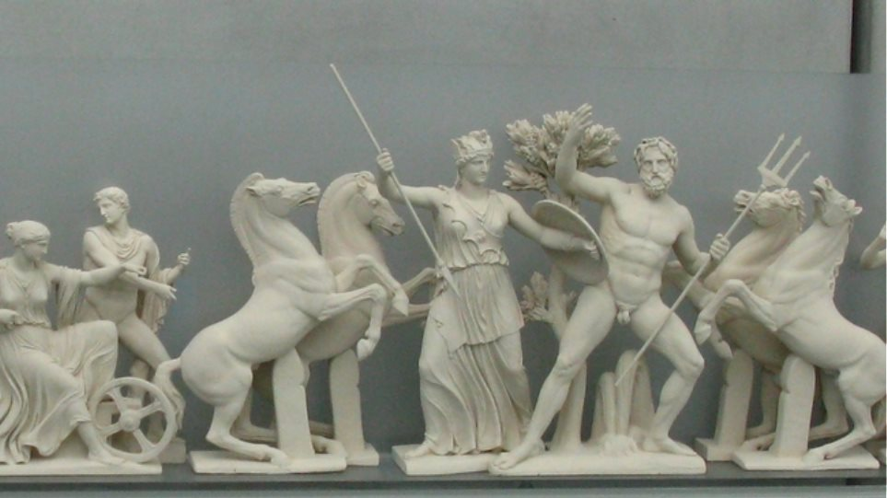

2. Athena is born out of the head of Zeus
Sites: Acropolis and Temple of Hephaestus
Zeus had numerous love affairs before and after his marriage to Hera. For some time Zeus pursued Titaness Metis, impregnating her with Athena.
Zeus, having been previously warned by Oracle of Gaea that Metis’ second child would be a boy who would overthrow him, swallowed Metis with Athena inside. After a while, Zeus developed an enormous headache, and howled so loud that the whole Earth could hear him. The other gods came to help him, and Hephaestus – the blacksmith god, struck Zeus’ head with his hammer, out of which Athena, in her full gown and armour, emerged.
The Temple of Hephaestus is situated overlooking the Agora, a marketplace of ancient craftsmen. The east pediment of the Parthenon in Athens’ Acropolis is decorated with the plasterwork showing the birth of Athena, who later became a patron of the city.

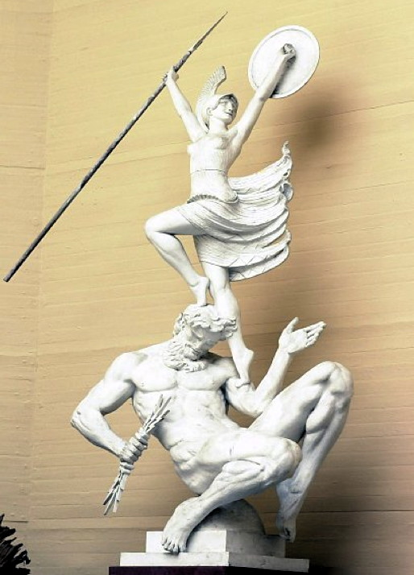

3. Lapiths against Centaurs

The legend goes that the centaurs were invited to the wedding of King Pirithous of the Lapiths and Hippodameia. Everyone drank large amounts of wine, and as Pirithous and Hippodameia were about to be wed, the centaur Eurytion jumped up and attempted to make off with the bride. This caused quite a mess as each centaur took it in his head to violate the wedding guests. Of course, the Lapiths were furious, and a great battle started. The Lapiths emerged victorious, and drove the centaurs from their lands.

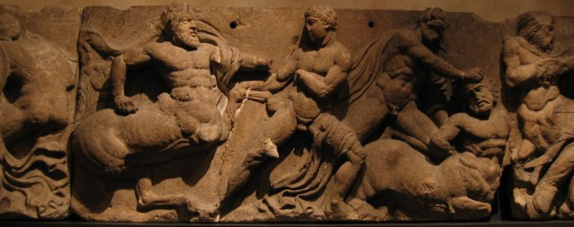

4. Birth of Dionysus
Site: Theater of Dionysus
Dionysus was the son of Zeus and Semele, a mortal who was famous for her extraordinary beauty and grace. Zeus was deeply in love with Semele, and to please her, he swore to make her every dream come true. However, Semele was persuaded by a vengeful Hera to ask Zeus to come in his true godly form. It saddened Zeus, who knew that a mortal who sees a deity in all his glory was cursed to die, but, having made the promise to Semele to fulfil her every desire, he was left with no choice. He appeared in his natural form and immediately the beautiful Semele was wrapped by fire, burning her body to death. Zeus, however managed to rescue Dionysus by stitching the foetus into his thigh to hold him until he was ready to be born. The Theater of Dionysus sits on the south slope of the Athenian Acropolis. Dating back to the 4th century BC, the structure could seat a staggering 17,000 spectators, and was used to host festivals in honor of Zeus and Semele’s tragic love-child.
