Visiting Greek Gods and Goddesses
Situation 4
Hera and Dionysos are dancing (Greek team)
Task 1
Look at the picture and study the situation 4.
Complete the mind-map below!

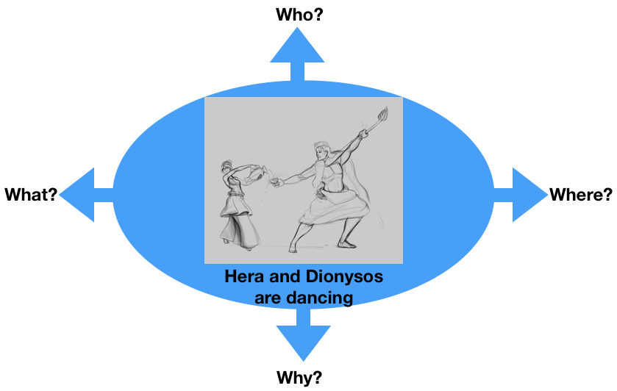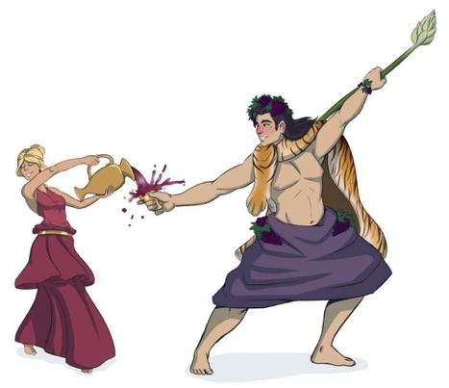

Task 2
Hera and Dionysos are dancing to express their vision of Europe in the future.
How are they performing?
For example:
- Classic dance like ballet
- Video-Clip dancing like on MTV
- Ballroom dancing like waltz
- Your suggestion…..

Discuss in the group.

Task 3

Write a dialogue using Task 1 and 2.
Express the emotions of Hera and Dionysos (e.g. angry, lovely, happy, anxious… etc.). Use the worksheet “Act 4”.

Worksheet Act 4
Write down the dialogue:
the introduction of the narrator, the dialogue of Hera and Dionysos, the emotions to express
Introduction: Today we will present you the dialogue of Hera and Dionysos about the future of Europe.
Hera: Tell me, Dionysos, how you imagine the future of Europe in 40 years?
Dionysos: I imagine Europe more modern with some traditions, with its people living peacefully and with no illnesses.
Hera: No way! They will still find something to argue about.
Dionysos: You are right! We have to find a way to make them do it. Do you have any ideas?
Hera: I am not the Goddess of Dancing and having fun. You have to find something.
Dionysos: Every Spring we will come together in one of the European countries and we will dance and have fun.
Hera: Great idea! Who is going to tell them?
Dionysos: I will do it right now! I will gather all Gods and I will tell them. What dance do you want to teach you?
Hera: I am in between syrtaki and Kalamatiano.
Dionysos: You decide the dance and I will bring the wine.

