GODS RENAME ATHENS
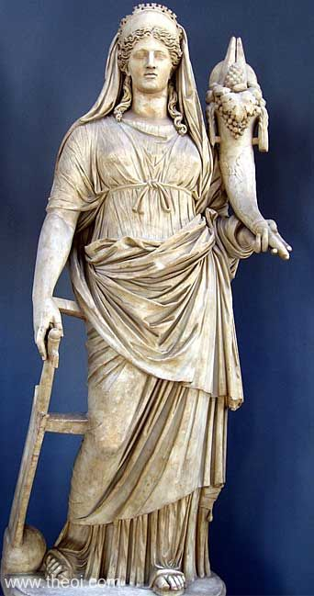
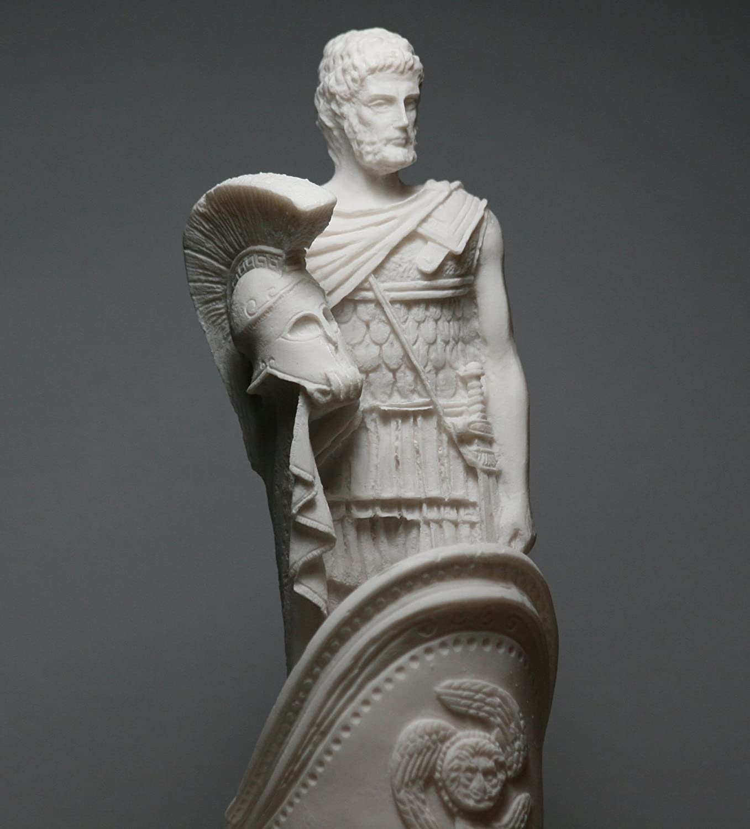
Ares & Demeter
Write a short dialogue between the two gods who are trying to name Athens after them. Each god gives a new name and a gift to the city and explains why this gift is important to the people. Then the students will vote which god offers the best gift and the new name of Athens!!!

<<<<<<<<<<<< ֍ >>>>>>>>>>>>
- Ares: <Your Text Here>
- Demeter: <Your Text Here>
- Ares: <Your Text Here>
- Demeter: <Your Text Here>
- Ares: <Your Text Here>
- Demeter: <Your Text Here>
- Ares: <Your Text Here>
- Demeter: <Your Text Here>
- Ares: <Your Text Here>
- Demeter: <Your Text Here>
- Ares: <Your Text Here>
- Demeter: <Your Text Here>
- Ares: <Your Text Here>
- Demeter: <Your Text Here>

