Visiting Greek Gods and Goddesses
Situation 2
Aphrodite and Apollo are dreaming after lunch time
(Romanian team)
Task 1
Look at the picture and study the situation 2.
Complete the mind-map below!
Who?: Aphrodite and Apollon
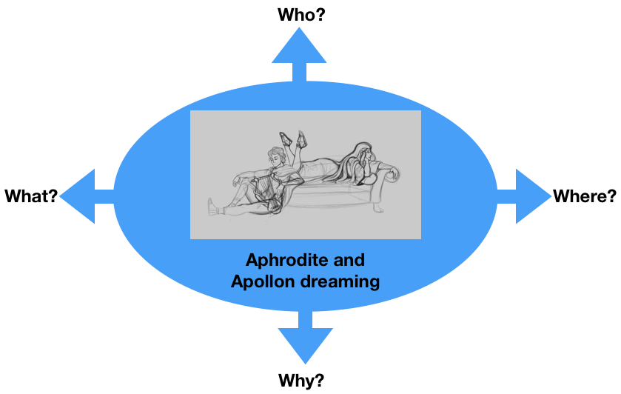
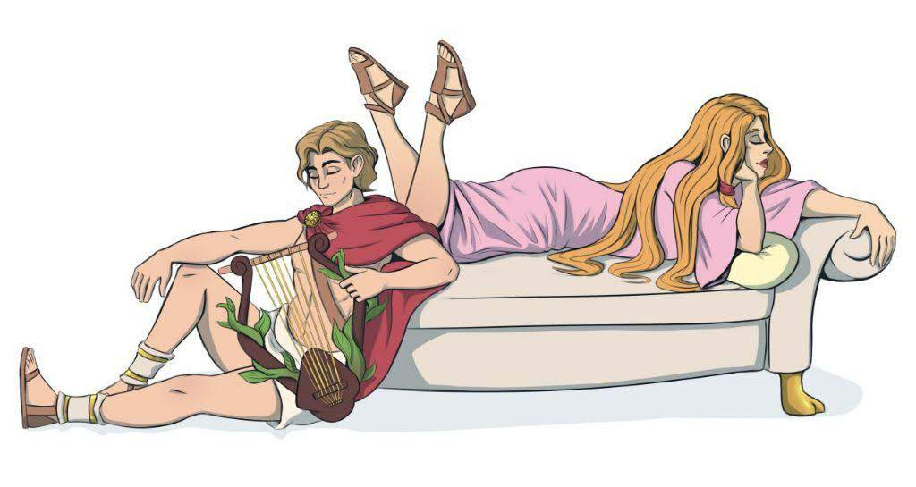
Where?: At the Palace

Why?: Because they want to take a break from the other gods
What?: They are dreaming

Task 2
Aphrodite and Apollo are dreaming of the future of Europe.
What are they dreaming of?
For example:
- Visiting France, Germany, Greece and Romania in 30 years
- The future of the €uro
- Traveling around Europe in 50 years
- Your suggestion…..

Discuss in the group. (Traveling around Europe in 50 years)

Task 3

Write a dialogue using Task 1 and 2.
Express the emotions of Aphrodite and Apollo (e.g. angry, lovely, happy, anxious… etc.). Use the worksheet “Act 2”.

Worksheet Act 2
Write down the dialogue:
the introduction of the narrator, the dialogue of Aphrodite and Apollo, the emotions to express
Introduction:
Apollo and Aphrodite were sitting at their special place for dreaming,
until both of them stood up in enthusiasm. They want to travel in Europe
in 50 years.
They are happy because of the idea.
(Aphrodite, a little dreamy):
We should first tell the others about our trip.
But where to go first?

(Apollo, calm as always):
We should visit Paris first. To see their beauty.

(Aphrodite, filled with joy):
I was thinking more about Romania, to see the joy in everything they do.

Apollo:
We could go there first then visit Germany.
I heard they are very proud people.

Aphrodite:
Then it’s settled.
In 50 years from now we’ll go.

Apollo:

Aphrodite:

Apollo:

