Exercise 1
The statues speak...

There are 10 pictures of Greek statues. (Observe attitudes, gestures, relationships between the characters.)

There are 10 short sentences that correspond to these pictures.

Exercice :

1. Which picture corresponds to which sentence?
2. How can you continue these monologues or dialogues?

The sentences

A. What's to be done? Men make war, and we, women, have no way to stop them.

B. Politicians make speeches and lots of promises.We not believe in them anymore. Come with us…

C. What do you recommend me to do? Sometimes you find it hard to make yourself understood.

D. What do you make of her? Aphrodite is beautiful, clever, her father is the god Zeus. She has done well in life.

E. How would you get on without me?You are in a critical situation.

F. Father, I would like to help you. And I appreciate what you’ve been doing for me.

G. Athena , you are the goddess of the war. You have no conception of what is involved. You don’t know the meaning of « peace » or « love. »

H. The meal arrives. We celebrate the victorious Odysseus who has won the love of Penelope.

I. Lacoon: I told you, people of Troy: « Beware of Greek’s gifts.This wooden horse sounds hollow. »

L. I’m going to hide .I had not considered coming with you.

The pictures

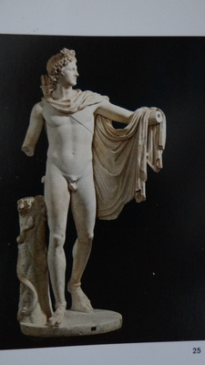1 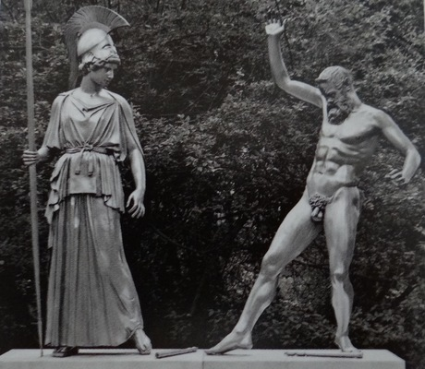 2

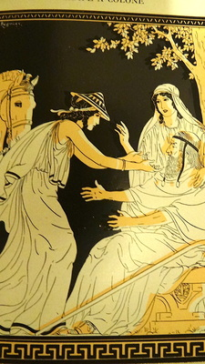 3 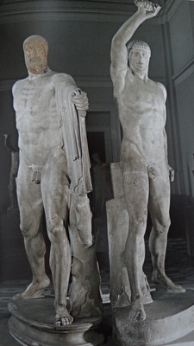 4 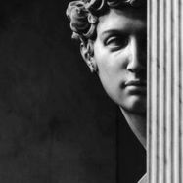 5
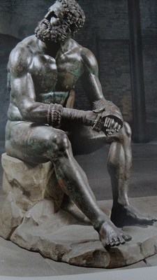 6 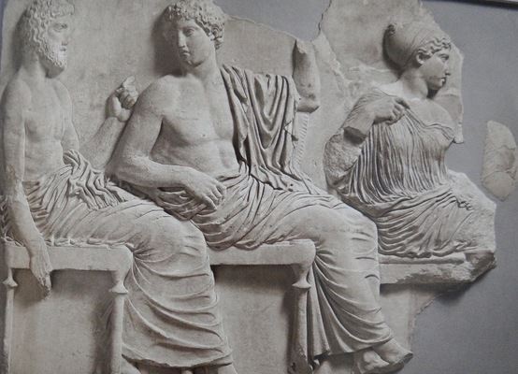 7

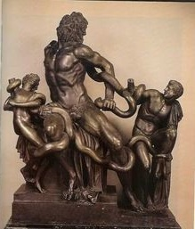 8 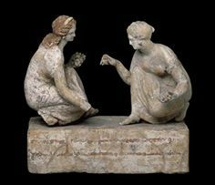 9

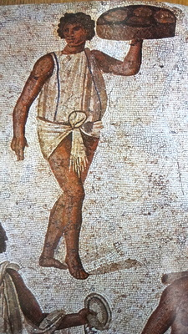 10

 | A | B | C | D | E | F | G | H | I | L
1 |  |  | x
2 |  |  |  |  |  |  | x
3 |  |  |  |  |  | x
4 |  |  |  |  |  | x
5 |  |  |  |  |  |  |  |  |  | x
6 |  |  | x
7 |  |  |  | x
8 |  |  |  |  |  |  |  |  | x
9 | x
10 |  |  |  |  |  |  |  | x

