Visiting Greek Gods and Goddesses
Situation 2
Aphrodite and Apollon are dreaming after lunch time
(Romanian team)
Task 1
Look at the picture and study the situation 2.
Complete the mind-map below!

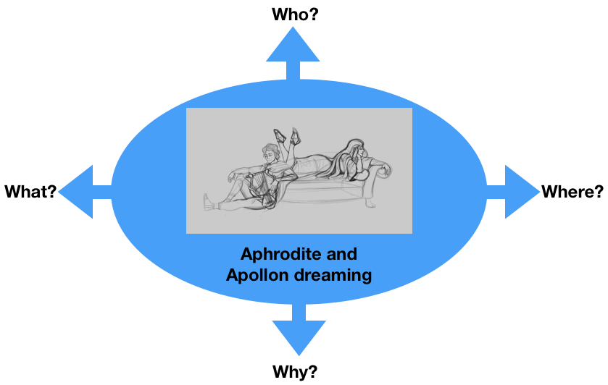
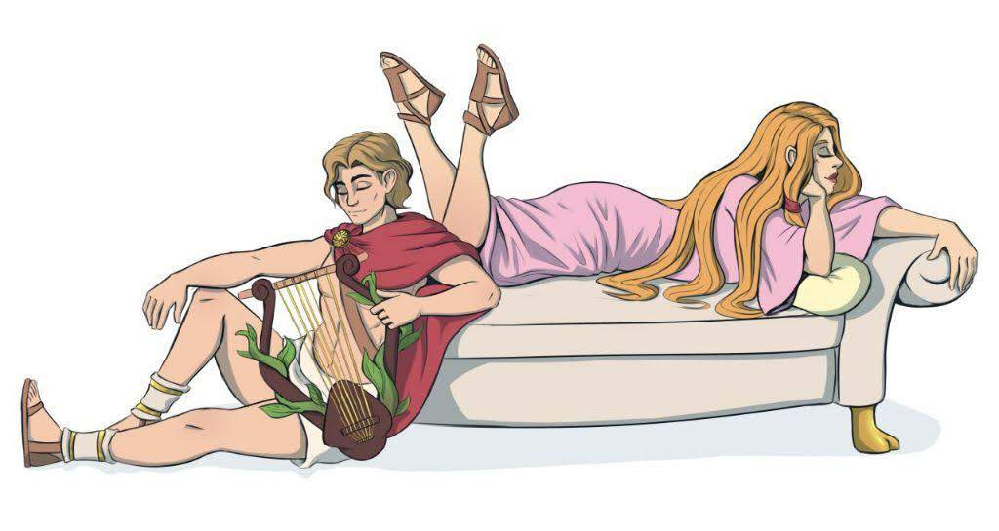

Task 2
Aphrodite and Apollon are dreaming of the future of Europe.
What are they dreaming of?
For example:
- Visiting France, Germany, Greece and Romania in 30 years
- The future of the €uro
- Traveling around Europe in 50 years
- Your suggestion…..

Discuss in the group.

Task 3

Write a dialogue using Task 1 and 2.
Express the emotions of Aphrodite and Apollon (e.g. angry, lovely, happy, anxious… etc.). Use the worksheet “Act 2”.

Worksheet Act 2
Write down the dialogue:
the introduction of the narrator, the dialogue of Aphrodite and Apollon, the emotions to express
Introduction:
Aphrodite and Apollon are dreaming to travel in Europe. They make different choices. The two gods wanted to travel out of the boundaries, but they weren’t yet determined.
Aphrodite:
I want to visit the Kissing Gate, which was built in 1938, in Târgu Jiu, Romania,by a romanian sculptor named Constantin Brâncuși.
Apollon:
I want to visit the Bucharest Conservatory, also called Bucharest National Music University, which was built in 1863 and from that place, known Romanian personalities graduated and started their career. It is nice to go there to hear the talented people.
Aphrodite:
And your idea is good,but sometimes we must see another places which are related to love and beauty.
Apollon:
Is not bad to hear sometimes a bit of music, Aphrodite!
Aphrodite:
Apollon, if wasn’t love, the music wouldn’t have been the same.
Apollon:
My dear friend, you must hear the mild sounds of the music and you will do that if you will go where I say to go.
Aphrodite:
Let’s stop arguing and concern on our holiday plan.Let’s think about it and make a good decision.
Apollon:
I have a great idea, Aphrodite!
Let’s travel the entire Romania to see the places we like

