Little red riding hood-GERMANY
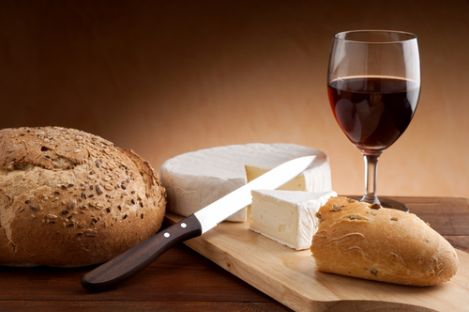
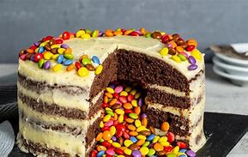
We choose Wine, Bread and Cheese. Because of the Wine he gets drunk and the cheese is heavy in the stomach and hot. For the dessert we think of some gummibears and Chocolatecake, when he eats these he gets stomach problems from the ingredients.

Ingredients for one big cake
preparation

Working time approx. 25 minutes
Melt chocolate with butter in the water bath. Stir eggs with sugar and add flour and cocoa and baking powder. Add the chocolate-butter mixture and undercut. Preheat the oven to 160 °C over/under heat and bake the cake in a greased springform pan for 30 min.

Heat the cream. Break the chocolate into pieces and put in a bowl, add the hot cream and stir until the chocolate has melted. Spread the cast on the cake and leave to cool.

https://www.chefkoch.de/rezepte/2742441426332010/Saftiger-Schokokuchen.html

150 g dark chocolate
250 g butter
120 g sugar
5 Eggs

2 tbsp flour
2 tbsp cocoa
1 tsp baking powder
For the casting:
100 g dark chocolate
100 ml whipped cream

For the casting:
100 g dark chocolate
100 ml whipped cream

