A summer day

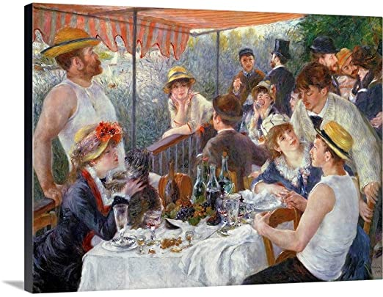

Peter:What a beautiful day!!
Ana:I am so glad that the war is over, we haven’t been to a café in the park for so long and now we can finally breathe some fresh air! It’s wonderful!
Mark: Yes, I agree, we can finally go back to our normal lifes.
Olivia: It’s so good that we can finally rest peacefully, that we can take care of ourselves after so much time. Me and Mark have been planning to go hiking for a while.
Ana: That’s great, I’m sure you will have a great time.
Peter: Where are the drinks?
Mark: Right over there in the cooling container.
Peter: Thank you!
Olivia: Can’t wait!

