Visiting Greek Gods and Goddesses
Situation 3
Athena and Ares are fighting (German team)
Task 1
Look at the picture and study the situation 3.
Complete the mind-map below!

Athena und Ares
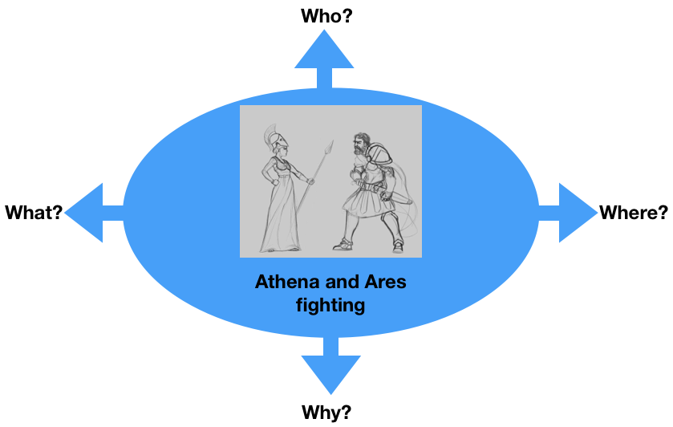
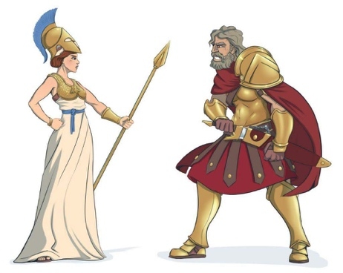
g
Task 2
Athena and Ares are fighting because of the future of Europe.
What are they fighting for?
For example:
- Peace
- Civil Rights
- Solidarity
- Your suggestion…..

Discuss in the group.

Task 3

Write a dialogue using Task 1 and 2.
Express the emotions of Athena and Ares (e.g. angry, lovely, happy, anxious… etc.). Use the worksheet “Act 3”.

Worksheet Act 3
Write down the dialogue:
the introduction of the narrator, the dialogue of Athena and Ares, the emotions to express
Introduction: Athena and Ares fight in Mallorca Ballermann for the Peace in Europe.

Athena: Ares what are you doing you are my brother and we must fighted for the peace not for the war.(angry)

Ares: No, Athena you understand me I’m the God of War.(very strong voice)

Athena: No, your greed of power is the reason for us fight.(powerful)

Ares: I have more power than you(powerful)

Athena: okay lets fight than you will see(sure)

Ares:okey are you sure you don’t know how powerfrul I am (powerful)

Athena:ahhahahahahaha okey let me see(provocation)

Ares:you are very stupid (arrogant)

