WHAT WOULD CINDERELLA COOK?

Cinderella would cook a Paella with Lobster and Shrimps, because is a fancy recipe that her stepmother would love to eat. It is exotic and something new, and she is a pretentious woman. Both her and her daughters would enjoy it. They would feel unique and special because nobody else in the kingdom has the opportunity to eat seafood, being expensive, and they would be grateful towards Cinderella. They would grant her the biggest wish: to spend more time at the ball.
This meal is eaten especially in Spain, but same recipes can be found in the Southern Italy and Sicily region.
We chose this recipe because Cinderella’s stepmother is a sophisticated, pretentious and capricious woman.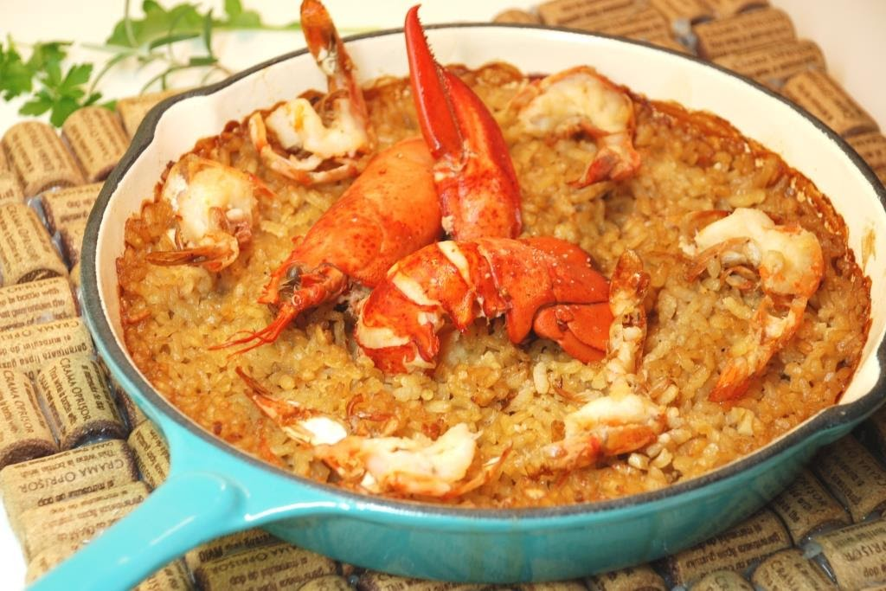

For 1 L of shrimps stock and/or lobster, we need:

1 L of fish stock
300 g of shrimps carcass and heads
2 spoons of cognac
2 spoons of butter
few garlic gloves, mashed
optional,a spoon of fish sauce

For 2 portions of paella:

8 spoons of rice for paella or risotto
few saffron threads
1 lobster
few big shrimps
salt, pepper, olive oil
few chili flakes
1 spoons of butter
few garlic cloves, finely chopped
1 finely chopped shallot
1 cup of dry white wine
1 half of L of shrimps stock
a non-stick pan or a enameled cast iron

