GODS RENAME ATHENS
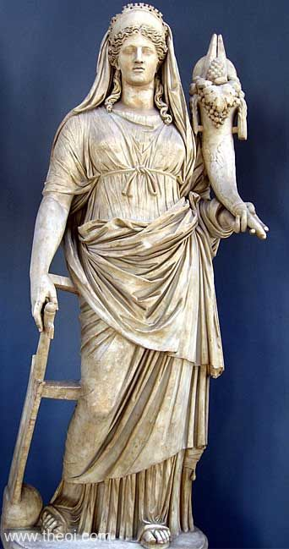
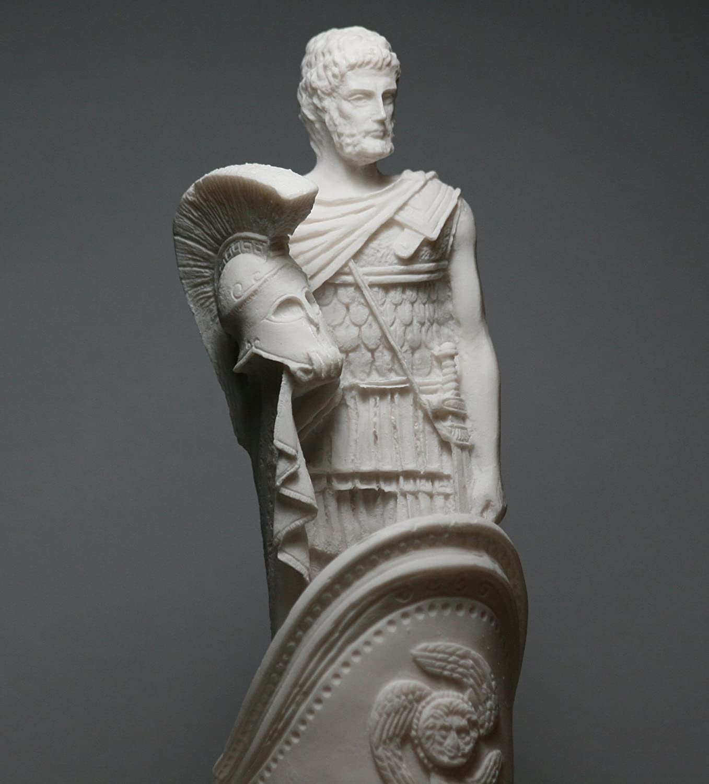
Ares&Demeter
Write a short dialogue between the two gods who are trying to name Athens after them. Each god gives a new name and a gift to the city and explains why this gift is important to the people. Then the students will vote which god offers the best gift and the new name of Athens!!!

<<<<<<<<<<<< ֍ >>>>>>>>>>>>
- Ares: Hello my name is Ares .I am the god of war and I want to name the City Ares
- Demeter: Hello my names Demetrer. I am the goddess of harvest and I want to name the City Utopia.
- Ares: OF COURSE NOT UTOPIA IS A SILLY NAME FOR A MIGHTY CITY!
- Demeter: The same goes for yours.
- Ares: NO it is not they deserve the best name for a fearless city.
- Demeter AND Utopia is the best name for A paradise.
- Ares: HAHAHA THAT’S FUNNY.
- Demeter: Why are you laughing ?
- Ares: Who needs a paradise when you have war and earning so much money.
- Demeter: War is never the answer to find pleasure.
- Ares: Yeah right and Paradise is nothing War.
- Demeter: I know that paradise needs war and war needs paradise so there can be balance in life.

- Ares: Ok then let’s have a contest to find whose name is better.
- Demeter: Ok you bring your knives and I ‘ll bring the wheat.

