Second Group: Poseidon

1. Athena and Poseidon compete over patronage of Athens

The first king of Athens, King Cecrops, set out a competition in order to decide which deity will be the patron of the city. The winner would come up with the best present to the city. Athena and Poseidon both desired to be the patron of Athens.
When Poseidon struck the Acropolis with his trident he created a salt-water well, the so-called “sea” of the Erechtheion, which lay inside the temple, and is said to make sounds of waves whenever the wind blows from the south. Athena in her turn thrust her spear to the ground, and a fruitful olive tree appeared.
In the end Athena was chosen as the winner, while the temple Erechtheion was built to soothe raging Poseidon and prevent him from flooding the city.

Heroes: Cecrops, Athena, Poseidon, the people of Athens 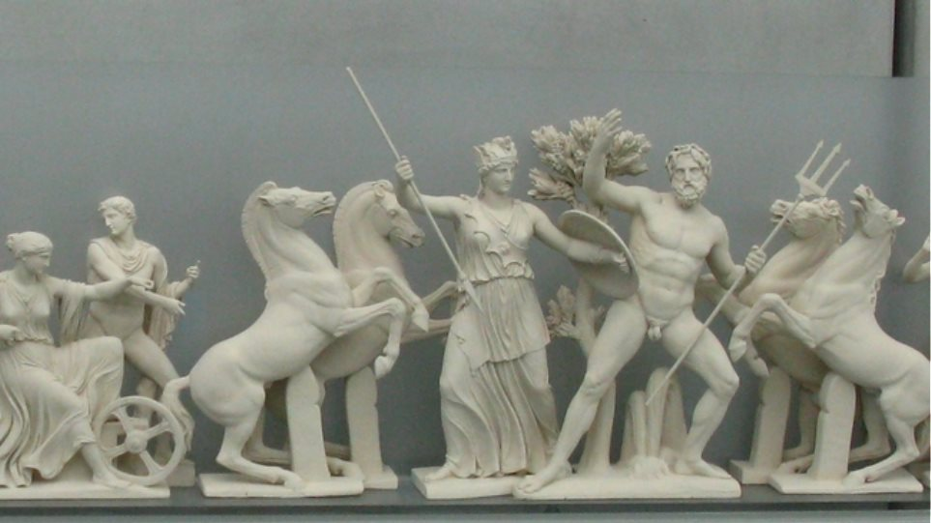

Dialogues
Cecrops: We will have a competition about the _______________ of our city.
Poseidon: I will give you ______________ !
Athena: I will give you the ______________ tree!
The people of Athens: We have decided that the winner is _____________!

