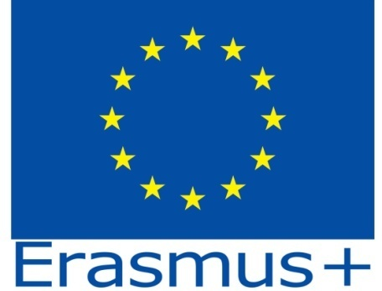

Inclusion in Secondary School
2018-1-DE03-KA229-047219_4

Iasi, Romania, the 12-19th of May 2019

Wednesday, the 15th of May 2019
Topic : Healthy Food
Activity 3 – Healthy Food Survey
Argument
Education for a healthy life/food starts from analysing the present situation .
Objective:
To estimate how many colleagues (%) are aware about what healthy food means.
Procedure
You have to interview 24 people. Divide you group into 4, so each of you can interview 6 persons. Make notes with the answers.
Question your colleagues about their daily habits concerning eating. Express the results in %. Make a chart and present the conclusions about awareness to healthy food. Use a sheet of flipchart and colours.
Questions:
1.Do you have a snack at school? Yes/No

2.What do you prefer as a snack?
- Biscuits
- Chips
- A fruit/a vegetable
- A sandwich
- A cake
- A burger
- Other

3.Whick is your favorite drink?
- Coke
- Milk
- Water
- Juice (orange, lemon, apricot, etc)
- Tea
- Nes tea
- Soda
- Hot chocolate
- Other

4.How many meals do you have per day? Put in a chart
- Breakfast
- Snack
- Lunch
- Snack
- Dinner
- More than 5

5.When you buy somethink to eat or drink, what do you take into consideration?
- Taste
- Brand
- Label/content
- Price
- Habit/experience
- Size

