Beethoven's Favorite Food

https://www.monteiromusicstudio.com/post/beethoven-was-a-mac-n-cheese-guy

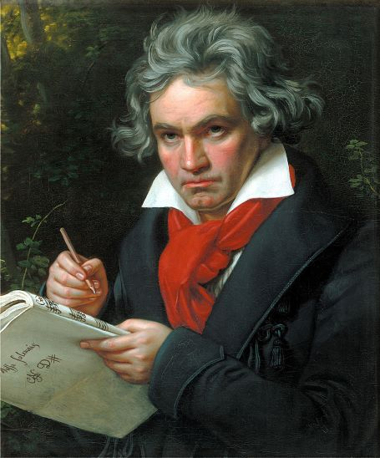
Ludwig van Beethoven (1770–1827); idealisierendes Gemälde von Joseph Karl Stieler, ca. 1820 in:
https://de.wikipedia.org/wiki/Ludwig_van_Beethoven
According to Anton Schindler’s biography, Beethoven As I Knew Him, one of the composer’s favorite dishes was Macaroni mit Parmesan-Käse. Yes, Beethoven's favorite meal was mac n cheese! When Beethoven was in the middle of one of his marathon composing sessions, he ordered his housekeepers to leave his dinner in the room for him to eat when he had finished.

Macaroni with Parmesan cheese was expensive in Beethoven’s day. Macaroni cost three times more than rice, and Parmesan cheese had to be imported from Italy. Also, from what I heard, Beethoven (besides macaroni and cheese) loved soup with twelve drowned eggs. He chose fish over meat, his favorite fish was pollock with potatoes and he liked flat water and light Austrian wine. I also believed he loved beer. What a surprise that one was, just kidding.

I found an authentic 1800's mac and cheese recipe online and here it is...

Ingredients
1 large yellow or white onion, diced and caramelized
2 cups spaetzle
⅓ cup butter, cut into small pieces
1 teaspoon minced fresh thyme
½ teaspoon freshly grated nutmeg
Salt and fresh coarse ground black pepper to taste.
About a cup of freshly grated well aged Parmesan
½ cup toasted bread crumbs
¼ cup freshly chopped parsley

Preparation
Preheat the oven to 350°. Caramelize the onions and set aside. Make the Späetzle, drain well, add the butter, thyme, nutmeg, salt and pepper, stir gently and set aside. Combine the Parmesan, bread crumbs and parsley. Reserve about ½ a cup of this mixture and toss the rest gently with the Späetzle. Put the Späetzle mixture into a well oiled baking dish. Sprinkle the remaining Parmesan mixture over the top and bake for about twenty minutes, or until the top is just beginning to brown.

Is this Beethoven’s favorite recipe? No idea… However, I do know that he wrote beautiful music! My favorite piece for this dish is his 7th Symphony! Love that piece :)

