Visiting Greek Gods and Goddesses
Situation 3
Athena and Ares are fighting (German team)
Task 1
Look at the picture and study the situation 3.
Complete the mind-map below!
Why? Athena was for the greeks

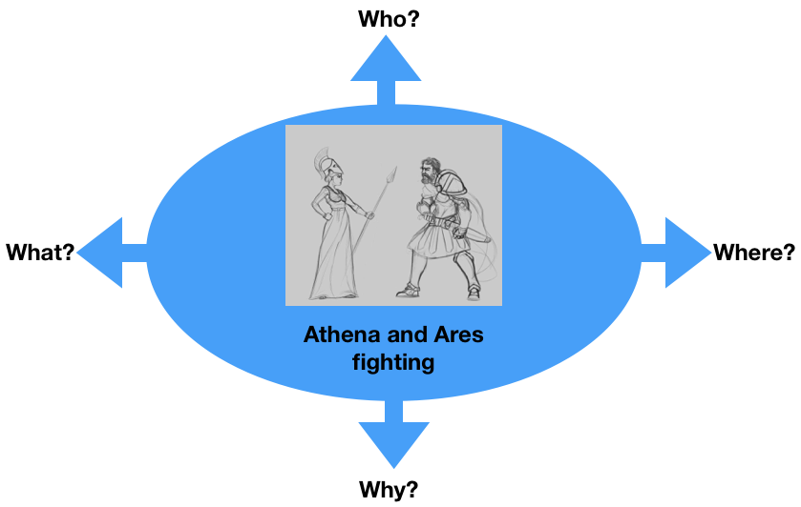
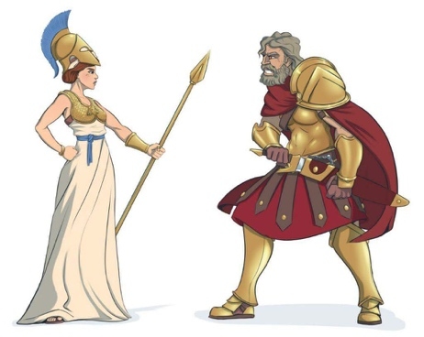

Task 2
Athena and Ares are fighting because of the future of Europe.
What are they fighting for?
For example:
- Peace
- Civil Rights
- Solidarity
- Your suggestion…..

Discuss in the group.

Task 3

Write a dialogue using Task 1 and 2.
Express the emotions of Athena and Ares (e.g. angry, lovely, happy, anxious… etc.). Use the worksheet “Act 3”.

Worksheet Act 3
Write down the dialogue:
the introduction of the narrator, the dialogue of Athena and Ares, the emotions to express
Introduction: Ares and Athena are in greece

Athena: I’m fighting for the Greece!

Ares: And I’m fighting for the Trojaner

Athena: I will defeat you

Ares: You will never defeat me!

Athena: are you sure little man

Ares: Who is the little man here show what you can do

Athena: and how I will show you Greece will win this war again

Ares: Θα δούμε τώρα ότι δεν είστε αντίπαλος για μένα

