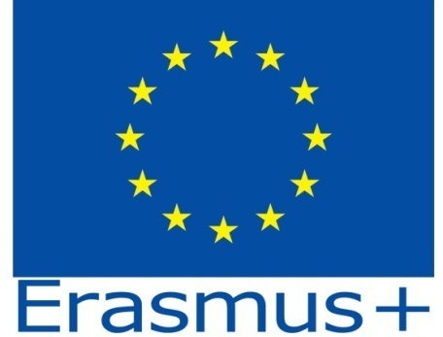

Inclusion in Secondary School
2018-1-DE03-KA229-047219_4

Iasi, Romania, the 12-19th of May 2019

Wednesday, the 15th of May 2019
Topic : Healthy Food
Activity 6 – Healthy /Unhealthy Snacks
Argument
Young people enjoy eating snacks. As there is a very large offer, we should chose the healthiest one.
Objective:
To compare the content of sodium/salt in different products and to chose the healthiest/unhealthiest product of that type.
Procedure:
- Purchase 8 different types of snacks (chips, pufuleti, baked rolls, tortilla chips, etc) that are approximatively the same size .
- Calculate how much salt is in each snack by studying the labels (4 grams is equal to 1 teaspoon).
- Set up the snacks in order from lowest to highest salt content.
- Decide for yourself which snacks are healthy and which are unhealthy.

