Visiting Greek Gods and Goddesses
Situation 4
Hera and Dionysos are dancing (Greek team)
Task 1
Look at the picture and study the situation 4.
Complete the mind-map below!

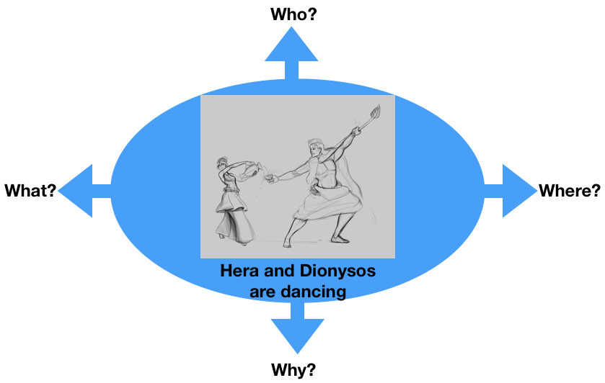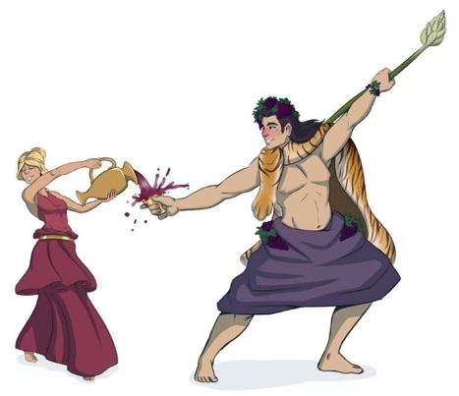

Task 2
Hera and Dionysos are dancing to express their vision of Europe in the future.
How are they performing?
For example:
- Classic dance like ballet
- Video-Clip dancing like on MTV
- Ballroom dancing like waltz
- Your suggestion…..

Discuss in the group.

Task 3

Write a dialogue using Task 1 and 2.
Express the emotions of Hera and Dionysos (e.g. angry, lovely, happy, anxious… etc.). Use the worksheet “Act 4”.

Worksheet Act 4
Write down the dialogue:
the introduction of the narrator, the dialogue of Hera and Dionysos, the emotions to express
Introduction:
It’s Hera’s birthday tomorrow.
She wants to have a party with all the gods from the other European countries!
She wants to dance in her party.
But she doesn’t know how.
Dionysos teachess her to dance.
They dance different european dances from all over the world.
Hera:
Oh Dionysos I am very sad.
It’s my birthday tomorrow.
I want to dance with my european friends.
But I don’t know how to dance.
The whole Europe is going to make laugh of me….
Dionysos:
Don’t worry! I will help you. I am very good dancer.
Which dance do you want to learn? Syrtaki from Greece maybe? Waltz? Or something else. European has many different dances. All of them are nice.

Hera:
Now I am confused!
I want to dance something for all the other european god friends. I want to be all together, to be calm with peace and to do things that make our people happy and safe!
Dionysos:
Join all the european countries with a dance?
Oh it’s difficult.
I feel anxious.
I don’t know if I can teach you such a dance.

Hera:
I am very disappointed now.
You are my only hope.
Please find a solution for me.
I promised a common dance for my bithday tomorrow.
Is it so diffucult to be all together?
Dionysos:
I am nervous but I will do my best.
Let’t start…..your birthday is tomorrow.
Let’s find a nice music and I will show you the way to dance all together tomorrow. It doesn’t matter if the other gods are from different countries. We can show each other some steps and we can make a european dance!
Hera:
I am very touched.
Let’s start dancing.
What a wonderful idea!!!
Dionysos:
Hera tomorrow you and the other European gods will create the best dance. The dance FOR ALL. Each god will give the best steps from his and her country and we will dance with our differences and our similarities around Europe.
Of course you had the best dance teacher!!!
in case all of you will forget the steps…. I will give you some wine to drink……….everybody dances after drinking!!! Trust me

