PAINTING THEATRE
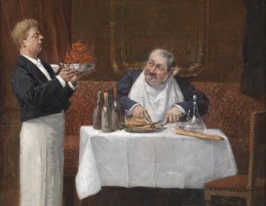
Waiter: Do you want something else?

Man: yes, a steak please

Waiter: yes i will bring it to you.

Man: thank you so much

Waiter: here your steak: was your food tasty?

Man: yes it was brilliant thank you

Waiter: Do you want a dessert?

Man: Yes an ice cream please

Waiter: Yes i will bring it to you

Man: Thank you

