GODS RENAME ATHENS
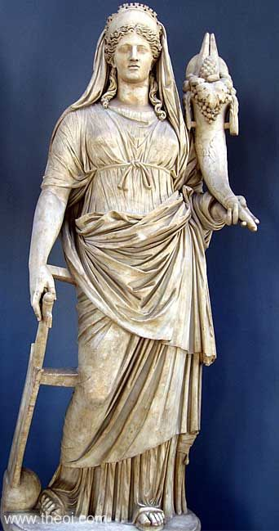
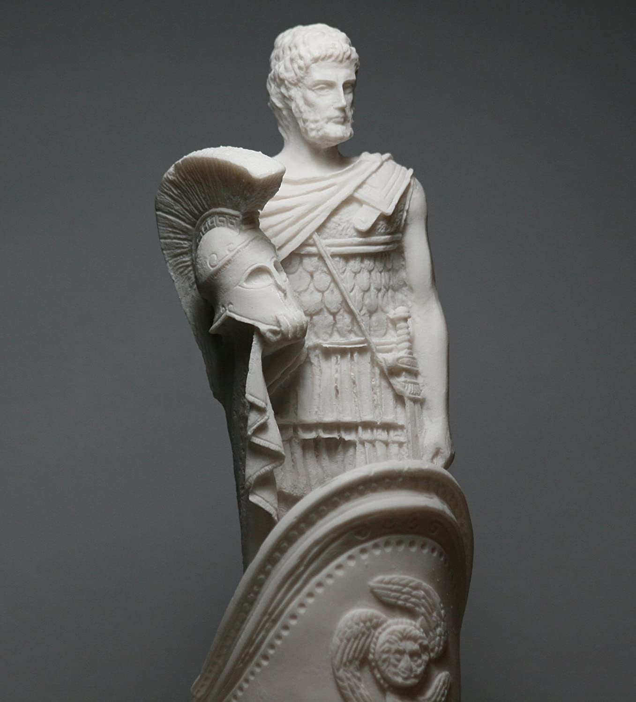
Ares & Demeter
Write a short dialogue between the two gods who are trying to name Athens after them. Each god gives a new name and a gift to the city and explains why this gift is important to the people. Then the students will vote which god offers the best gift and the new name of Athens!!!

<<<<<<<<<<<< ֍ >>>>>>>>>>>>
- Ares: I am the god of war and I will give to the people of Athens my weapons.
- Demeter: I am the goddess of agriculture and I will give you the cereal.
- Ares: No way! The people of Athens will definitely choose me! I will help them to win all the wars.
- Demeter: I cannot believe that this will happen! I am sure that they will choose my present. Don’t forget that this way they will have food.
- Ares: Don’t exaggerate! They can always hunt with my weapons!
- Demeter: Oh! You are so arrogant, Ares!
- Ares: This is not arrogance! This is self esteem!
- Demeter: And what will be the name of the city then?
- Ares: Aria! What about you?
- Demeter: Demetria!
- Ares: That’s a really awful name, Demeter!
- Demeter: You, little fool! I am sure that I will win the competition.
- Ares: I bet that I will make it!
- Demeter: H who laughs last, laughs best!

