Morphe’s hide and seek - Το κρυφτό του Μόρφη
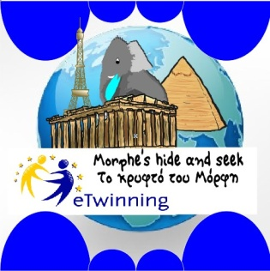
Morphe is an elephant who travels in an air balloon and loves hiding behind monuments. He loves learning the history of the monuments and their use.
He is very hungry though, so he asks from the children to prepare for him the same breakfast they eat.
He also wants to learn how they play hide and seek in their countries.

Phase 1: November - December
Morphe, an elephant puppet, visit schools (you have to make or buy one)
All the schools:
- Present their country’s monument (with Morphe ),
- What do children eat for breakfast at school?
- How they play hide and seek?
- They make a web brochure with travelling instructions of their country
- drawings of the monument with Morphe hiding behind it,
- maps of how to get there from school,
- breakfast recipes,
- history of their monuments,
- video with hide and seek game,
- record the song of how do they count while playing hide and seek?
And publish them on a padlet.
5. We write a riddle for our monument, which will be used for our knowledge game we will design.
- In December a letter will come and say that Morphe is in trouble. His sister is in danger. We have to save her.
So WE WILL raise some money from the Christmas carols and ADOPT AN ELEPHANT (all together) from https://www.sheldrickwildlifetrust.org/asp/fostering.asp
You are NOT obliged to give any money. We will adopt a BABY elephant, learn about the danger elephants have to deal with, and watch their life through from the photos they will send to us.

Phase 2: January – April
Every 15 days we will deal with ONE country of the project, learn songs, play hide and seek in their language and draw Morphe hiding behind their monument.
We examine other schools’ monuments and prepare at school their breakfast. We have breakfast together in a video conference

Phase 3: Research – Collaborative activities April - May
We examine together 2-3 monuments where Morphe wants to visit (it depends from the countries that will take part in the project)
Each school chooses a task and uploads the results in twinspace
FINAL PRODUCTS
- We write a collaborative story about Morphe’s journey in titanpad
- We make a playlist with the hide and seek songs in several languages
- We design a game with all the riddles about the monuments
- Online breakfast contest. Which one did we like most?

During the program, you can add whatever collaborative task you want.
It will be fun, if you embrace Morphe and his journey.
Please answer if you are in or out of the project
Thanks!!!
Marina

