The second day of the meeting
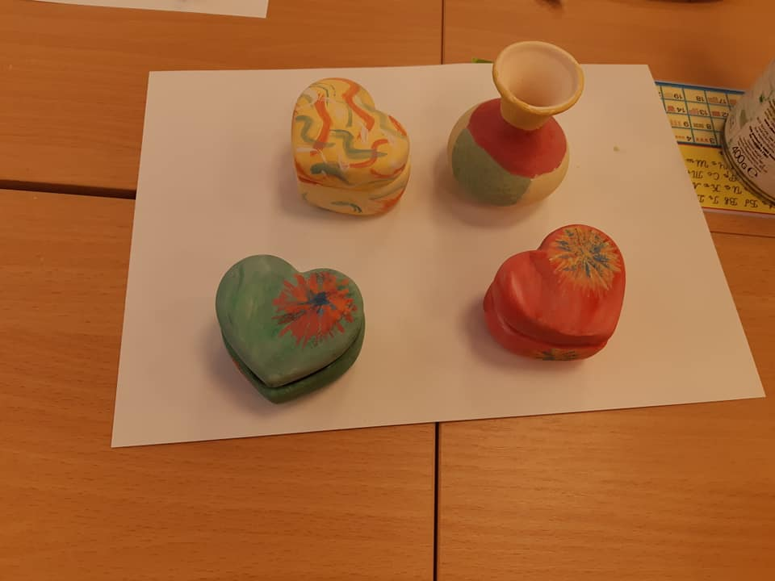
The second day of the meeting started with a meeting of the project coordinators. As a significant result of the work the participants point out the knowledge of the new tendencies in the field of education, the development of the creative potential for innovations, the opportunity for exchange of good pedagogical practices. In the course of the working meeting an assessment was made of the level of implementation of the project activities. The time capsule opened, in which the partners had set their expectations of the project. The students participated in a workshop "Decorating objects" - working with water-soluble material for painting, using tempera to decorate clay objects. The Mayor of Lukovit Municipality, Mr. Ivan Grancharov, met with the representatives of the schools participating in the international project. He welcomed the guests, introduced the city and the municipality, as well as the highlights of the educational policy. He got acquainted with the results of the project activities so far and gave the guests souvenirs and materials representing the country and the region. The delegation visited the wastewater treatment plant in Lukovit. There Mr. Ivaylo Ivanov - ecologist in the Municipality of Lukovit and director of the regional landfill for non-hazardous waste showed the laboratory process and infiltration, water purification through chlorination plants. This process doppinacya charter namalyavane zagybite voda na, na poctigane ctabilni and yctoychivi tempove na cotsialno-iĸonomichecĸo pazvitie, izgpazhdane na ĸachectvena zhiznena cpeda and ocigypyavane na vicoĸ ctandapt na na zhivot nacelenieto. Then we visited the Regional Center for Waste Management - Lukovit. We got acquainted with the technology for composting of waste, which with additional treatment can be used as an enrichment and stabilizer of the soil. The composting of biodegradable waste is done in order to recover the organic matter depleted from the soil. The students took part in the technological process of composting and got on a 32-ton compactor machine.актор.

