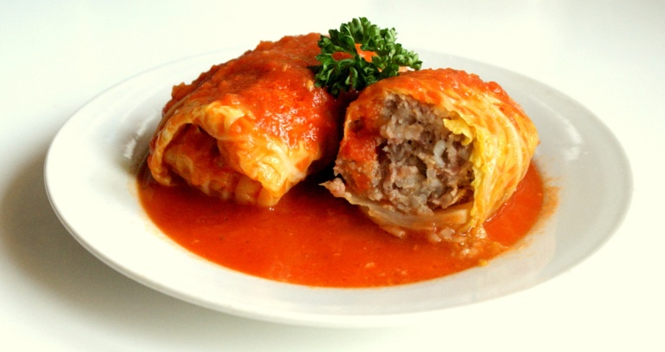
Ingredient for "Gołąbki":

- one glass of boiled rice
- one white cabbage
- two spoons of fat
- two large onions
- two cloves of garlic
- fifty five decagrams of minced, lean meat
- two eggs
- salt
- pepper
- oregano
- two teaspoonfuls of paprika
- fifty five decagrams of sauerkraut
- half a glass of chicken stock
- half a glass of tomato purée
Preparation of "Gołąbki":
Boil cabbage. To warm a fat and brown sliced onions and garlic. To minced mean add boiled and colled rice, raw eggs, browned onion, garlic and spices: salt, pepper, oregano and paprika. Everything mix.
Put tuffing on white cabbage leaves and oo wrap.
Put sauerkraut in the bottom of pot, next "Gołąbki" pleis on the sauerkraut. Mix chicken stock with tomato purée and to pour "Gołąbki".
To put everything to warmed oven. To roast with lid at a temperature of one hundred eighty centigrades. "Gołąbki" is ready after ninety - one hundred twenty minutes.
Good appetite!

