Chicken Fajitas
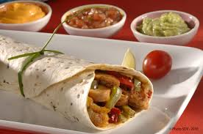
Preparation : 50 minutes
Baking : 30 minutes

Ingredients (for 5 people) :
- 1 kg of chicken fillets
- 3 peppers (green or red)
- 2 onions
- salt, pepper
- cayenne pepper (in powder)
- 1 lemon
- About 15 fajitas
- guacamole
- 5 tablepoons of fresh cream
- 10 leaves of green salad
- 3 tomatoes

Directions :
Dice the tomatoes.
Chop the peppers. Stir fry the peppers until they are nearly cooked .
Meanwhile, chop the onions and stir fry them.
When they are almost cooked, add the peppers and cook until soft. Add in the lemon juice.
Season with salt and pepper and Cayenne pepper according to your taste.
Cut the chicken in small pieces.
Remove the peppers and the onions from the fire.
Cook the chicken.
Stuff the fajitas : Spread some fresh cream, guacamole, tomatoes, salad, chicken and peppers.
Roll, eat, enjoy ! ! !

