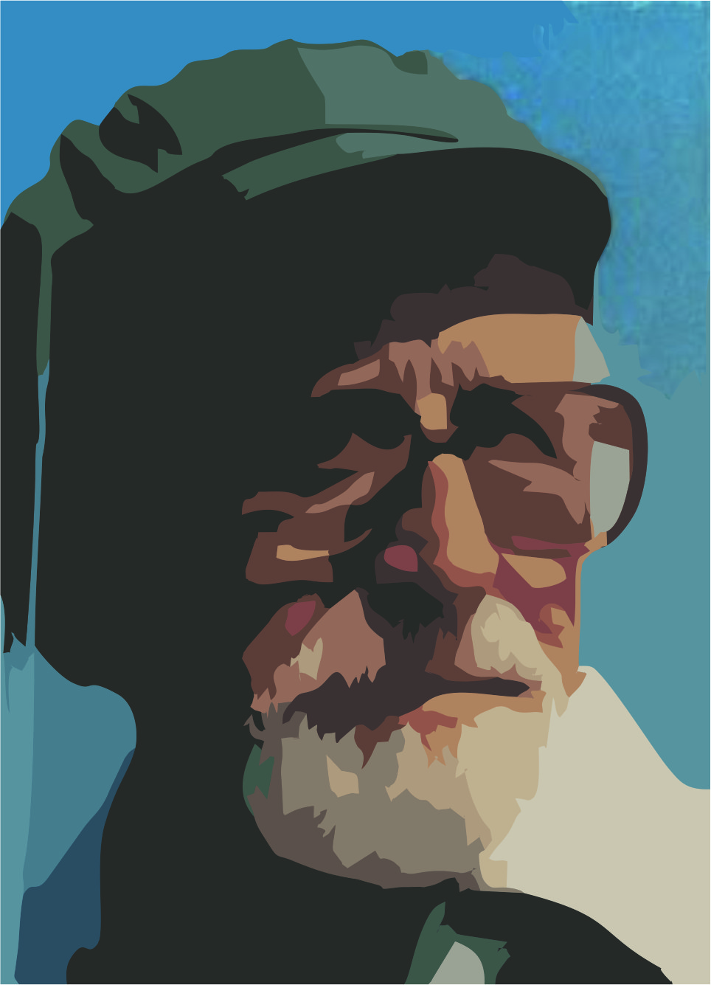

“MY INVOLVEMENT AS A EUROPEAN WITH REFUGEE CHILDREN”
DISSEMINATION OF THE 4RD PART OF THE INTERCULTURAL TRAINING AT THE GREEK SCHOOL

RESEARCH

The purpose of our research is to detect the problems of our school that have to do with disabled people and find solutions which can help them become better assimilated in our school community. The results of the survey we conducted are of major importance because they will help our school realize the differences between disabled and non-disabled people and try to suggest solutions that can promote equality.

The way we conducted our survey and we reached our conclusions consists of several stages. First of all, we splitted into three groups, consisting of two people each. Secondly, we wandered around our classrooms in order to find what the problems are. Afterwards, we created a list of the problems we detected, being assisted by the respective education we received throughout the workshop. We then attempted to figure out possible and applicable measures, the implementation of which could provide disabled people with the facilities they need in order to obtain access to our school.

We realized our school is not the most “friendly” school concerning the accessibility offered to people with special needs. To start with, the school yard doesn’t include ramps and the main building doesn’t dispose of an elevator thus making the situation for the handicapped ones hard. Moreover the narrow classroom and WC doors cause unfeasible access to people in wheelchairs. The disabled people also face difficulties when it comes to opening the heavy school doors that are made of iron. The stage located in the assembly hall is too high to be reached by the handicapped ones. The way the desks are also arranged makes it difficult for the students with defective eyesight to actually pay attention to class. Unfortunately the school bell can’t be heard by the deaf ones whilst the bathroom signs and the information on the announcement boards can’t be read by the blind ones.

As a team that is concerned about our school improvement, we came up with a few solutions to the problems mentioned. First of all it is necessary that the school PTA (Parent-Teacher Association) decides to build ramps and install an elevator in the school building. Meanwhile the school doors’ material could be changed for something a bit lighter so that it becomes easier for disabled people to open them. As for the problem concerning the desks, we believe that a pattern rearrangement would be a helpful alteration. When it comes to deaf people difficulties, a solution would be to add a light sign when the school bell rings and to provide the announcements in BRAILLE language too to help blind people be better integrated in the school society.

In conclusion, a realistic approach of the matter suggests that our school cannot be fully changed in a way that will fulfill all the requirements of people with special needs. This can only happen on several conditions, which include a successful sensibilisation of the PTA and most importantly, a detailed design and proper funding of the project. Should this project be implemented, we are strongly convinced that people with special needs will henceforward be encouraged to enroll in our school and have the normal school life they deserve.

