The 3 Greek teams: Each team consists of 2 teachers and 4 students

- IN REACH TEAM
Salonikidis Dimitrios and Antikoulani Kyriaki: Teachers
Liotopoulou Maria-Eleni, Arampatzis Achilleas, Grammatikopoulou Georgia and Gatza Vasiliki: students

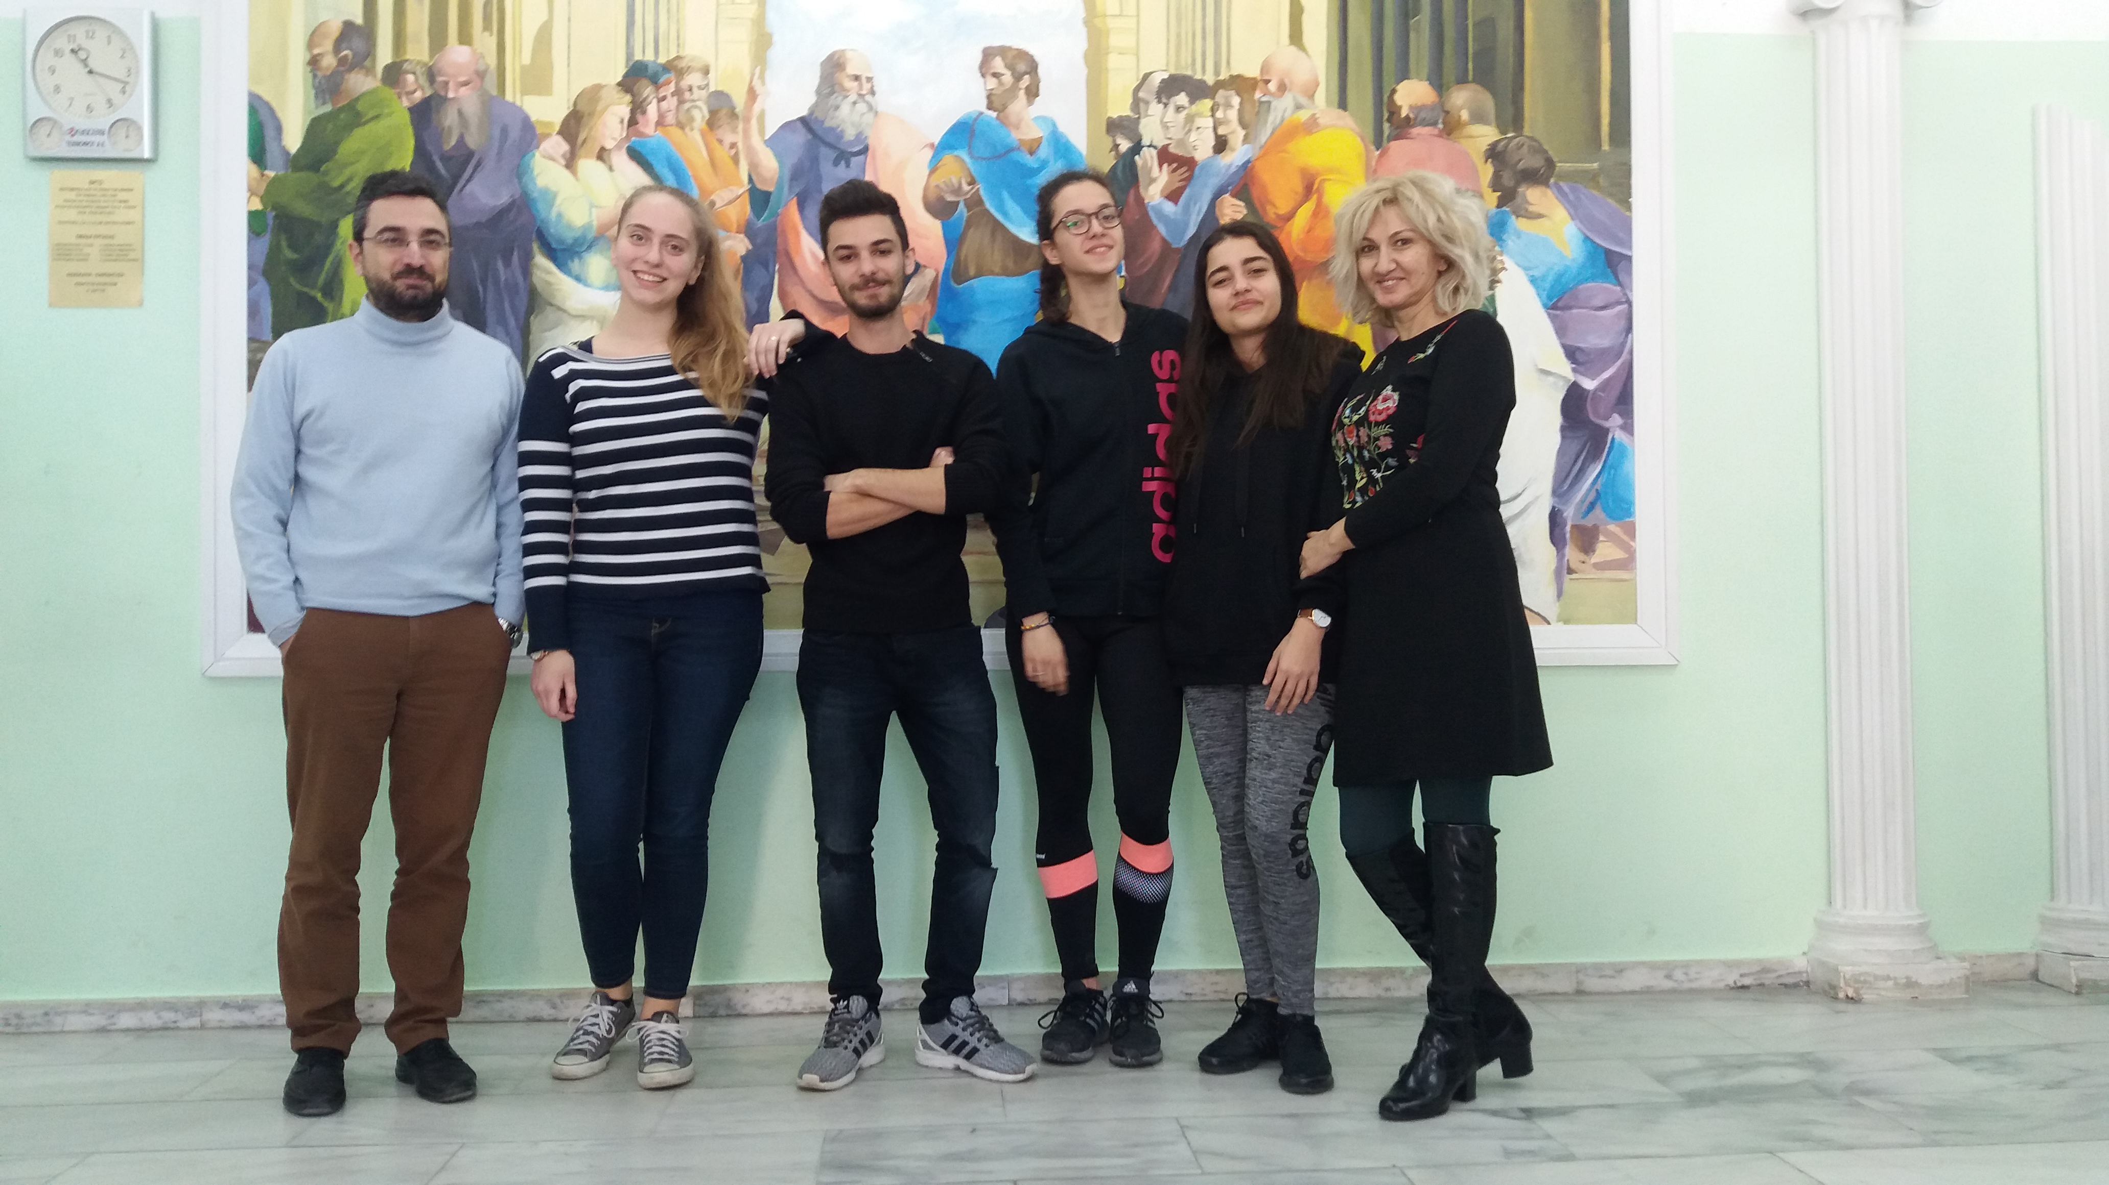

Duties (according to our application)
- To communicate about progress and results in the school by designing an 'intercultural board',
- To inform about project activities on the school webpage,
- To develop content in form of reports, articles and announcements to be published in the school newspaper, yearbook and media.

2. OUT REACH TEAM
Grigoriadou Kyriaki and Kokkinidou Avgi: teachers
Giagkou Athina, Papitsa Politimi-Christina, Alvanou Alkmini, Chatzigiannis Michalis: students

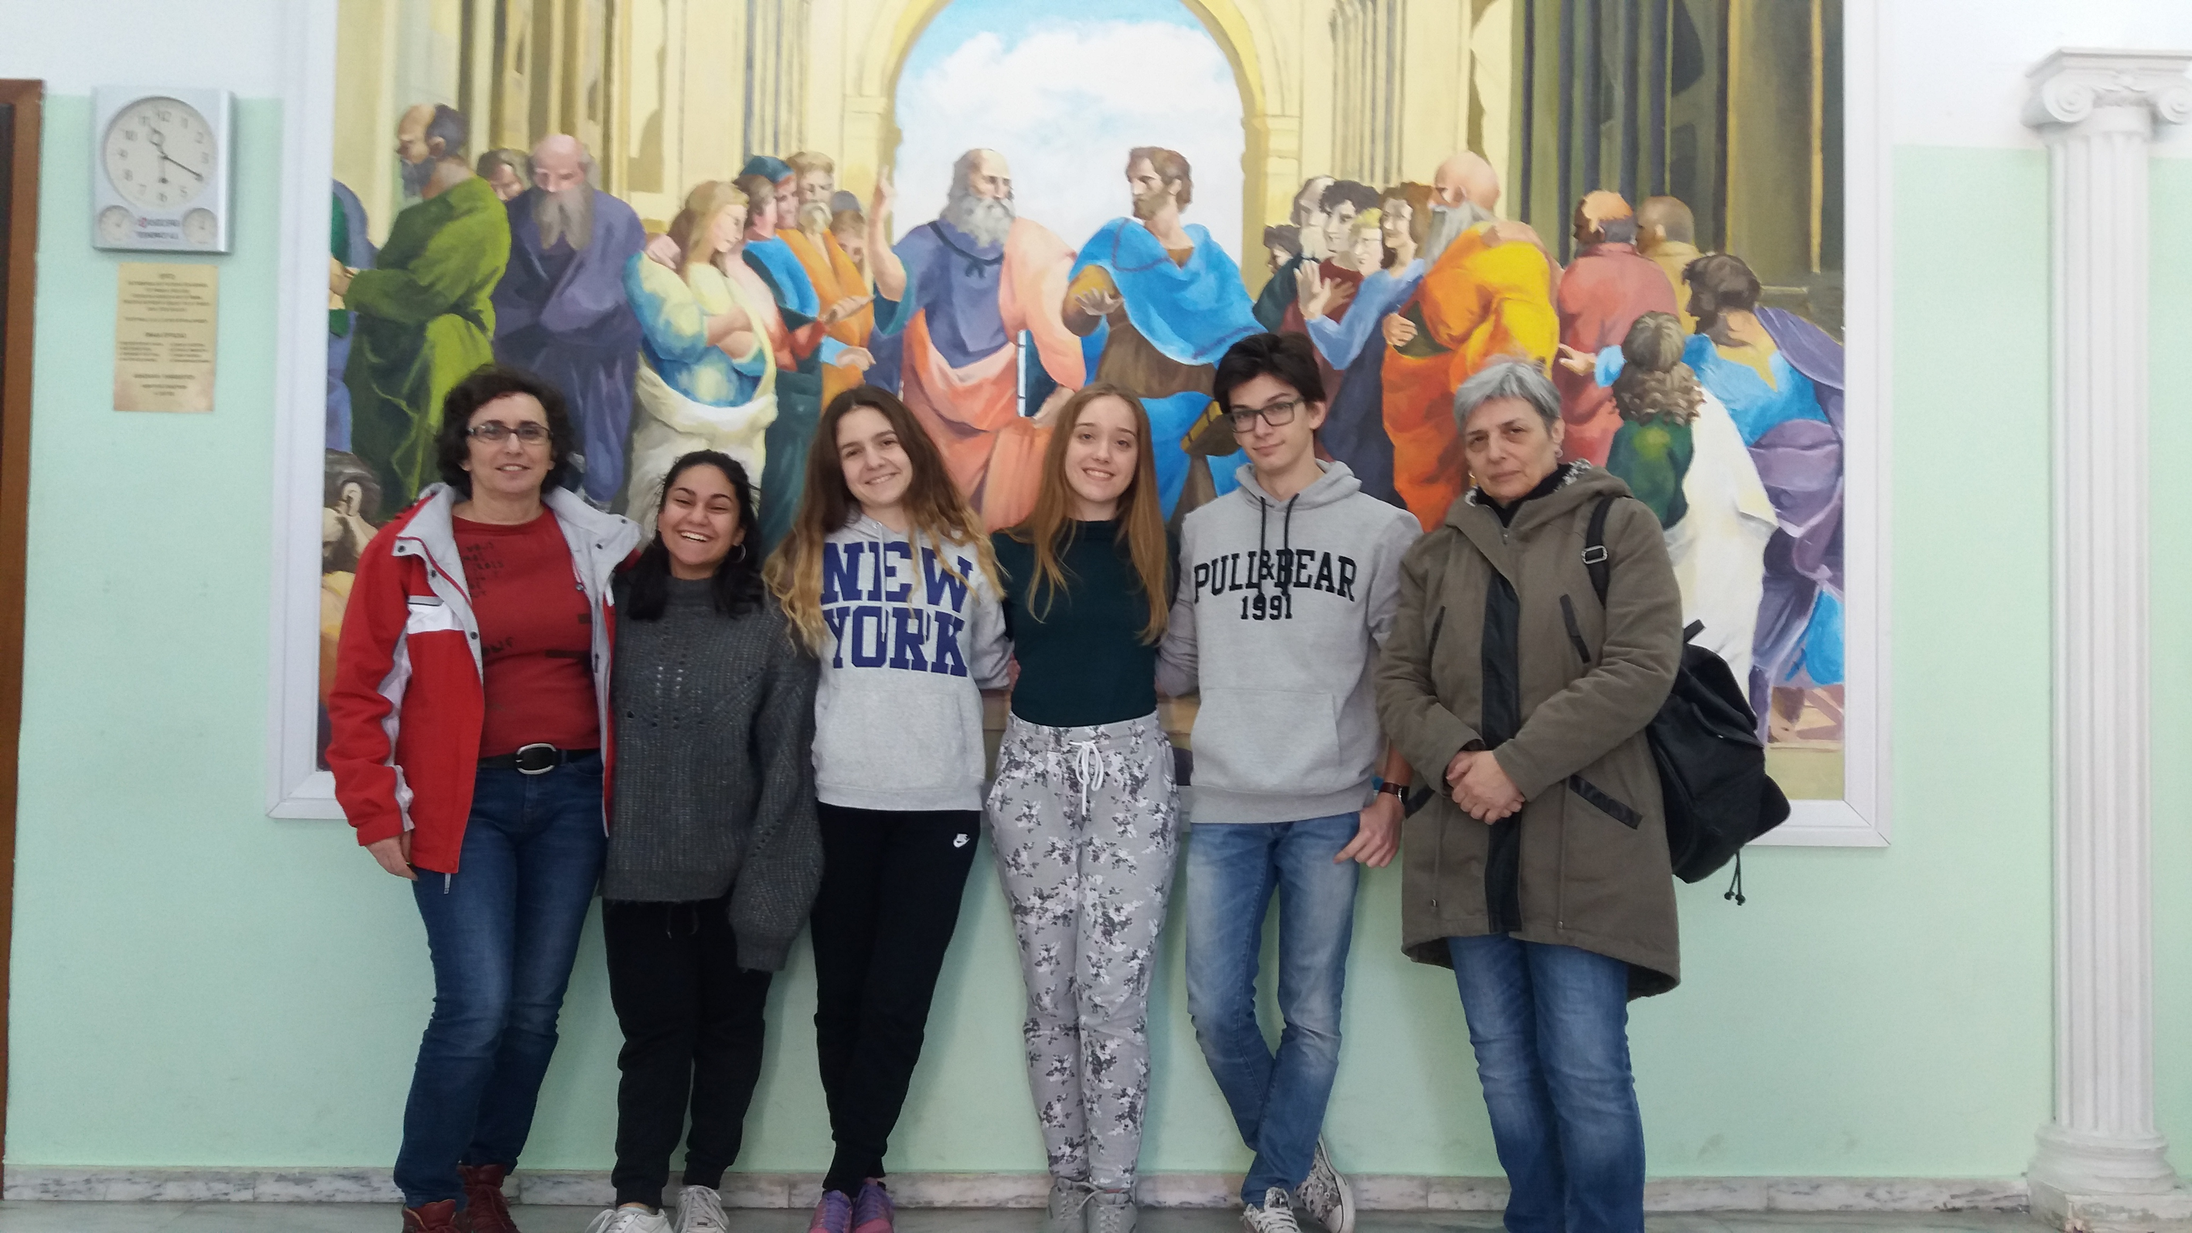

Duties
- To share all project activities and results on e-Twinning,
- To collect ideas for further activities from the activities implemented at the other project schools,
- To initiate and be in charge of joint (transnational) activities.

3. MONITORING TEAM
Grigoriadou Anastasia and Michailidou Christina: teachers
Karathanasi Ekaterini, Kanavouras Nikolaos, Ritsas Athanasios, Parasxakis Zafiris: Students

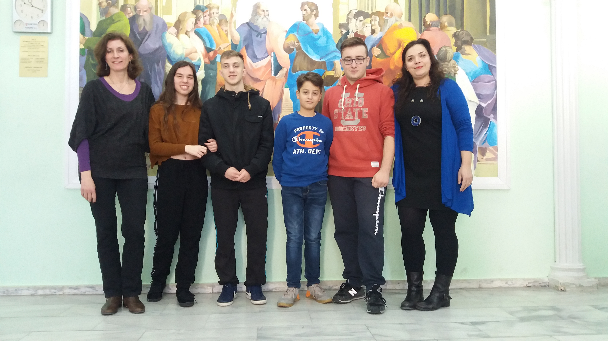

Duties
- To be in charge of time management,
- To monitor partner activities and collect further ideas,
- To monitor and announce delays and develop solutions.
Furthermore, there will be an overall evaluation meeting as the final project stage.

