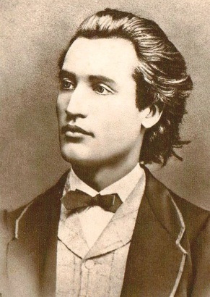 MIHAI EMINESCU

Mihai Eminescu (Romanian pronunciation: [miˈhaj emiˈnesku] ( listen); born Mihail Eminovici; 15 January 1850 – 15 June 1889) was a Romantic poet, novelist and journalist, often regarded as the most famous and influential Romanian poet. Eminescu was an active member of the Junimea literary society and worked as an editor for the newspaper Timpul ("The Time"), the official newspaper of the Conservative Party (1880–1918). His poetry was first published when he was 16 and he went to Vienna to study when he was 19. The poet's Manuscripts, containing 46 volumes and approximately 14,000 pages, were offered by Titu Maiorescu as a gift to the Romanian Academy during the meeting that was held on 25 January 1902. Notable works include Luceafărul (The Vesper/The Evening Star/The Lucifer/The Daystar), Odă în metru antic (Ode in Ancient Meter), and the five Letters (Epistles/Satires). In his poems he frequently used metaphysical, mythological and historical subjects.
His poems span a large range of themes, from nature and love to hate and social commentary. His childhood years were evoked in his later poetry with deep nostalgia.
Eminescu's poems have been translated in over 60 languages. His life, work and poetry strongly influenced the Romanian culture and his poems are widely studied in Romanian public schools.
His most notable poems are:
Doina (the name is a traditional type of Romanian song), 1884
Lacul (The Lake), 1876
Luceafărul (The Vesper), 1883
Floare albastră (Blue Flower), 1884
Dorința (Desire), 1884
Seara pe deal (Evening on the Hill), 1885
O, rămai (Oh, Linger On), 1884
Epigonii (Epigones), 1884
Scrisori (Letters or "Epistles-Satires")
Și dacă (And if...), 1883
Odă în metru antic (Ode (in Ancient Meter), 1883
Mai am un singur dor (I Have Yet One Desire),1883
La Steaua (At Star),1886
He was soon proclaimed Romania's national poet, not because he wrote in an age of national revival, but rather because he was received as an author of paramount significance by Romanians in all provinces. Even today, he is considered the national poet of Romania, Moldova, and of the Romanians who live in the Ukrainian occupied part of Bucovina
Eminescu is omnipresent in present-day Romania. His statues are everywhere; his face was on the 1000-lei banknote issued in 1998 and is on the 500-lei banknote issued in 2005 as the highest-denominated Romanian banknote (see Romanian leu); Eminescu's Linden Tree is one of the country's most famous natural landmarks, while many schools and other institutions are named after him. The anniversaries of his birth and death are celebrated each year in many Romanian cities, and they became national celebrations in 1989 (the centennial of his death) and 2000 (150 years after his birth, proclaimed Eminescu's Year in Romania).
