THE LIGHT OF ALEXANDRIA
With its sumptuous palaces and a library that stored all human knowledge, Alexandria was the envy of the ancient world.
And the great lighthouse that stood sentinel on the island of Pharos in the city's harbour was its radiant beacon.
Alexandria was founded by Alexander the Great, who wanted a symbol of his power to light up all Egypt and beyond. But it was his successor, the general Ptolemy - the Greek pharaoh of Egypt - who fulfilled his vision and began the lighthouse in 260 BC.
It was completed by Ptolemy's son around 20 years later, the same year another Wonder of the World, the Colossus of Rhodes, was completed.
The lighthouse was built on Pharos, a limestone outcrop on the northwest coast of the Nile Delta, first mentioned by Homer in The Odyssey.
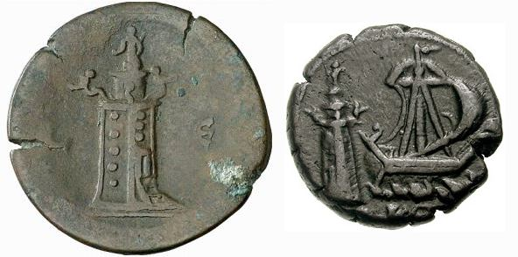
Lighthouse of Alexandria coins
The Lighthouse engraved on coins from second century
(first a reverse of a coin of Antoninus Pius and second a reverse of a coin of Commodus)
Legend says it got its name when Helen, returning home from Troy with her husband Menelaus, was blown off course there. Menelaus asked a local which island it was, and was told: 'Pharoah's.' He misheard it as Pharos - and thus it became.
A device invented by Archimedes which reflected the sun's rays is said to have provided the beacon for the lighthouse. It is probable that fire from a brazier reflected on to mirror, projecting a beam of light outwards. This was said to be capable of setting ablaze a ship 100 miles away - the seas were awash with enemy vessels - and to be visible 700 miles away in Constantinople, today's Istanbul.
Standing in a colonnaded court, the lighthouse was built in four gigantic sections. In the main central section could be seen the windows of 300 rooms. Here, the most revered astronomers and mathematicians of the day gathered - hungry for knowledge, constantly debating and exchanging ideas that shaped the world.
The same section contained a double spiral staircase and a hydraulic machine for raising fuel to the roof. It was topped by a cornice on the four corners of which stood colossal statues.
Just below the cornice was a message from the architect to the 'Saviour Gods of Mariners', who were - in his estimation - Castor, Pollux and Ptolemy himself.
The next tier was octagonal, containing another spiral staircase ascending to the heavens, and then a cylindrical section supported the lantern holding the fire.
On top was a 22ft high statue of the sea god Poseidon, or possibly the sun god Helios, masquerading as Alexander or Ptolemy. Either way, the architect seems to have covered himself.
But for all its glory, the great monument at Pharos was eventually to tumble. How was the mighty fallen?
The records of its rise and fall are scanty. When the Romans set fire to the great library at Alexandria, the archives - and much of that earnestly-debated scholarship - were lost forever.
The end of the Pharos as a working lighthouse was attributed to a jealous Christian emperor in Constantinople, who sent an emissary to persuade the ruling Caliph that great treasure was buried under it.
The Caliph ordered its demolition. But halfway through knocking down the lighthouse, he smelled a rat and stopped work. His attempt to rebuild the structure in brick failed, and the mirror was shattered.
Then in 1375 a major earthquake finally toppled the Wonder into the sea over which it had ruled for so long.
Today, the original site is covered by the picturesque Fort Kait Bey, which was built in 1477 from the ruins of an Arab mosque that replaced the beacon.
The Pharos was the last of the Seven Wonders to be completed.
As well as the Colossus, the others were the Pyramids of Egypt, the Hanging Gardens of Babylon, Phidias's statue of Zeus at Olympia, the Temple of Artemis at Ephesus, and the Tomb of Mausolus at Halicarnassus in Asia Minor.
There are plans to turn the area into an archaeological park, with the prospect of recreational divers being able to explore the seabed site.

