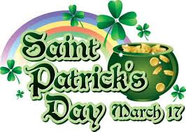 by Philip Iskas ,Γ2

Saint Patrick’s Day or the Feast of Saint Patrick is a cultural and religious celebration occuring annualy ,on March 17th ,the death date of the most commonly recognised patron saint of Ireland.

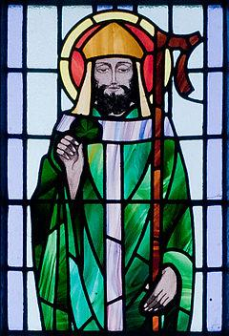

St Patrick’s Day was made an official Christian feast day in the early 17th century and is observed by the Catholic Church ,the Anglican Communion,the Eastern Orthodox Church and the Lutheran Church.
The day commemorates Saint Patrick and the arrival of Christianity in Ireland ,as well as celebrating the heritage and culture of Ireland in general.
Celebrations ,generally, involve public parades and festivals and everybody is wearing green attire or shamrocks .Christians also attend church services and the Lenten restrictions on eating and drinking alcohol are lifted for the day,which has encouraged and propagated the holiday’s tradition of alcohol consumption.

Saint Patrick’s Day is a public holiday in the Republic of Ireland,Northern Ireland ,Newfoundland,Labrador and Montserrat.It is also widely celebrated by the Irish diaspora around the world ,especially in Great Britain ,Canada, the USA,Argentina ,Australia and New Zealand.

