FOOD HABITS IN PORTUGAL
In Portugal we are used to eat very well. Tourists often fall in love with our food and discover new tastes and dishes when visiting the country. We are a small country but with many typical dishes. Even if we already have a lot of fast-food chains and restaurants, ours is still a Mediterranean diet.
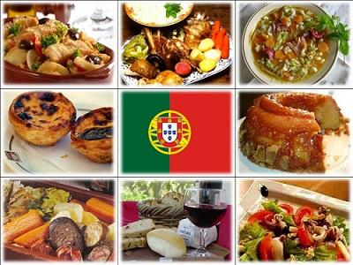

A regular family usually eats:
Breakfast – Bread with butter or ham and cheese with white or chocolate milk. Other options are a bowl of cereals with milk or just coffee and toasts.
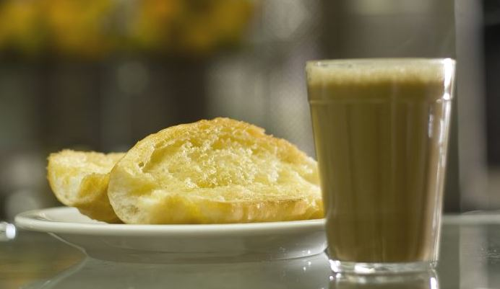
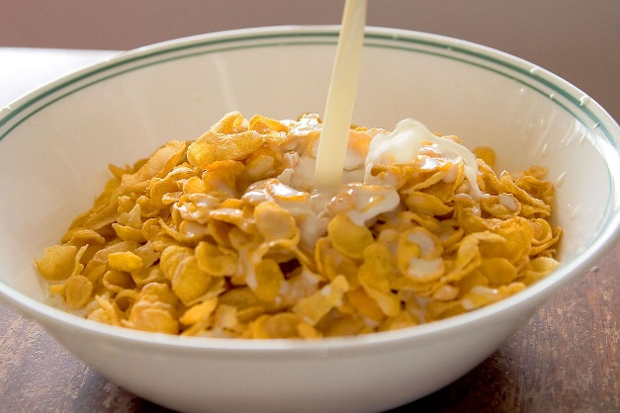
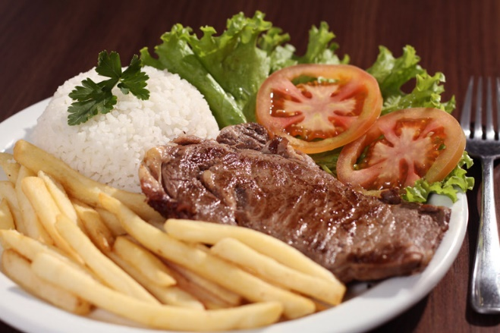
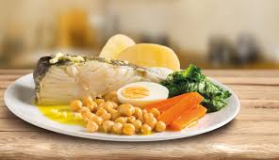
Lunch – This meal begins with a vegetable soup in almost every home. After that, we eat meat or fish, with rice, potatoes or pasta and vegetables such as a tomato and lettuce salad or boiled green vegetables. We finish with a fruit or sweet.

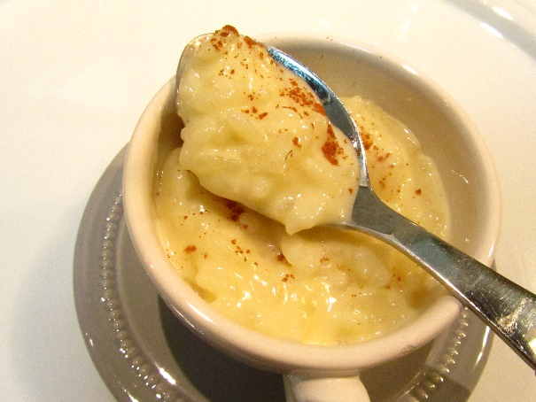

Snack – In the middle of the afternoon it’s common to have an yogurt, a sandwich or some fruit.
Dinner – This meal is the same as lunch. In some cases, people just eat soup and a bit of cheese and bread.
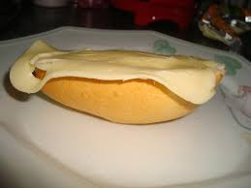
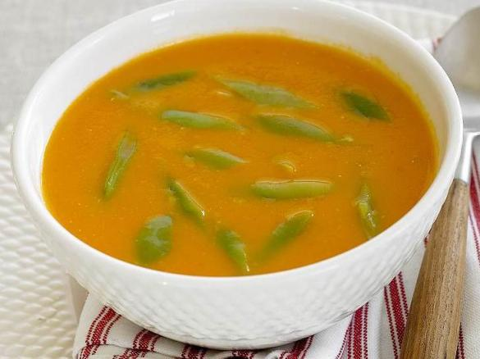

Portuguese people drink a lot of black expresso coffee, in the morning, after the meals or during the day. Some can drink 4 ou 6 cups of coffee per day.
