Mmmmm…Delicious!

We hope you enjoy looking at pictures of some of the traditional food we eat here in Great Britain.

For more details visit this website: <http://projectbritain.com/food/>

Roast beef

[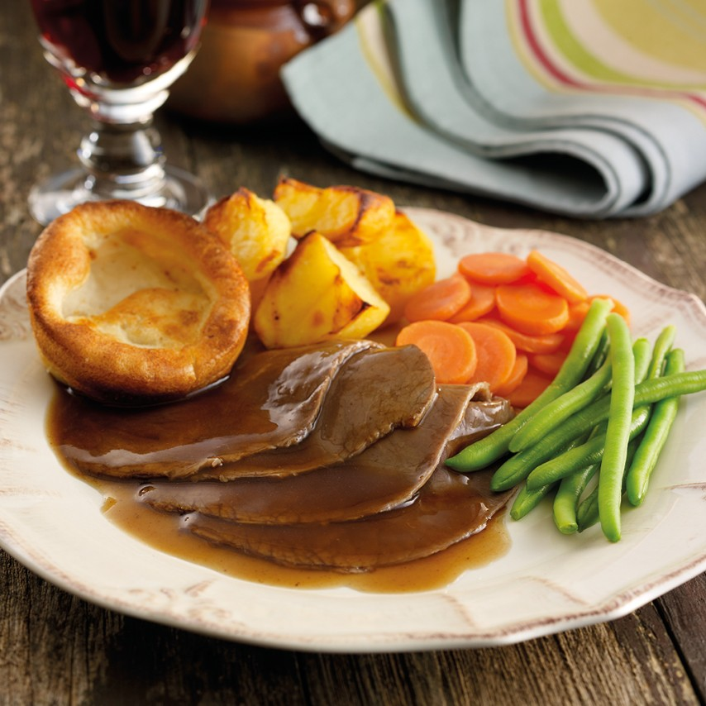](https://www.google.co.uk/url?sa=i&rct=j&q=&esrc=s&source=images&cd=&cad=rja&uact=8&ved=0ahUKEwiA24bStaLXAhWGSBQKHTmoBCQQjRwIBw&url=https://www.oakhousefoods.co.uk/roast-beef-dinner.html&psig=AOvVaw2ysr00QONUnttcYH_aRc94&ust=1509798957342140)

Roast chicken

[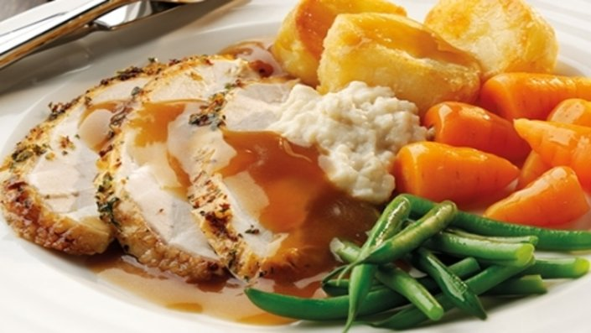](http://www.google.co.uk/url?sa=i&rct=j&q=&esrc=s&source=images&cd=&cad=rja&uact=8&ved=0ahUKEwig5sfltaLXAhUGOBQKHbDhAOwQjRwIBw&url=http://www.foodnetwork.co.uk/recipes/roast-chicken-gravy-0.html&psig=AOvVaw3SyN7T1dz60bYkSPvXy1TX&ust=1509799018809391)

[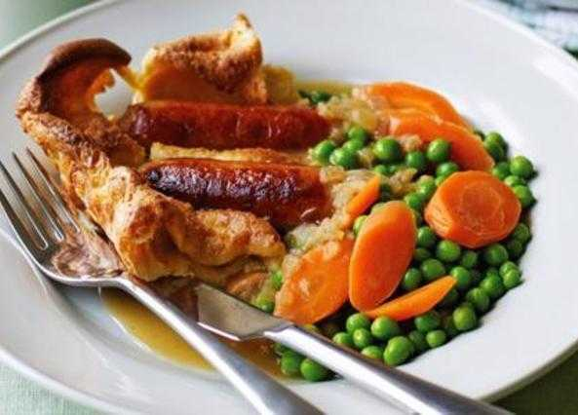](https://www.google.co.uk/url?sa=i&rct=j&q=&esrc=s&source=images&cd=&cad=rja&uact=8&ved=0ahUKEwiF_fOJtqLXAhXFOBoKHWh5CXwQjRwIBw&url=https://recipes.sainsburys.co.uk/recipes/main-courses/toad-in-the-hole&psig=AOvVaw0OXF9s99W7tKfKeuXqULuW&ust=1509799063958393)Toad in the hole

Full English breakfast

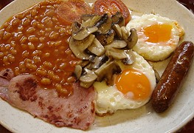

Shepherd’s pie

[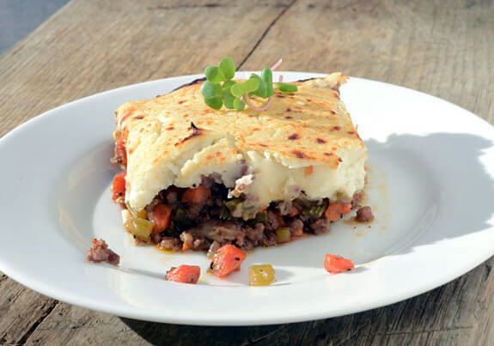](https://www.google.co.uk/url?sa=i&rct=j&q=&esrc=s&source=images&cd=&cad=rja&uact=8&ved=0ahUKEwjA0sLStqLXAhUE1hQKHf6yDjQQjRwIBw&url=https://elanaspantry.com/paleo-shepherds-pie/&psig=AOvVaw27rc0g3-EeEstO6dhl6TO0&ust=1509799245791519)

[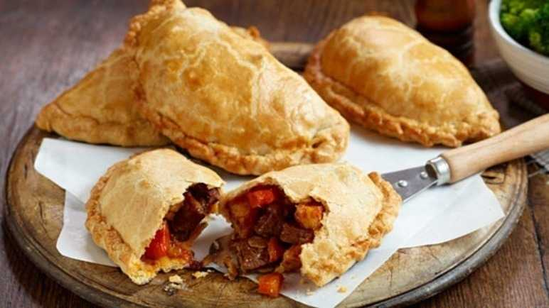](https://www.google.co.uk/url?sa=i&rct=j&q=&esrc=s&source=images&cd=&cad=rja&uact=8&ved=0ahUKEwiijvHptqLXAhVHvBoKHc5gAHcQjRwIBw&url=https://recipes.sainsburys.co.uk/recipes/main-courses/spicy-cornish-pasty&psig=AOvVaw0FjEahE_NvDwCvfmsb96R7&ust=1509799298055444)Cornish Pasty

Devon Cream Tea

[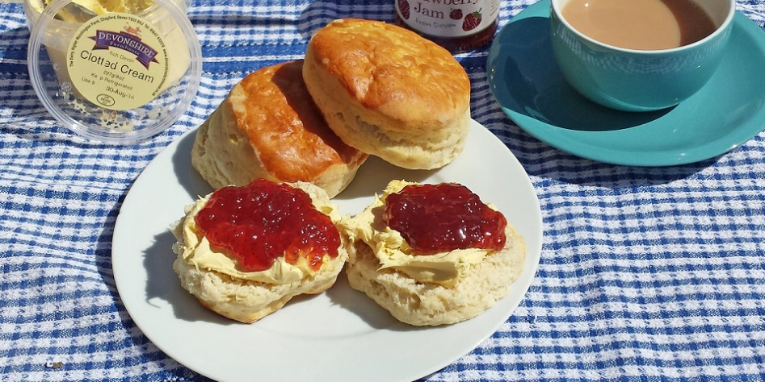](https://www.google.co.uk/url?sa=i&rct=j&q=&esrc=s&source=images&cd=&cad=rja&uact=8&ved=0ahUKEwjO9puLt6LXAhVKOBQKHQTkBuYQjRwIBw&url=https://www.coastandcountry.co.uk/food-drink/blog/top-5-places-to-enjoy-a-traditional-devon-cream-tea/&psig=AOvVaw2RAwUHd3whCJbdTKUPvZVm&ust=1509799367108920)

Fish and chips

[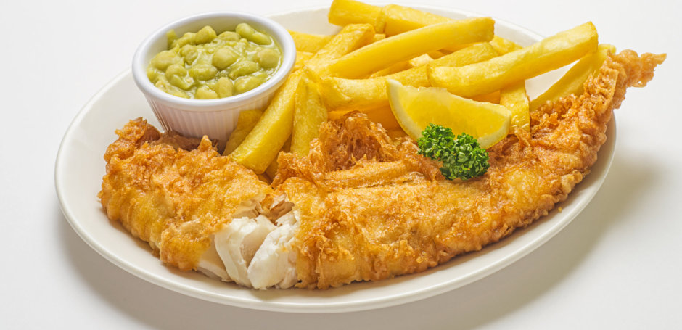](http://www.google.co.uk/url?sa=i&rct=j&q=&esrc=s&source=images&cd=&cad=rja&uact=8&ved=0ahUKEwjd87ynt6LXAhUB6RQKHUu-AIYQjRwIBw&url=http://www.bizzielizzies.co.uk/&psig=AOvVaw3VNRJ2ojD6YNXDGRgt5DKK&ust=1509799424232733)

Ploughman’s Lunch

[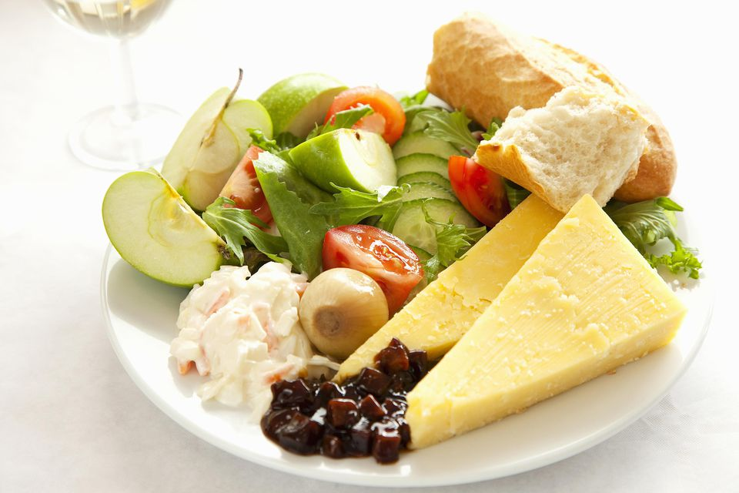](https://www.google.co.uk/url?sa=i&rct=j&q=&esrc=s&source=images&cd=&cad=rja&uact=8&ved=0ahUKEwipqtu9t6LXAhWMuRQKHf9SDtsQjRwIBw&url=https://www.thespruce.com/what-is-a-british-ploughmans-lunch-435331&psig=AOvVaw1DtQJxhFtMb2RkYzdcx3jS&ust=1509799468252150)

Trifle

[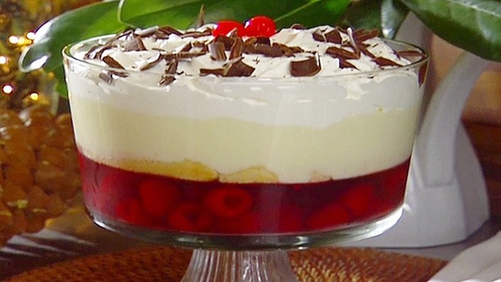](http://www.google.co.uk/url?sa=i&rct=j&q=&esrc=s&source=images&cd=&cad=rja&uact=8&ved=0ahUKEwiy-rD-_b3XAhWJoKQKHbLCDV4QjRwIBw&url=http://www.foodnetwork.co.uk/recipes/coconut-cream-trifle.html&psig=AOvVaw3bUqYWzmIr8QyTqxPXQZyT&ust=1510746102471159)

Apple pie

[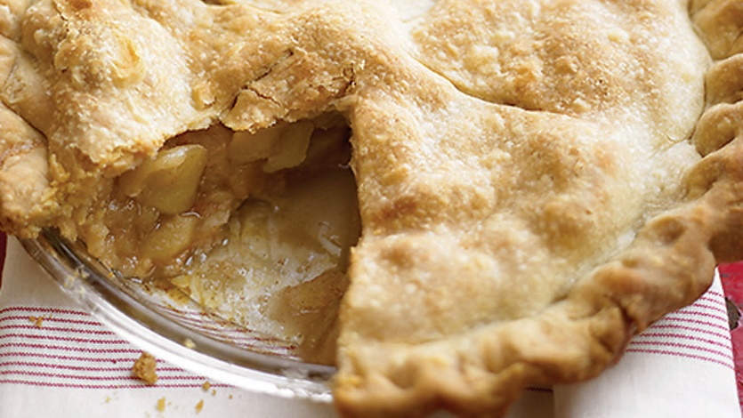](https://www.google.co.uk/url?sa=i&rct=j&q=&esrc=s&source=images&cd=&cad=rja&uact=8&ved=0ahUKEwj4huCT_r3XAhVLblAKHfwFDuUQjRwIBw&url=https://www.marthastewart.com/341735/apple-pie&psig=AOvVaw0xfktoApoMbrGMzlfV2qUv&ust=1510746154431938)

Jelly and Ice Cream

[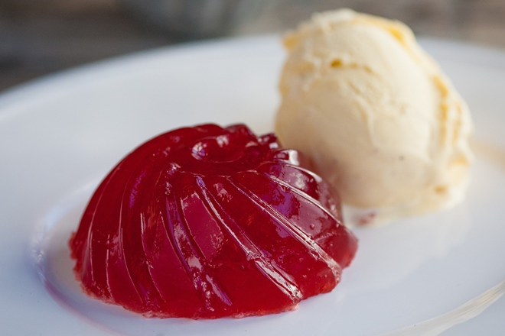](http://www.google.co.uk/url?sa=i&rct=j&q=&esrc=s&source=images&cd=&cad=rja&uact=8&ved=0ahUKEwjDkoGw_r3XAhXJJewKHUlwCHMQjRwIBw&url=http://www.greatbritishchefs.com/recipes/jelly-and-ice-cream-recipe&psig=AOvVaw2EPdUMbHVCxwSKkMHnNmTU&ust=1510746212271288)

Jam Roly-Poly

[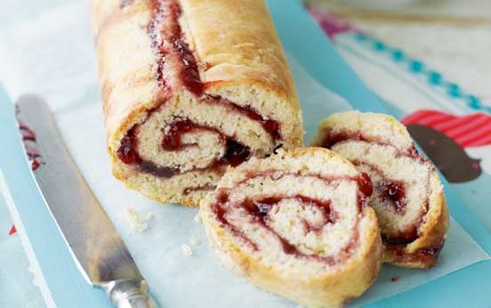](http://www.google.co.uk/url?sa=i&rct=j&q=&esrc=s&source=images&cd=&cad=rja&uact=8&ved=0ahUKEwjV4fzL_r3XAhWJIuwKHUlJBAQQjRwIBw&url=http://www.goodtoknow.co.uk/recipes/530425/jam-roly-poly-with-custard&psig=AOvVaw2VeASsX8NZ09w8uflmVvfw&ust=1510746275716211)

Custard

[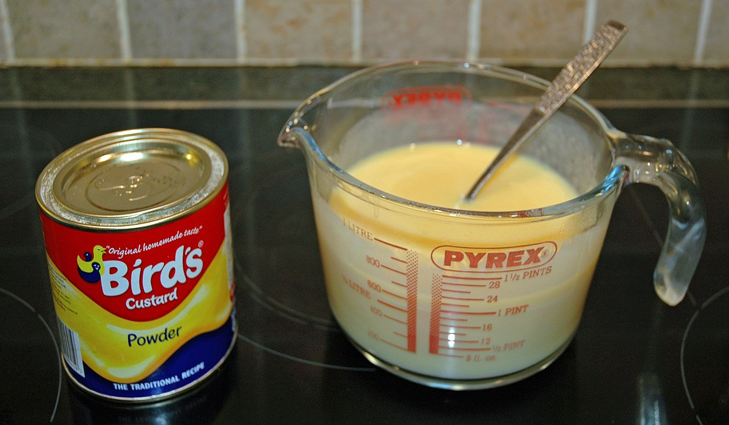](https://www.google.co.uk/url?sa=i&rct=j&q=&esrc=s&source=images&cd=&cad=rja&uact=8&ved=0ahUKEwiIo_Pc_r3XAhWsDcAKHRKFAsAQjRwIBw&url=https://en.wikipedia.org/wiki/Bird%27s_Custard&psig=AOvVaw2TDbIUHkLPQnvy0qgynfB-&ust=1510746306094713)

Crumpets

[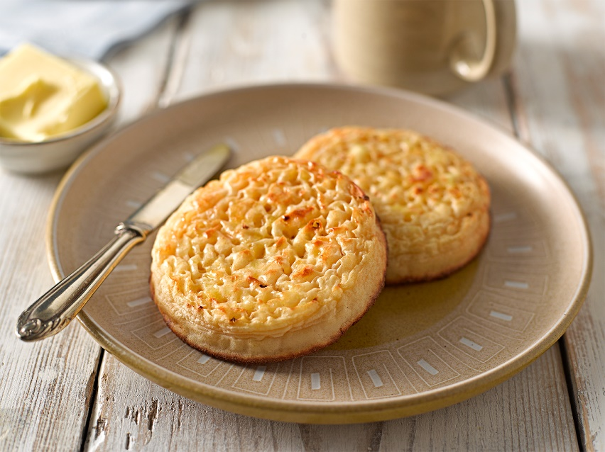](http://www.google.co.uk/url?sa=i&rct=j&q=&esrc=s&source=images&cd=&cad=rja&uact=8&ved=0ahUKEwjFyJCY_73XAhWRYlAKHThRC5cQjRwIBw&url=http://www.newburnbakehouse.com/the-joy-of-crumpets-now-available-gluten-free&psig=AOvVaw36Cnw-5wDrS2oZav8dIQaR&ust=1510746406287741)

Victoria Sponge Cake

[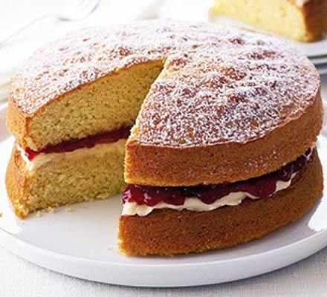](https://www.google.co.uk/url?sa=i&rct=j&q=&esrc=s&source=images&cd=&cad=rja&uact=8&ved=0ahUKEwjfgoq4_73XAhUQLFAKHezLCKkQjRwIBw&url=https://www.bbcgoodfood.com/recipes/1997/classic-victoria-sandwich&psig=AOvVaw1A2zXgVMKohXW_5d6d5sCn&ust=1510746501851966)

Beef stew and dumplings

[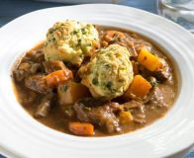](https://www.google.co.uk/url?sa=i&rct=j&q=&esrc=s&source=images&cd=&cad=rja&uact=8&ved=0ahUKEwiot_WegL7XAhVF-aQKHY06AHoQjRwIBw&url=https://www.bbcgoodfood.com/recipes/2416642/beef-casserole-and-dumplings-&psig=AOvVaw3V8VIgJyOYxAHRU0SPwzpY&ust=1510746689819215)