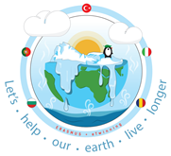

We live in a wonderful world

Full of LifeFull of Colour

Full of Beauty

But in recent years our world has been devastated by HURRICANES, EARTHQUAKES, FLOODS and DROUGHTS.

What does the future hold for Planet Earth ? (The place we all call HOME)

CLIMATE CHANGE can destroy the world that we live in

We can prevent this if we all work together

There are still many things that we could be doing

Things that you and your family can do together

1. You can REDUCE the amount of WASTE that you produce. This ccan be done by being more resourceful with the things that you use and buy. Just look at the things that you can reuse:
   * JARS
   * BOTTLES
   * BAGS
2. You and your family can recycle many things in your home . Many things that you use can be recycled:
   * CANS (your used can easily become part of a new car)
   * BOTTLES (and your used glass bottle can become new windows for your home)
   * PAPER
   * ELECTRICAL DEVICES
   * FOOD

So, make sure you use a recycle bin every time

There are many simple things that you and your family can do around your home.

1. Plant a tree in your garden and watch it grow
2. Make compost with your leftover food and grow new food
3. When the weather is nice hang your clothes out to dry

What we have now is a chance to preserve our future

Tell your PARENTS, YOUR GRANDPARENTS and YOUR FRIENDS

To do the small things that count

We must take it step by step to make sure you have a future to grow up in

PERSON BY PERSON

FAMILY BY FAMILY

COMMUNITY BY COMMUNITY

TOGETHER we can make a difference.

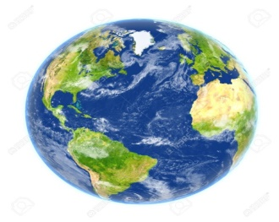We live in a wonderful world

Full of ___________________

Full of ___________________

Full of ___________________

But in recent years our world has been devastated by _________________, _________________, ___________ and _________________.

What does the future hold for Planet Earth ? (The place we all call HOME)

________________________ can destroy the world that we live in

We can prevent this if we all work together

There are still many things that we could be doing

Things that you and your family can do together

1. You can _______________ the amount of ________________ that you produce. This can be done by being more resourceful with the things that you use and buy. Just look at the things that you can reuse:
   * _________
   * _________
   * _________
2. You and your family can recycle many things in your home. Many things that you use can be recycled:
   * __________ (your used can easily become part of a new car)
   * __________ (and your used glass bottle can become new windows for your home)
   * ___________
   * ___________
   * ___________

So, make sure you use a recycle bin every time

There are many simple things that you and your family can do around your home.

1. ____________ a tree in your garden and watch it grow
2. Make ____________ with your leftover food and grow new food
3. When the weather is nice _____________ your clothes out to dry

What we have now is a chance to preserve our future

Tell your ________________, your ______________________ and your __________________

To do the small things that count

We must take it step by step to make sure you have a future to grow up in

_____________ by person,

____________ by family

_________________ by community

__________________________ we can make a difference.