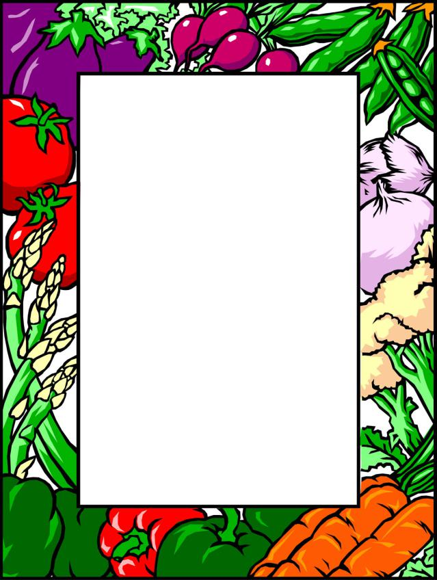
PICKLES

Ingredients:
One cucumber
One carrot
One bell peper
One raw tomato
A small cauliflower
Pepper, laurel and mustard
A teaspoon of salt
½ litre of water
A jar (800g) with a lid

Wash the vegetables and cut them into small pieces. Put all the vegetables in a jar, then add pepper, laurel and mustard.
Boil a ½ litre of water with a teaspoon of sald. Poor the hot mixture in the jar and put the lid on.
Put the jar in a cold place for a month.

We often say that pickels protect our organism of flew during winter.

