GREEK AUTUMN JUICES
Orange, banana, sour cherries juice
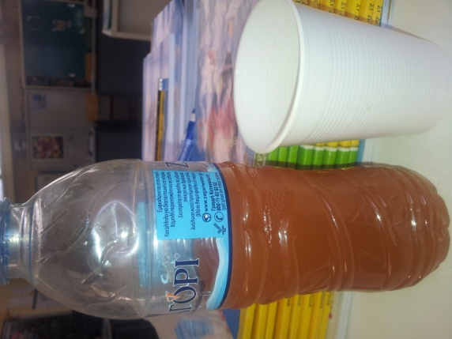
Apples, carrots, banana, pears, tangerines, oranges, lemons, pineapple, whipped cream
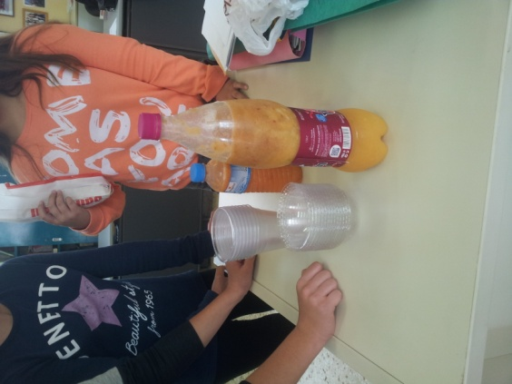
Banana, apple, tangerines

