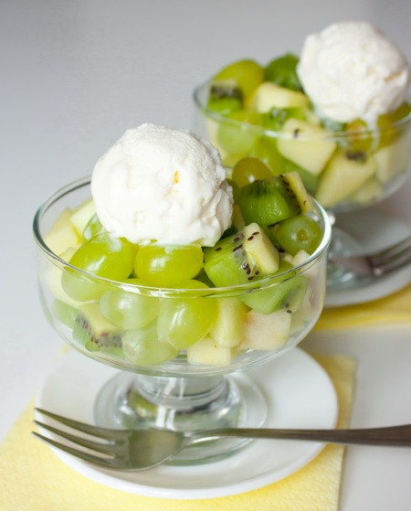

INGREDIENTS

Vanilla ice cream - 1/4 gallon
1 kiwi
1 banana
Seedless grapes - 1 bunch(atleast 15 grapes)
Any other fruit of your liking

Step 1. Cut the fruits into small pieces and slice the grapes in half.
Step 2. Keep stirring 4 - 5 scoops of ice cream in a serving bowl, till its soft and melted.
Step 3. Mix the fruits with ice cream.
Step 4. Add more ice cream, till all the fruit pieces are covered.
Step 5. :- Serve chilled.

