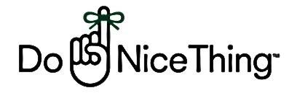eTwinning project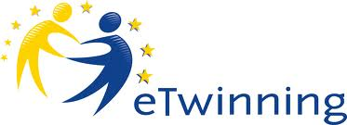

„Change the world: let‘s make it better“

Proposed By JONAVA SENAMIESTIS GYMNASIUM, LITHUANIA( Teacher Leonora Večkienė)
Situation in the world is getting worse and worse : wars, crises, misunderstanding between people.It is easy to claim that there are alot of nagativity around us but do we do anything to change it . Small actions in daily life could contribute to better understanding among people.
OBJECTIVE : Contribute to the situations in students surrounding with small and big good deeds.
Project is designed for 15-16 years old students,B1 lavel of English and some ICT skills.
Stages:
- Personal introductions, introductions of schools and living places-October 2015
(IT tools – Voki , Prezi, Powtoon, Voicethread, Animoto etc)
- Good deeds for people:
2.1 Family members( students discuss with their family members what help can they provide to their family members)
(IT tool flipbox, videos, prezi)-----------November 2015
Logo competition for the project
2.2 Friends (discuss the problems that your friends have and try to help them)
Christmas sharings December 2015
2.3 Society( You have to decide what places you are going to visit to share your good deeds) - January/February 2016
- Surroundings/environment
(Every partner school sets up the activity according to the school situation) March-April 2016
- Final stage, evaluation, feedback May 2015

Addionallly :
Good deeds bucket ( prepare the list of good deeds for weekly small activities) or other forms of presentaion of small good deeds.
e.g October 1st week Make somebody smile
2nd week Give a compliment to someone
3rd week Good manners week( saying hello, goodbye, thank you etc.)
4th week Nice behaviour in the lessons you don‘t like
( before beginning of every month students discuss these small activities what they will do )
Then there should be prepared good deed cards or leaves ( I enclose the example, and people who will be involved in the action should write something on this card and sign) EVERY MONTH WE WILL CHOOSE THE LEADERS IN EVERY COUNTRY.

Activities could be carried out in any order and be adapted to the situation of partner‘s school after discussion with the project partners .

