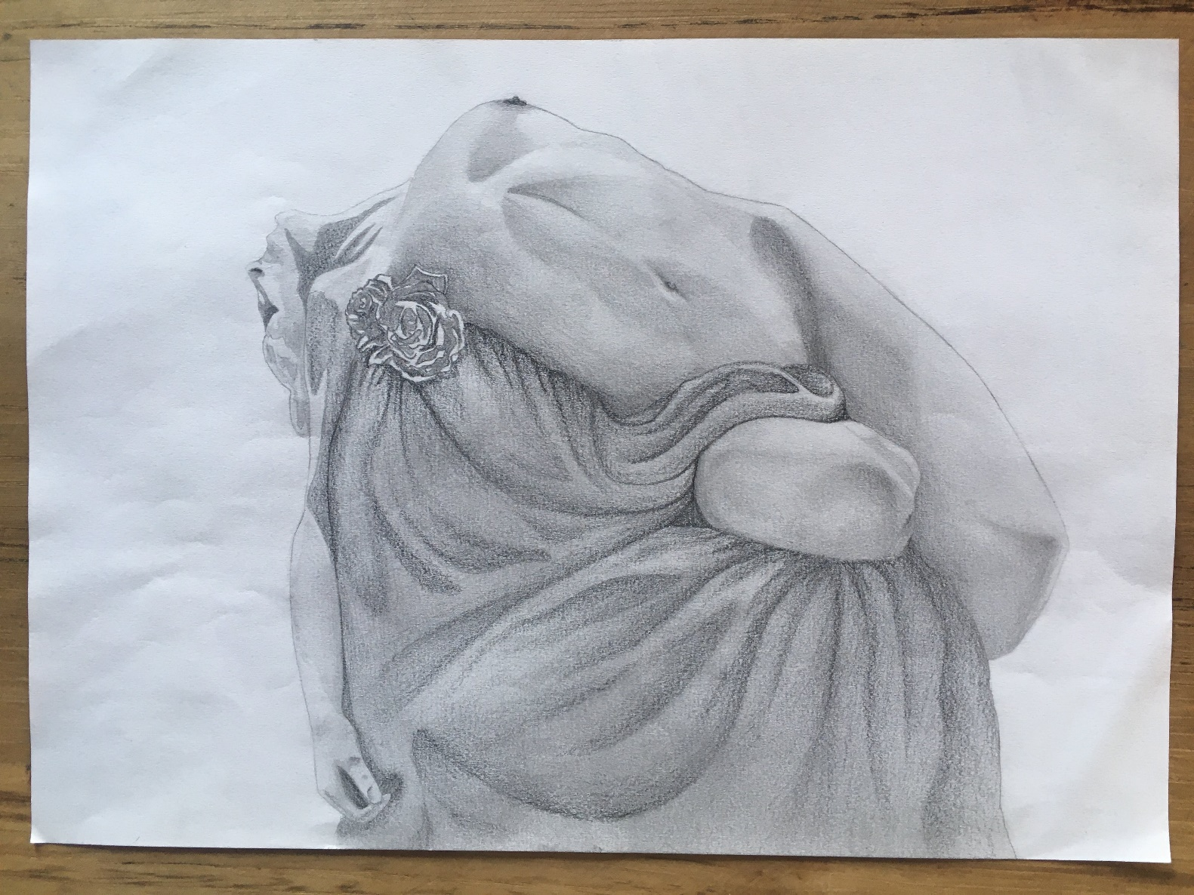

Mauro Barreras, arrived in Rome in 1997; awriter and dance master with the passion of painting, it is not by chance that he begins at only 8 years, attracted by faces and their expression. He began studying drawing with a pencil and at the age of 16 he began studying painting with the world-renowned master, Enrique Campuzano, immediately learning the technique of oil painting and consequently the path of study and study of the human figure. Tango master with classical training, has trained masters and dancers throughout the country. And it is precisely the world of dance that inspires his pictorial creation. The artist is famous for the expressive intensity of his figures. In his works the female figure is dominant: slender and ethereal, with harmonious proportions as required by the guiding canons of perfection of the world of ballet, often caught «behind the scenes» in a moment of abandonment, when the body gives up as by the excessive pretension of perfection and sometimes shows itself suffering, physical suffering due to exhausting effort but also inner suffering. The music of tango, of which the artist is a representative of excellence as a Master, dancer and choreographer, enters his painting: his dominant themes, love, passion, strength, feelings, emotions, lightness, abandonment are an inspiring muse for his work. Light is also an essential component of the painter’s artistic elaboration, and the expressiveness of the works is decidedly characterized by the role of light. In his paintings light often becomes a protagonist element of the composition, in which concentrated or diffused light sources may appear, luministic effects (reflections, reverberations), color palettes of different brightness and saturation.

GRAZIA DE FRANCESCO-3^ MODA

